Advanced Placement French Language and Culture Syllabus
Bexley High School 2016-2017
“A community of learners becoming productive global citizens and leaders.”

Class: French
Instructor: Mr. Kozy
Contact: david.kozy@bexleyschools.org
School Phone: (614) 231-4591
Room: 4306
Planning: 5th period
Office Hours: Mon- Thurs., second half of lunch

Course Information:

The AP French Language and Culture course is a college level course equivalent to a third year college course, conducted entirely in French, which prepares students to communicate proficiently through three modes (interpretive, presentational, and interpersonal) as described in the ACTFL Performance Guidelines for K-12 learners and the Ohio World Language Standards.

This course emphasizes the five domains of learning found in the ACTFL World-Readiness Standards for Language Learners: Communication, Cultures, Connections, Comparisons, and Communities. These 5 domains of learning involve the skills of listening, speaking, reading, writing, and developing cultural awareness appropriate to this level of coursework.

This course is open to all interested students who have completed French 4 Honors and are expected to take the AP French Language and Culture Exam at the end of this course. Students who are enrolled in this course should already have a good command of the grammar and considerable competence in listening, reading, speaking and writing. When communicating, students in the AP French Language and Culture course demonstrate an understanding of the culture(s), incorporate interdisciplinary topics (connections), make comparisons between the native language and the target language and between cultures (comparisons), and use the target language in real-life settings (communities).

This course uses only authentic materials and resources from francophone websites and publications. These materials come from a variety of sources which include but are not limited to newspapers, songs, websites, bogs, podcasts, magazines, social media, and literary works.

Work outside of class will consist of reading preparation, online activities, exercises and vocabulary study, as well as writing. Writing assignments will develop from manageable essays on simple topics to timed essays in class on AP style subjects.

Course Objectives:

By the end of this course, the successful AP French Language student will be able to:

- Demonstrate strong communication skills in the interpersonal, presentational, and interpretive modes.
- Understand spoken French that is intended for natives in a variety of settings, types of discourses, topics and registers.
- Understand written French of a variety of authentic Francophone texts including newspapers, magazines, visual graphics, and literary texts.
- Speak French with accuracy and fluency using appropriate pronunciation and intonation in presentational and interpersonal settings.
- Express ideas accurately and fluently in written French with appropriate register in interpretive and presentational settings without the use of a dictionary.
- Demonstrate and understanding of the six principal course themes and sub-themes.
- Demonstrate and understanding of the products, practices, and perspectives of the target cultures including but not limited to: France, DOM-TOM, Belgium, Canada, Haiti, Louisiana, Madagascar, Burkina Faso, etc.
- Demonstrate comparisons within the target languages and cultures.
- Use the French language in real-life settings.
- Develop a wide-ranging French vocabulary and mastery of grammatical structures.

Course Design:

- This course is conducted 100% in French by both the teacher and students.
- Authentic materials are selected according to the topics or sub-topics in a unit of study.

Interpretative Mode of Communication – Reading

- Students will read a variety of authentic literature, news articles, websites, poems, song lyrics, and essays from the Francophone world.
- Students will participate in pre-reading activities to activate prior knowledge, vocabulary and structures.
- Students will analyze literary and stylistic elements in order to understand the message of the text.
- Students will interpret the text, share their opinions and support their point of view with information from the text.
- Students will develop knowledge on topics for future use in comparisons in presentational speaking and writing activities.

Interpretative Mode of Communication – Listening

- Students will analyze francophone songs, movie excerpts, and commercials to highlight the current unit of study.
- Students will watch and interpret visual/audio media from the francophone world.

Interpersonal Mode of Communication – Writing

- Students will post and respond to comments relating to the unit theme on blogs, social media websites, messaging technology, and hand written notes.
- Students will reply to email correspondence using standard, formal French.

Interpersonal Mode of Communication – Speaking

- Students will use digital recorders to record their responses to various prompts, targeting the various themes selected according to the topics in the unit of study.
- Students will participate in group conversations where thematic conversation prompts are used to elicit short paired/group exchanges.
- Students will perform improvised “skits” based on a thematic prompt.
- Students will debate various issues stemming from the thematic units studied.
- All in-class group assignments or projects/presentations will be conducted in French.
- All in-class formal, informal, and spontaneous conversations, lessons, activities, directions will be done in French.

Presentational Mode of Communication – Writing
- Students will read/hear sources and will use them to illustrate their point view in a formal essay format on a current sub-theme being studied.
- Students will prepare a variety of shorter presentations on Francophone culture and countries.
- Students will engage in in-class timed writing assignments in order to express their thoughts, opinions, or comparisons in preparation of the AP exam.
- Students will keep a diary in which they record their thoughts on the week’s events, issues, and readings.

Presentational Mode of Communication – Speaking

- Students will prepare multimedia presentations on cultural topics that they will present orally to the class.
- Students will present oral summaries of related content from audio/video and print sources such as those found in the new, Preparing for the AP French examination by Ladd.

Course Themes:

The six themes will be addressed via lessons on sub-themes / topics. A unit may include from two to five of the six themes. The recycling of themes will reinforce the connections of all themes.

- Contemporary Life/ La vie contemporaine
- Families and Communities/ La famille et la communauté
- Global Challenges/ Les défis mondiaux
- Science and Technology/ La science et la technologie
- Personal and Public Identities/ La quête de soie
- Beauty and Aesthetics/ L’esthétique
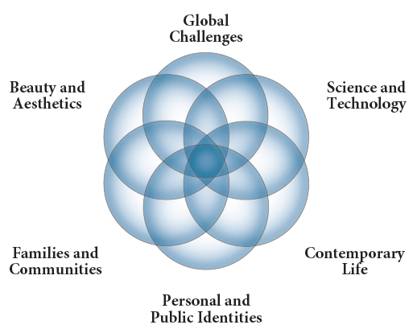

Course Materials :
Primary Textbooks:

Title: Thèmes
Publisher: Vista Higher Learning
Author: Delfosse, Kurbegov, and Draggett
Date: 2015

Title: AP French: Preparing for the Language and Culture Examination
Publisher: Pearson
Author: Ladd
Date: 2012

Title: Une Fois Pour Toutes
Publisher: Addison Wesley Longman
Author: Sturges
Date: 2009

Other Print and Online Resources:

- The following resources may or may not be used in class; however, they are available for students to use in order to independently strengthen their language skills.

** Students! If you know of or find any websites, materials, articles, movies, songs, books, artists, current event issues, etc. that you find interesting and relevant to class, please share them with me!**

1. Liens culturels / journaux/ magazines

• Civilation Francaise: Cortland - http://web.cortland.edu/flteach/civ/
• Activités culturelles en FR - http://culturebox.france3.fr/#/all
• Culture à la une - http://www.culture.fr/fr/sections
• L'avis des jeunes sur la société - http://www.lemonde.fr/week-end/visuel/2011/06/10/vie-de-jeunes-a-l-age-ou-tout-oscille_1534639_1477893.html
• Espace Apprendre - http://www.canalacademie.com/apprendre/index.php
• Site européen par theme - http://www.europarl.europa.eu/news/archive/search.do;jsessionid=69CB359E34EE24B34848B86A2B072D0A.node2?language=fr
• Espace Français - http://www.espacefrancais.com/home.php
• En première Page dans les journaux - http://www.newseum.org/todaysfrontpages/flash/
• RTBelge-Société (vidéos) - http://www.rtbf.be/info/societe
• Magazine France-Amérique - http://www.france-amerique.com/
• Journal "Le Monde" - http://www.lemonde.fr/

2. Sites divers

• Un nuage de mots - http://www.wordle.net/
• Dictionnaire TV5 - http://dictionnaire.tv5.org/dictionnaires.asp?Action=1&mot=symbole&che=1
• Word reference: excellent dictionnaire Fr -An - http://www.wordreference.com/
• Synonyme - http://www.synonyms-fr.com/
• Verbix - Conjugaisons des verbes - http://www.verbix.com/languages/french.shtml

3. Written Interpretative communication: Littérature et textes actuels

• Articles actuels en ligne par thèmes - http://www.internetactuel.be/
• Wiki: Reading Resources for French Teachers - http://readingresources4frenchteachers.wikispaces.com/home
• Ebook en francais - http://www.litteratureaudio.com/
• Maupassant : Ouvres - http://maupassant.free.fr/
• La poésie 1 - http://poesie.webnet.fr/home/pages/liens_utiles_poesie.html
• Poème à écouter - http://wheatoncollege.edu/academic/academicdept/French/ViveVoix/
• Le club des poètes - http://www.poesie.net/framot2.htm
• Littérature audio-vidéo - http://www3.unileon.es/dp/dfm/flenet/culturecours.htm
• Les Proverbes - http://www0.hku.hk/french/dcmScreen/lang2043/proverbes.htm
• Etiquette du Savoir Vivre en France - http://www0.hku.hk/french/dcmScreen/lang2043/etiquette.htm
• RAFT project - http://www.readingquest.org/strat/raft.html

4. Written interpretative communication: audio

• France 2 - http://www.france2.fr/
• TF1 - http://www.tf1.fr/
• Télévision Suisse Romande - http://www.tsr.ch/info/
• Courtes vidéos sur l'info TSR - http://www.tsr.ch/video/info/
• Radio France Internationale - http://www.rfi.fr/
• TV5 - http://www.tv5.org/
• Radio Télévision Belge - http://www.rtbf.be/info/monde
• 7 jours sur la planète - http://www.tv5.org/TV5Site/7-jours/
• Sites de chansons - http://platea.pntic.mec.es/~cvera/hotpot/chansons/index.htm
• Site chansons 2 - http://www.lepointdufle.net/chansons.htm
• Lyrics Training - http://lyricstraining.com/
• Podcast : one thing in a French Day - http://onethinginafrenchday.podbean.com/
• Podcast facile: la France bis - http://www.lafrancebis.com/
• Radio Canada - http://www.radio-canada.ca/

5. Vocabulaire

•Par thème: Middlebury - http://cr.middlebury.edu/public/french/Lexique/
• Voc: University Texas - http://www.laits.utexas.edu/fi/
• Listes de sites de voc - http://www.ph-ludwigsburg.de/html/2b-frnz-s-01/overmann/baf3/3r.htm

6. Grammaire

• Univeristé du Texas - http://www.laits.utexas.edu/tex/gr/index.html
• TV5 Jeu interacrif grammaire - http://www.tv5.org/cms/chaine-francophone/lf/Tous-les-dossiers-et-les-publications-LF/Jeux-de-lettres-interactifs-grammaire/p-9446-Jeux-de-lettres-interactifs-grammaire.htm

AP French Exam Information 2016-2017:
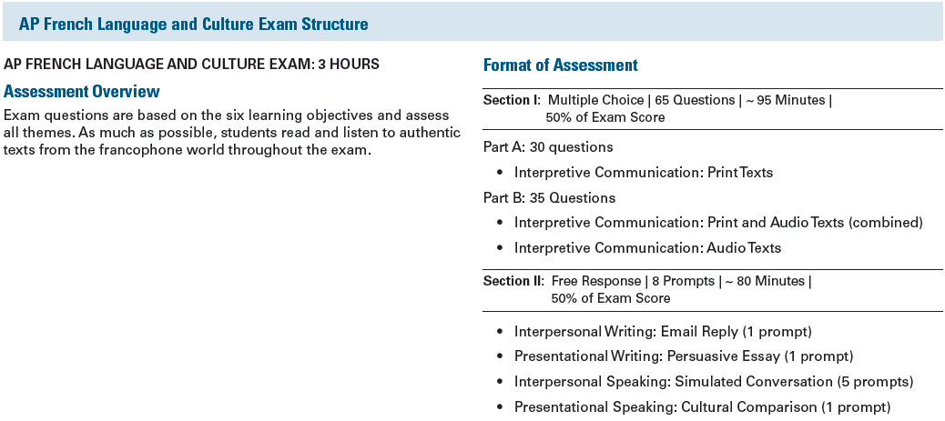

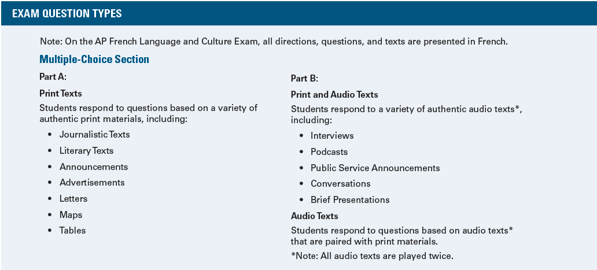
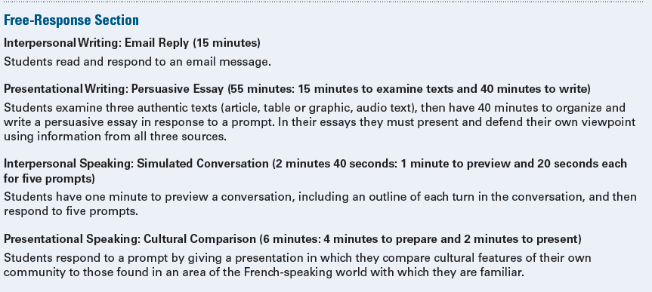
***AP French Language and Culture Exam will be Tuesday, May 9, 2017 in the afternoon at 12:00PM***

