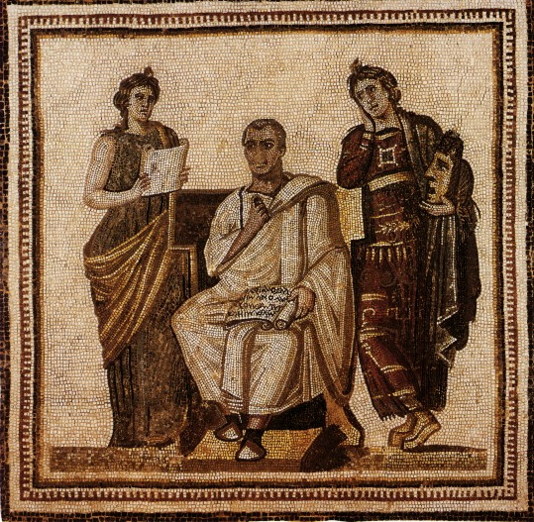
Contact Information:

Instructor: Melissa Grasso
Room: 4302
Email: melissa.grasso@bexleyschools.org

“Virgil and the Mousai,” Bardo Museum, Tunis

Course Description:

Salvēte omnēs and welcome to Honors Latin IV! I have high expectations for our class this year. During the first quarter, we will spend our time reviewing the most critical components of Latin grammar, vocabulary, and culture. Be prepared to review essential concepts such as indirect statement, ablative absolutes, and subordinate clauses using the subjunctive, in addition to fundamental vocabulary. Once we finish reviewing, we will plunge head-first into reading Latin prose for meaning and discussion. For this reason, the dynamic of the class will change to more like that of a history or English class, in which the reading provokes conversation about language expression and larger issues of daily life and culture. At this time, I expect that you are prepared to read with minimal difficulty in elementary and intermediate grammar concepts. I want to steer away from grammar discussion and toward more thought-provoking topics such as the foundations and heroes of Rome, all in the original Latin language! Very few people have the ability to read about the foundation of Western Civilization in the original language and through the educated lenses that you are creating for yourselves- consider yourself privileged!

Course Objectives:

- To communicate and interpret Latin
- To gain knowledge and understanding of Greco-Roman culture
- To connect Latin with other disciplines and expand our knowledge of both
- To develop insight into our own languages and cultures
- To participate in wider communities of language and culture

Classroom Expectations:

- Respect your peers and Magistra in your words and actions
- Be productive and put your best effort forward
- Come to class prepared with all required materials
- Class time is for class activities
- Follow Magistra’s directions
- Cell phones belong in the cell phone parking lot at all times unless you are otherwise instructed by Magistra

Classroom Policies:

- Absences: You are responsible for all missed work due to absence. You will be given one make-up day for each day absent. Please be sure to collect any returned work or handouts that were missed and to obtain notes from a classmate. Missing assignments can be found in the “Makeup” bin in the classroom. If you have questions about missing work or cannot find your assignment in the bin, please do not hesitate to see or e-mail me.
- Homework or projects: Since homework assignments are announced in class and posted on Canvas, the excuse that you did not know there was a homework assignment will not fly, even if you were absent. I will deduct from your homework or project grade for late work. No homework will be accepted by the following chapter, e.g. I will not accept work from Chapter 1 once we’ve started Chapter 2. If you are ever unsure about an assignment, please send me an e-mail.
- Retakes: Students are not allowed retakes. All students are permitted to make test corrections in which they revise and resubmit their tests. Students will earn one-third credit for all correct revisions. Students who score below 70% are required to make test corrections in conjunction with Magistra. Test corrections will not be accepted after the next test (i.e. Test 3 corrections will not be admitted after Test 4 has been taken). There are no test corrections on quizzes. Please feel free to ask me to clarify this policy if necessary.
- Discipline: If you choose not to adhere to classroom and/or school policies, there will be progressive consequences.
1st Consequence- Verbal warning
2nd Consequence- Meeting with Magistra
3rd Consequence- Phone call or conference with parent/caretaker
4th Consequence- Removal from class
- Extra credit: I will offer various opportunities for extra credit throughout the year. However, extra credit will only be offered to those who did test corrections for every test below 80% over the semester. Extra credit will not be accepted in the final week of classes before the final exam.

Required Materials:

- Ecce Romanī I, II, and/or III, depending on the needs of our review (provided by school)
- Fabulae Romanae (provided by school)
- Paper, either a notebook or loose-leaf
- Pens or pencils
- How you choose to organize your binder is your choice. However, I recommend that you have a three-ring binder with four sections: notes and classwork, homework, culture and history, and assessments.

Grading Procedures:

Semester grades are calculated on a 1,000-point system, with each quarter worth 400 points and the final exam worth 200 points. A ten-point assignment is therefore worth 1% of your semester grade. Components of your grade consist of tests, quizzes, projects, and homework. The grade breakdown of the first quarter is as follows:

200 points (50%) Tests (4 total)
50 points (12.5%) Quizzes (5 total)
100 points (25%) Homework
50 points (12.5%) Projects/Presentations
400 points (100%)- Total

(Please note that the grade breakdown is subject to change from quarter to quarter)

Bonam fortunam!

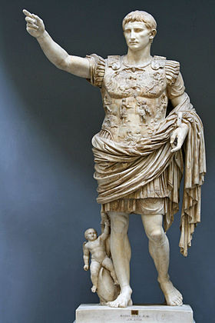

Can you identify this figure? Be the first person to do so and earn a bonus point!

