Algebra 1  Practice #7  Parallel and Perpendicular Lines | Name___________________________________  Date________  Period________

1. Write the equation of the line that has y-intercept $(0,10)$ and is parallel to the line $y=\frac{7}{4}x+2$. Write your answer in slope-intercept form.

2. Write the equation of the line that is perpendicular to the line $y=3x+10$ and has y-intercept $(0, 1)$. Write your answer in standard form.

3. Write the equation of the line that is perpendicular to the line$y=\frac{5}{2}x-1$ and passes through the point $(-1,8)$. Write your answer in standard form.

4. Write the equation of the line that is parallel to $5x+4y=10$ and passes through the point $(-4, -8)$. Write your answer in slope-intercept form.

5. Write the equation of the line that has an x-intercept at $(3, 0)$ and is parallel to the line given by $y-5=-\frac{1}{6}(x+3)$. Write your answer in slope intercept form.

6. Write the equation of the line that passes through the points $\left(0,6\right) and (-3, 4)$. Write your answer in point-slope form.

Determine whether the pairs of lines are parallel, perpendicular, or neither.

7.  $\begin{matrix}3x-6y=6 \\ x-2y=10\end{matrix}$ | 8.  $$\begin{matrix}-7x+14y=1 \\ 8x+4y=11\end{matrix}$$
9.  $$\begin{matrix}y-3=\frac{4}{5}\left(x+1\right) \\ y=-\frac{4}{5}x+3\end{matrix}$$ | 10.  $$\begin{matrix}8x+24y=48 \\ -9x+3y=27\end{matrix}$$

11. Water freezes at 32 degrees Fahrenheit and 0 degrees Celsius. It boils at 212 degrees Fahrenheit and 100 degrees Celsius.

a) Let X represent degrees Fahrenheit and Y represent degrees Celsius. Write the numbers given above as ordered pairs. (x, y).

b) Now write the equation of the line relating Fahrenheit to Celsisus.

c) If the temperature outside is 65 degrees Fahrenheit, then what is the temperature in Celsius?

12. If a child’s foot is 7.75 inches long, then the child wears a size 13 shoe. If the child has a foot that is 5.75 inches long, then the child wears a size 7 shoe. The shoe size S is a linear function of the length of the foot L.

a) Write the equation of the linear function.

b) What is the child’s approximate shoe size if his/her foot measures 6.25 inches in length?

13. Suppose that 530 people choose to purchase a doll from a store if its price is $1.00. If the price goes up to $4.00, then only 140 people will purchase a doll.

a) Write the equation of the line that represents the customers’ preferences. Write your answer in point-slope form.

b) If the dolls are free, then how many dolls will the customers want to purchase?

c) What price will cause customers to buy zero dolls?

14. A contractor found that his labor cost for installing 100 feet of pipe was $30. He also found that his labor cost for installing 500 feet of pipe was $120.

a) If the cost C (in dollars) is a linear function of the length L (in feet), then what is the formula for this function?
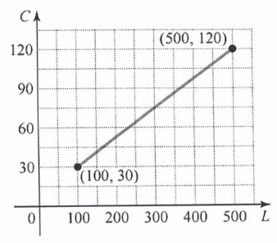

b) What would his labor cost be for installing 240 feet of pipe?

