United States History

Unit 8: Document-Based Question on Women in the Progressive Era

Question:
How did the (a) social, (b) political, and (c) economic position of women change from 1890-1925?

Document A:
Source: Susan B. Anthony, "The Status of Women, Past, Present, and Future," Arena, May 1897

The close of this 19th century finds every trade, vocation, and profession open to women, and every opportunity at their command for preparing themselves to follow these occupations.

A vast amount of the household drudgery that once monopolized the whole time and strength of the mother and daughters has been taken outside and turned over to machinery in vast establishments.

Document B:
Source: The Brandeis Brief in the Muller v. Oregon Case, 1908

Long hours of labor are dangerous for women primarily because of their special physical organization. In structure and function women are different from men. Physicians are agreed that women are fundamentally weaker than men in all that makes for endurance: in muscular strength, in nervous energy, in the powers of persistent attention and application.
When the health of women has been injured by long hours, not only is the working efficiency of the community impaired, but the deterioration is handed down to succeeding generations. Infant mortality rises, while the children of married working-women, who survive, are injured by inevitable neglect.

Document C:

Source: National American Woman Suffrage Association, “Mother’s Day Letter,” 1912

Women are recognized as the most religious, the most moral and the most sober portion of the American people. Why deny them a voice in public affairs when we give it for the asking to every ignorant foreigner who comes to our shores?

In view of the fact that in the moral and social reform work of the churches, the Mothers and Women of the churches are seeking to correct serious evils that exist in our cities as a menace to the morals of their children outside the home.

Document D:
Source: Marie Jenney Howe, “Antisuffrage Monologue,” 1913

My first argument against suffrage is that the women would not use it if they had it. You couldn’t drive them to the polls. My second argument is, if the women were enfranchised they would neglect their homes, desert their families, and spend all their time at the polls. You may tell me that the polls are only open once a year. But I know women. They are creatures of habit. If you let them go to the polls once a year, they will hang round the polls all the rest of the time.
If the women were enfranchised they would vote exactly as their husbands do and only double the existing vote. Do you like that argument? If not, take this one. If the women were enfranchised they would vote against their own husbands, thus creating dissension, family quarrels, and divorce.

Document E:
Source: Anti-Saloon League Advertisement, 1919
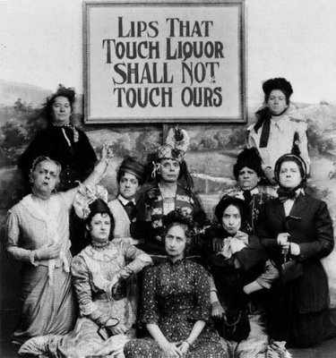

Document F:
Source: Women Garment Workers on Strike, 1915

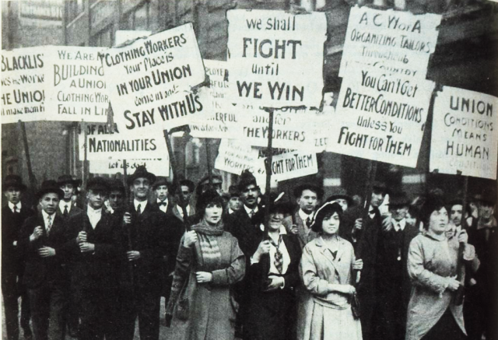

Document G:
Source: National Women’s Party Vigil outside the White House, 1917

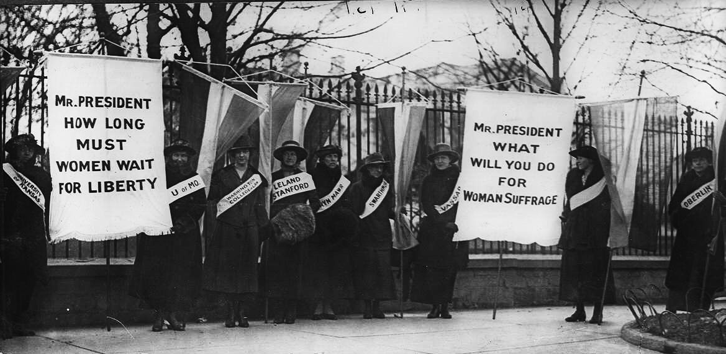

Document J:

Source: Clara Lemlich, “Life in the Shop,” 1909

First let me tell you something about the way we work and what we are paid. There are two kinds of work - regular, that is salary work, and piecework. The regular work pays about $6 a week and the girls have to be at their machines at 7 o'clock in the morning and they stay at them until 8 o'clock at night, with just one-half hour for lunch in that time.
The shops are unsanitary - that's the word that is generally used, but there ought to be a worse one used. Whenever we tear or damage any of the goods we sew on, or whenever it is found damaged after we are through with it, whether we have done it or not, we are charged for the piece and sometimes for a whole yard of the material.

UNITED STATES HISTORY Name:______________________________
WRITING AN ESSAY: THE 5-PARAGRAPH ESSAY FORMAT Date:________________ Period: _____

A. Introduction: Start with a general sentence that introduces your topic to a reader:

__________________________________________________________________________________________________________________________________________________________________________________________________________________________________________________________________________________________________________________________________________________________________________________________
______________________________________________________________________________________________________________________________
B. Thesis statement: A sentence that tells your reader what you will talk about in the essay:
Between 1890 and 1925, the position of American women changed as they ____________________________________________________________________________________________________________________ (social), ____________________________________________________________________________________________________________ (political), and _______________________________________________________________________________________________________________ (economic).
C. Paragraph One: Discussion of the Social
__________________________________________________________________________________________________________________________________________________________________________________________________________________________________________________________________________________________________________________________________________________________________________________________
D. Paragraph Two: Discussion of the Political
__________________________________________________________________________________________________________________________________________________________________________________________________________________________________________________________________________________________________________________________________________________________________________________________
E. Paragraph Three: Discussion of the Economic
__________________________________________________________________________________________________________________________________________________________________________________________________________________________________________________________________________________________________________________________________________________________________________________________
F. Conclusion: Restate your thesis statement and summarize the entire essay.
__________________________________________________________________________________________________________________________________________________________________________________________________________________________________________________________________________________________________________________________________________________________________________________________

