United States History Name: ____________________________

Unit 8: The Progressive Presidents Date:________________ Period:_____

Teddy Roosevelt, 1900-1908  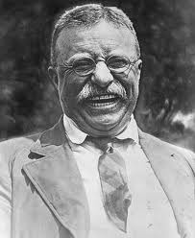 | William H. Taft, 1909-1912  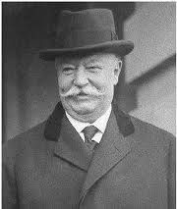 | Woodrow Wilson, 1912-1920  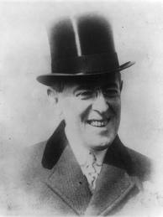
President Roosevelt used the power of government to break up trusts, solve labor conflicts, and to reform business practices. Trusts, large companies that acted like monopolies, controlled about 80 percent of U.S. industries by 1900. Using the Sherman Antitrust Act, Roosevelt filed 44 antitrust suits and was known as a “trustbuster.” In 1902, Roosevelt forced mine owners and workers to settle their differences to prevent a strike. Roosevelt supported laws such as the Hepburn Act of 1906, which strictly limited the distribution of free railroad passes, a common form of bribery. Roosevelt’s efforts resulted in fairer shipping rates and less corruption in the railroad industry. After reading The Jungle by Upton Sinclair, which described filthy conditions in the meatpacking industry, Roosevelt pushed for passage of the Meat Inspection Act. This law, passed in 1906, called for strict cleanliness standards and inspections for meatpackers. Also in 1906, Congress passed the Pure Food and Drug Act which halted the sale of contaminated foods and medicines and called for truth in labeling. | Roosevelt wanted William Howard Taft to become president because Roosevelt felt Taft would carry out his policies. Taft was elected in 1909, and he did continue many of the progressive programs. In fact, Taft busted more than twice as many trusts as Roosevelt had. However, Taft was not as effective as Roosevelt as a leader of the Republican Party. The Republican Party had two wings: (1) the progressives, who wanted change and (2) the conservatives, who did not want reform. Taft was not able to hold the two wings of his party together. By 1912, Teddy Roosevelt decided to run for a third term as president against Taft. When the Republican Party nominated Taft, Roosevelt’s supporters and formed the Progressive, or Bull Moose Party. It ran on a platform of reform. The Democrats were in a stronger position now that the Republicans were split. They nominated the reform governor of New Jersey, Woodrow Wilson. Wilson campaigned on a platform of progressive reform, antitrust laws, banking reform, and lower taxes on imports. He won the election and Democrats won a majority in Congress. | Under Wilson, Congress passed two antitrust measures. The first was the Clayton Antitrust Act of 1914. This law (1) made it more difficult for monopolies to form, (2) made the people who ran a company personally responsible if the company violated the law, and (3) ruled that labor unions would not be treated as trusts. The second antitrust measure was the Federal Trade Act of 1914, which set up the Federal Trade Commission (FTC). This agency had the power to investigate businesses. The FTC became very active during Wilson’s administration, issuing almost 400 orders telling companies to stop breaking the law. To pay for reforms, the government turned to an income tax. This tax on people’s earnings was created by the Sixteenth Amendment to the Constitution (1913). Wilson also focused on the banking system. It was difficult for people far from banking centers to obtain credit. The new Federal Reserve System helped by dividing the country into 12 districts, each with a federal bank. The “Fed” controlled the money supply and made credit easily available. The federal reserve was one of Wilson’s most important reforms.
Teddy Roosevelt, 1900-1908 | William H. Taft, 1909-1912 | Woodrow Wilson, 1912-1920
- Why was Roosevelt called a “trustbuster”?  - What did the Hepburn Act do?  - What did the Meat Inspection Act and Pure Food and Drug Act have in common? | - Could Taft be called a “trustbuster”?  - Why was Taft an ineffective leader of his political party?  - How did Bull Moose Party help the Democrats win the election of 1912? | - How did Wilson limit the power of trusts?  - What did the Sixteenth Amendment do?  - Why was the “Fed” one of Wilson’s most important reforms?

Imagine you are called upon to give a “Most Progressive President” award to one of the three Presidents above. Who would get the award? Why?

