United States History
Unit 9 Reading: The Great Migration

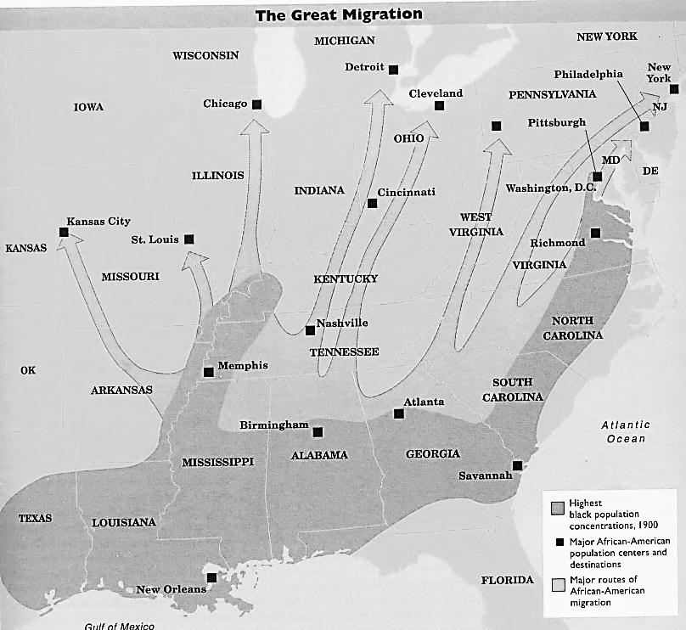
In 1910, three out of every four black Americans lived on farms, and nine out of ten lived in the South. Hoping to escape a life of sharecropping, debt, and discrimination, 1.5 million Southern blacks moved to northern cities in a movement historians called “The Great Migration.” Southern blacks resented Jim Crow laws, segregation, discrimination, and the threat of lynching, factors that pushed them to go north. They were pulled to the North by the promise of new jobs, especially during the labor shortages occurring during World War I. During the 1910s and 1920s, Chicago's black population grew by 148 percent; Cleveland's by 307 percent; Detroit's by 611 percent.

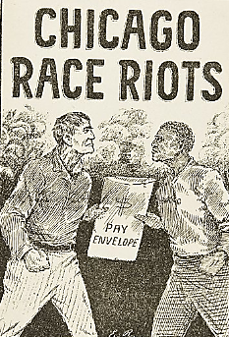
When southern blacks arrived in northern cities, they had difficulty finding homes. Northern whites disliked African Americans who wanted to move into all-white neighborhoods. Many northern cities adopted residential segregation ordinances to keep blacks out of white neighborhoods. In 1917, the Supreme Court declared city-wide segregation ordinances unconstitutional. In response, whites used the restrictive covenant, a rule written into a deed for property that forbid white owners from selling to black buyers. Whites who sold their property to black buyers could be sued by their neighbors. Confined to all-black neighborhoods, African Americans created cities-within-cities during the 1920s. The largest was Harlem, in upper Manhattan, where 200,000 African Americans lived in a neighborhood that had been nearly all-white fifteen years before. The creation of these all-black neighborhoods helped African-American culture grow in the North, especially in the areas of literature and music.

Even though they had left behind southern racism, African-Americans found many northerners to be just as racist as southerners. Many white northerners worried that African-Americans were going to take away their jobs. Because of the friction caused by the Great Migration, twenty-five anti-black riots took place in 1919. One of the worst was in Chicago in July, 1919. When a young African-American man came too close to a white beach, he was killed by whites. When police arrested a black man instead of the whites responsible for the young man’s death, riots broke out. Black residents suffered the worst of the violence. Twenty-three African Americans died and nearly a thousand were left homeless after their homes were burned.

African Americans responded strongly to northern violence by protesting discrimination and racism. The National Urban League, organized in 1911 by social workers, white philanthropists, and black leaders, helped urban African Americans find jobs. The National Association for the Advancement of Colored People (NAACP) won important Supreme Court decisions against the grandfather clause (1915) and restrictive covenants (1917). The NAACP also fought school segregation in Northern cities during the 1920s and worked, though unsuccessfully, for a federal anti-lynching bill.

