United States History Name:__________________________
Advertising the New Deal Date:______________ Period:_______

Directions: President Roosevelt used advertising and propaganda to build public support for his New Deal programs. Pick one of the New Deal programs below. Research it and come up with a brochure that would advertise that program to the public. See pages 488-501 in your text.

Programs:

Civilian Conservation Corps
Federal Emergency Relief Act
Public Works Administration
Agricultural Adjustment Act
Tennessee Valley Authority
Securities Exchange Act
National Labor Relations Act
Glass-Steagall Banking Act
Works Progress Administration
Federal Housing Administration
Food, Drug, and Cosmetic Act
National Youth Administration
Rural Electrification Act
Fair La bor Standards Act

Questions to Answer for Designing Your Brochure:
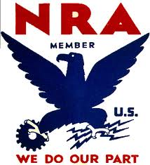
1. Who will the act benefit?

2. What does the act do?

3. Is the act part of the plan for relief, reform, or recovery?

4. What would be a good symbol for the act?

5. What would be a good slogan (catchy phrase) to describe the act?

Standards for the Brochure:
1. You may hand-write or draw the brochure OR design the brochure on the computer.
2. The brochure may be 2-fold or 3-fold.
3. The cover should catch the eye and let the reader know immediately what the Act is and what it will do for Americans.
4. The inside of the brochure should clearly explain the provisions of the act.

