United States History Name:___________________________________
Reading: The Puritan Worldview Date:____________________ Period:_______

Directions: Read the following selections on the Puritan’s views of law and community. Then answer the questions.

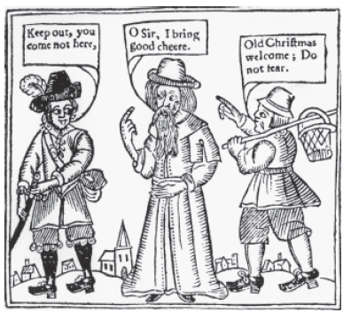
The Laws and Liberties of Massachusetts (1647)

- If any man after legal conviction shall HAVE OR WORSHIP any other GOD, but the LORD GOD: he shall be put to death.
- IF any person commit ADULTERY with a married or espoused wife; the Adulterer and Adulteress shall surely be put to death.
- If any child, or children, above sixteen years old, shall CURSE, or SMITE [hit] their natural FATHER, or MOTHER; he or they shall be put to death.
- No person shall henceforth use the said game of Shuffle-board in any house upon pain of five shillings for every offense.
- If any Christian shall go about to subvert and destroy the Christian Faith and Religion, such a person shall after due means of conviction be sentenced to Banishment.
The Puritans hated Christmas because it was a time of disorderly behavior. So, when Puritans took control of England in 1647, they banned Christmas celebrations for 22 years.
- No person, Householder or other shall spend his time idlely or unprofitably under pain of punishment.
- Every person found drunken: so that he be thereby without or disabled in the use of his understanding, shall forfeit ten shillings.
- Every person at least of fourteen years of age who shall wittingly make or publish any LIE which may be damaging to the public, or tending to the injury of any person, or with intent to deceive the people with false news, such person shall be fined ten shillings for the first offense. For the second offense, the said person may be whipped upon the naked body not exceeding ten lashes.
- If any man behave himself offensively at any Town-meeting, the rest then present shall have the power to sentence him for such offense, not to exceed twenty shillings.

- According to the above reading, which of the following did Puritans NOT punish?
- Being lazy
- Telling lies
- Drinking alcohol
- Adultery

- What was the punishment for going around and discouraging people from following Christianity?
- Death
- Banishment
- 20 shilling fine
- Public whipping
- Which of the following best describes Puritan society as revealed by the above laws?
- Open to different viewpoints
- Respectful of freedom of religion
- Punishments are light and easy
- Strict and harsh use of the law

- Taking all of the laws together, which of the following might explain why Puritans banned gaming (shuffle-board)?
- It often led to public drunkenness.
- It was an unprofitable waste of time.
- It encouraged adultery.
- It made children disobedient.

