# United States History Name:__________________________________

Diagram: How Tariffs Work Date:________________ Period:__________

C:\Users\Scott\AppData\Local\Microsoft\Windows\Temporary Internet Files\Content.IE5\GKSY2DIP\MC900329284[1].wmf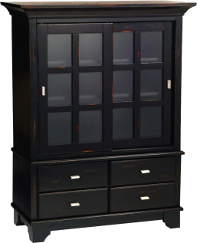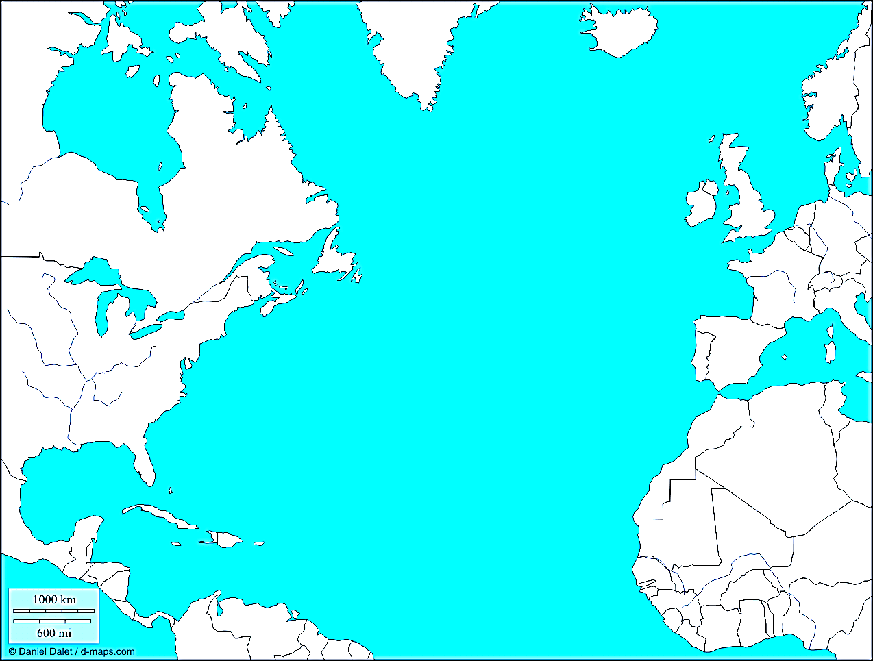

The purpose of a tariff is to _________________________________

______________________________________________________________