United States History
Reading: Andrew Jackson, Friend of the Common Man

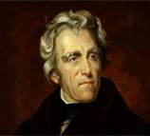
- The Jacksonian Democrats believed in:
  - Freedom of religion – the state should not get involved in religious issues

  - The dignity of workingmen – those who work hard with their hands deserve more credit for building the nation than bankers and other parasites who live off the labor of others

  - Extension of voting rights to all adult white males – by 1850 almost every state had ended property requirements for voting

  - The Spoils System – the same people should not serve in government jobs their entire lives because it makes them think that they have a right to their job; after every election for a new president, he should clean house, removing all current employees, and replace them with new people who would be loyal to the new president

  - Strict Interpretation of the Constitution – the federal government should have limited powers; Jackson once vetoed a law for building a road because it would have spent federal money entirely within a single state, which Jackson believed was unfair since the money would only benefit a small group of people

  - Laissez-Faire Approach to the Economy – the federal government should not regulate the economy; businesses should succeed without government controls OR help; Jackson especially did not like banks, which he believed formed a “money power” that was capable of controlling elections because of their wealth

Stories about Jackson

- Inauguration, 1829: After winning 59.0% of the popular vote, Jackson was inaugurated in the first ever outdoor affair (for all previous presidents, it was an invitation-only event). About 21,000 people came to see the President. The mob followed the President to the White House afterwards, where they broke several thousand dollars’ worth of china trying to see the President and shake his hand.

- Peggy O’Neill Timberlake Eaton Affair: One of Jackson’s cabinet members married a young widow, Peggy Timberlake, after her husband died at sea. The wives of Jackson’s other cabinet members thought that Peggy was lewd, lacking in morals, and low-class because she had a scandalous reputation. These wives refused to invite Peggy to parties and treated her very poorly. Jackson was furious because his beloved wife Rachel died after rumors spread that she and Jackson had not been legally married. He hated to see another girl suffer publicly from the abuse of the “real housewives of D.C.” Jackson eventually got all his cabinet members to resign (except one) to put an end to the mistreatment of Peggy Eaton.

United States History
Reading: Andrew Jackson, Tyrant

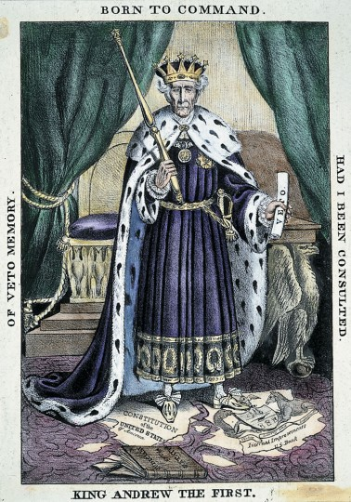
Jackson and the Bank: Jackson believed that Nicholas Biddle, head of the Second Bank of the United States, asked for an early re-charter of the bank to embarrass Jackson in the election of 1832. He told his vice-president, “The bank, Mr. Van Buren, is trying to kill me, but I will kill it.” Jackson vetoed the bank’s re-charter. To kill the bank, Jackson had to get rid of two Treasury secretaries before he found one who agreed that it was legal to stop putting the United States’ deposits in the bank. By 1833, Jackson succeeded in getting the deposits sent to pet banks, run by friends of the Jacksonian Democrats in the states. The Senate censured Jackson, the “backwoods Caesar,” but Biddle’s bank closed by 1839.

Jackson and the Indians: Jackson wanted to remove the southern Indians, even those who had become “civilized,” to lands across the Mississippi River. He argued that it would be best to protect the Indians from land-hungry whites. Truthfully, the discovery of gold in northern Georgia on Indian land increased white pressure to get the Indians out of the way. States, also, worried about these “civilized” tribes living within their borders, particularly those that had their own governments and laws. Cherokee Indians challenged their treatment in court and the Supreme Court ruled that Indians were under the protection of the federal government, but Jackson refused to support the Court’s rulings. The Indian Removal Act of 1830 allowed for removal of some 50,000 Indians in the South. More than 45,000 Indians would be moved to the west. So many Cherokee died in 1838 (4,000) that the removal was named the “Trail of Tears.”

Jackson and Slavery: The Jacksonians were relentless advocates of expansion to lands in the West, Texas especially. Many of the Jacksonians were southerners (like Andrew Jackson) and owned slaves. They saw in the West a place to expand slavery and find new profits from growing cotton.

Jackson Opposes Internal Improvements: Jackson believed that the federal government should not spend a lot of money, nor did he believe that the federal government should spend money to benefit a single state or group of people. When Jackson was presented with a bill to help build a road in Kentucky (that would become part of an interstate road system), Jackson vetoed it even though Jacksonian Democrats in Kentucky supported the bill.

Jackson and the Veto: Andrew Jackson used his veto powers more than all previous presidents combined. He vetoed 12 pieces of legislation (his 6 predecessors only vetoed 10).

Jackson and South Carolina: When South Carolina, led by John C. Calhoun, wanted to nullify the collection of tariffs, Jackson threatened to “hang” the first nullifer he could find. He rejected the states’ rights ideas of Calhoun and was given authority to use force to restore order in South Carolina, though he chose compromise over force.

