United States History
Choral Reading of Common Sense by Thomas Paine, 1776

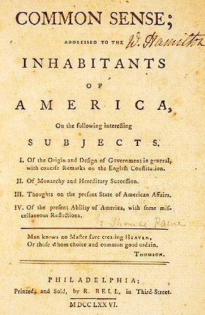
Thomas Paine published his 48-page pamphlet, Common Sense, on January 10, 1776 to stir Americans to the potential for independence by destroying all arguments for remaining attached to England. The pamphlet sold 500,000 copies in its first year. Paine argued that monarchy was a foolish system of government, that it was stupid for an island (England) to rule a continent (America), and that Americans had a golden opportunity to establish the best system of government the world had ever seen.

PAINE: IN the following pages I offer nothing more than simple facts, plain arguments, and common sense. I have heard it asserted by some, that as America has flourished under her former connection with Great Britain, the same connection is necessary towards her future happiness, and will always have the same effect.

PUBLIC: Her motive was INTEREST not ATTACHMENT.

PAINE: But Britain is the parent country, say some. Then the more shame upon her conduct. Even brutes do not devour their young, nor savages make war upon their families.

PUBLIC: Europe, and not England, is the parent country of America.

PAINE: This new World hath been the asylum for the persecuted lovers of civil and religious liberty from EVERY PART of Europe. Hither have they fled, not from the tender embraces of the mother, but from the cruelty of the monster. I challenge the warmest advocate for reconciliation to show a single advantage that this continent can reap by being connected with Great Britain.

PUBLIC: Not a single advantage is derived.

PAINE: It is not in the power of Britain to do this continent justice: The business of it will soon be too weighty, and intricate, to be managed with any tolerable degree of convenience, by a power, so distant from us, and so very ignorant of us. To be always running three or four thousand miles with a tale or a petition, waiting four or five months for an answer, will in a few years be looked upon as folly and childishness —

PUBLIC: A government of our own is our natural right.

PAINE: While we profess ourselves the subjects of Britain, we must, in the eyes of foreign nations, be considered as Rebels. A manifesto must be published, and dispatched to foreign Courts, setting forth the miseries we have endured, and the peaceful methods which we have ineffectually used for redress.

PUBLIC: By independence we take rank with other nations.

ALL: Now is the seed-time of Continental union, faith and honor.

