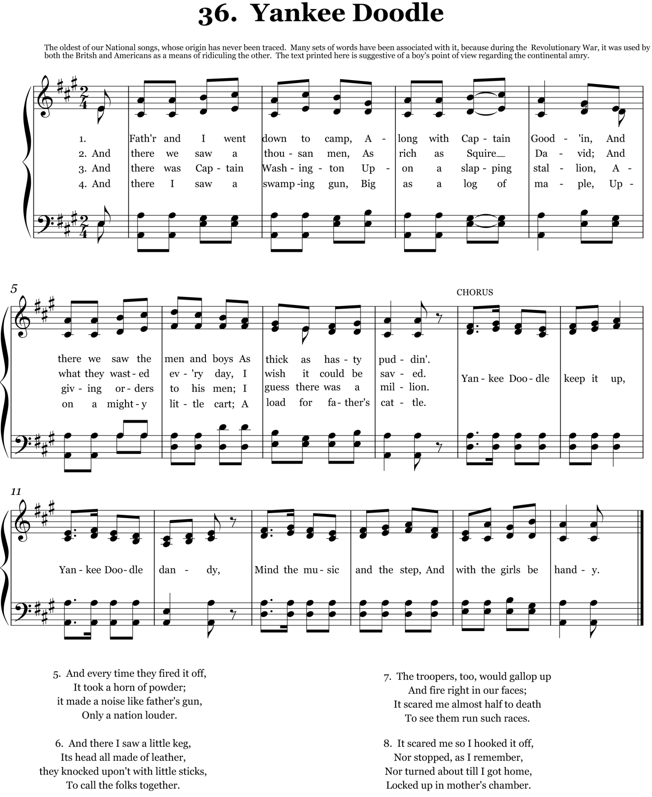

American Taxation by Peter St. John
To the tune of "The British Grenadiers"
While I relate my story, Americans give ear;
Of Britain's fading glory, you presently shall hear.
I'll give a true relation, attend to what I say,
Concerning the taxation of North America.
The cruel lords of Britain, who glory in their shame,
The project they have hit on they joyfully proclaim;
Tis what they're striving after our rights to take away,
And rob us of our charter in North America.
There are two mighty speakers who rule in Parliament,
Who ever have been seeking some mischief to invent;
'Twas North, and Bute his father, the horrid plan did lay,
A mighty tax to gather in North America.
These subtle arch-combiners addressed the British court,
All three were undersigners of this obscure report--
There is a pleasant landscape that lieth far away,
Beyond the wide Atlantic in North America.
O King, you've heard the sequel of what we now subscribe,
Is it not just and equal to tax this wealthy tribe?
The question being asked, his majesty did say,
My subjects shall be taxed in North America.
Invested with a warrant, my publicans shall go,
The tenth of all their current they surely shall bestow;
If they indulge rebellion, or from my precepts stray,
I'll send my war battalion to North America.
I'll rally all my fores by water and by land,
My light dragoons and horses shall go at my command;
I'll burn both town and city, with smoke becloud the day,
I'll show no human pity for North America.
O George! you are distracted, you'll by experience find
The laws you have enacted are of the blackest kind.
I'll make a short digression, and tell you by the way,
We fear not your oppression in North America.
Our fathers were distressed, while in their native land,
By tyrants were oppressed, as we do understand;
For freedom and religion they were resolved to stray,
And trace the desert regions of North America.
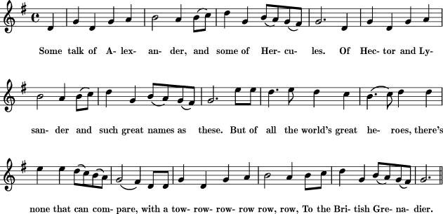

God bless this maiden climate,
And through her vast domain
May hosts of heroes cluster
That scorn to wear a chain.
And blast the venal sycophants
Who dare our rights betray;
Assert yourselves, yourselves, yourselves
For brave America,
Lift up your hearts, my heroes,
And swear with proud disdain,
The wretch that would ensnare you
Shall spread his net in vain;
Should Europe empty all her force,
We'd meet them in array,
And shout huzza, huzza, huzza
For brave America.
The land where freedom reigns shall still
Be masters of the main,
In giving laws and freedom
To subject France and Spain;
And all the isles o'er ocean spread
Shall tremble and obey,
The prince who rules by Freedom's laws
In North America.

Joseph Warren, Free America (to the tune of the British Grenadiers)

The Rich lady over the Sea

There was a rich lady lived over the sea,
And she was an island queen,
Her daughter lived off in the new country,
With an ocean of water between.
With an ocean of water between.
With an ocean of water between.
The old lady's pockets were filled with gold,
Yet never contented was she,
So she ordered her daughter to pay her a tax,
Of thruppence a pound on the tea.
Of thruppence a pound on the tea.
Of thruppence a pound on the tea.
Oh mother, dear mother, the daughter replied,
I'll not do the thing that you ask,
I'm willing to pay fair price on the tea,
But never the thruppenney tax.
But never the thruppenney tax.
But never the thruppenney tax.
You shall, cried the mother, and reddened with rage,
For you're my own daughter, you see,
And it's only proper that daughter should pay
Her mother's a tax on the tea.
Her mother's a tax on the tea.
Her mother's a tax on the tea.
She ordered her servant to come up to her,
And to wrap up a package of tea.
And eager for thruppence a pound she put in
Enough for a large family.
Enough for a large family.
Enough for a large family.
The tea was conveyed to her daughter's own door,
All down by the oceanside,
But the bouncing girl poured out ever pound
On the dark and the boiling tide.
On the dark and the boiling tide.
On the dark and the boiling tide.
And then she called out to the island queen,
Oh mother, dear mother, called she,
Your tea you may have when 'tis steeped enough,
But never a tax from me!
But never a tax from me!
But never a tax from me!

