United States History
Unit 2 Reading: The Articles of Confederation

Historians used to argue that the Articles of Confederation, America’s first government (from 1781 to 1789) was a complete failure. Obviously, they believed, the Constitution that replaced the Articles was a far better government. Recently, however, some historians have disagreed, saying that the Articles did some good and was perhaps more popular with most people than the Constitution was when it was written. Read the following and decide: were the Articles of Confederation “good” or “bad”?

The Powers of the Articles
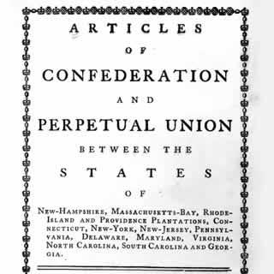
The Articles created a Confederacy, or a loose “friendship” of states that retained almost all their powers, only giving up a few powers to the central government. Because the American Revolution had been about overthrowing a tyrannical government, the men who designed the Articles did not want an oppressive central government. The Congress created under the Articles had the following powers:
- The ability to declare war
- The right to conduct foreign relations
- The power of regulating the Indian trade
- The authority to establish post offices
This Congress was a in which groups of representatives sent from the states had one vote for their state. Congress could not tax the states but could ask the states for a voluntary contribution to pay the nation’s debts. The Articles did not have a separate executive branch (or president) nor did it have its own judicial branch (courts). To change the Articles required a unanimous vote.

Western Lands
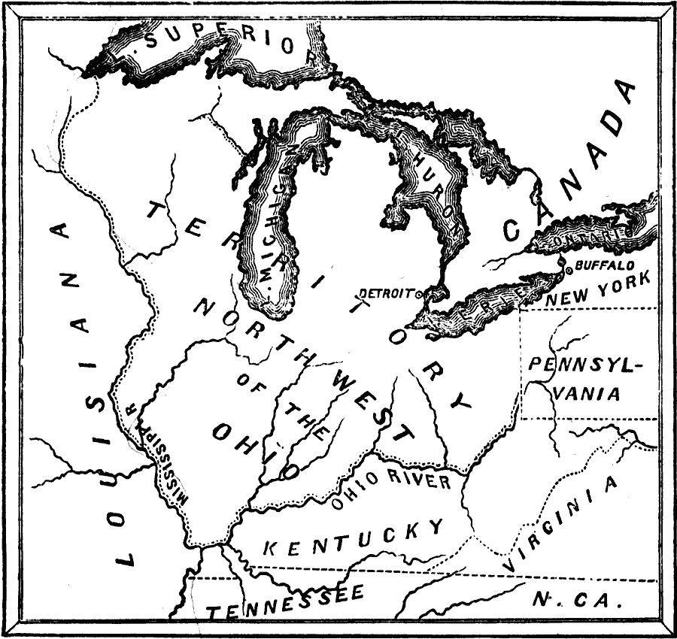
Congress was most successful in the 1780s in how it established western land policy. The Land Ordinance of 1785 established the process for dividing the western lands for sale while the Northwest Ordinance of 1787 created the process of governing the western lands until they became states. Settlers began moving to the Northwest Territory (today located in Ohio, Indiana, Illinois, Michigan and Wisconsin) in the 1780s. When an area had more than 5,000 adult males, the Northwest Ordinance allowed those men to elect a territorial legislature. When an area reached 60,000 adult males, they could write a state constitution and ask to become a new state. The Northwest Ordinance also protected the rights of settlers. Specifically, settlers were given freedom of religion, trial by jury, the protection of property rights, rights of contract, and encouragement for free public education (among many rights that the document listed). The Ordinance even banned slavery in the Northwest Territory and encouraged settlers to respect the rights of the Indians to their lands.

Critics of the Articles
In spite of the success of the Northwest Ordinance, the Congress of the Articles of Confederation had many problems. First, it could not force people in the states to follow the terms of the Treaty of Paris (1783), which angered the British and caused them to hold onto forts in modern-day Michigan and Wisconsin in retaliation. America was seen as so weak and unable to gain respect, that the Spanish closed access to the Mississippi River to Americans in 1784. America further lost respect when it found that it could not even pay the interest payments on loans from France and the Netherlands for money it borrowed to pay for the American Revolution.
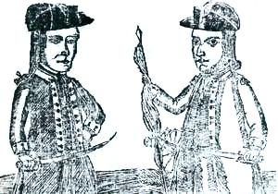
At the state level, the Congress could not prevent states from doing economic harm to each other. States started passing taxes on goods coming from other states, which lowered trade and caused disagreements between the states. Some states were printing their own paper money, which, because it was nearly worthless, caused other states to reject people using worthless paper money to pay their debts. Because Congress had no power to tax, it could not force the states to pay any money for the common debt of the entire nation. The national debt at the time was around $40 million.
As the paper money and tax policies of each state were different, it caused some riots and disturbances to break out in some states but not all of them. Most of the riots were led by farmers who were angry about the lack of money to pay their debts. When they could not pay their taxes, the state took their property. Farmers responded by closing courts and preventing the states from taking their property. Riots occurred in Pennsylvania, South Carolina, and New Hampshire, but the most famous was in western Massachusetts in 1786. 1200 farmers, led by Daniel Shays, marched on an armory to get weapons but were stopped. Within a year, the rebellion was suppressed by the state militia of Massachusetts.

Weaknesses of the Articles?
Critics of the Articles of Confederation pointed to Shays’ Rebellion and other riots as proof that the governments of the states and the nation were headed for a complete breakdown. These critics compiled long lists of the problems of the union, blaming the structure of the Articles for the weaknesses. Others were not so sure. They still believed that the Articles provided the best structure for protecting the rights of states and individual Americans from a tyrannical government. All that would be needed was minor tweaking of the powers of the Articles to solve a few problems. Few people would suspect in 1787 that the 55 men gathered in Philadelphia to fix the problems of the Articles would scrap the entire document and start over to frame a completely new government.

"To suppose that the general concerns of this country can be directed by thirteen heads, or one head without competent powers, is a solecism [a mistake], the bad effects for which every man who has had the practical knowledge to judge from, that I have, is fully convinced of; tho' none perhaps has felt them in so forcible and distressing a degree. . . .” (George Washington to Dr. William Gordon, July 8, 1783)

