United States History
Handout: The Origins of the First Political Parties

By 1792, American politics had begun to divide between two different views on how the national government should operate. Like modern political parties, these two different views tried to shape laws and get the people involved in supporting or opposing different policies. Study the chart below.

 | FEDERALISTS  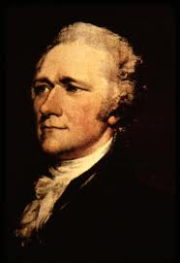 | DEMOCRATIC-REPUBLICANS  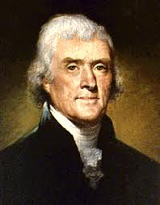
LEADERS | Presidents George Washington and John Adams; Alexander Hamilton | Presidents James Madison and Thomas Jefferson
SUPPORTERS | Wealthy merchants  Well-educated elites  Wealthy town residents  Most New Englanders | Farmers  Common people  Rural people  Most Southerners
BELIEFS ABOUT PEOPLE | Wealthy and well-educated are the best leaders; they know what policies are good for everyone and ordinary people should just trust them. The mob is dangerous—ordinary people are too easily confused by smooth-talking, power-hungry leaders. | Ordinary people should have a voice in their own government; the wealthy cannot always be trusted to do what is best for everyone. We should be more afraid of a tiny elite of power-hungry elites gaining all control over the government.
GOVERNMENT | Strong, active central government able to solve problems and respond to crises. Too much power given to states will make the central government too weak. | Weak, inactive central government that should respond to problems only if they are too big for states to handle. Otherwise, states should have the most power.
ECONOMY | Supporters of manufacturing and building industry. A national bank would help grow the economy and regulate money. Strong taxes on imports (protective tariffs) would allow American industries to grow without foreign competition. | Supporters of farming. The most honorable and dependable people in the nation are farmers. America does not need to manufacture goods, because that will only lead to poverty and the protective tariffs will hurt our farmers trying to sell their goods.
CONSTITUTION | Loose or open interpretation of the Constitution. The central government must have the most freedom to do what its leaders think is necessary. | Strict or literal interpretation of the Constitution. The national government can only do things that are specifically listed in the Constitution.
FOREIGN AFFAIRS | Pro-British. The British are our best trading partners and they have a strong navy. It is best not to be on their bad side. | Pro-French. The French just helped us win the Revolution and we should trade more with them out of respect for their friendship.

