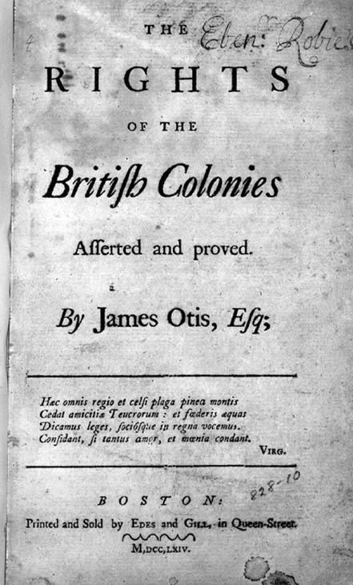
United States History
Enlightenment Ideas in Revolutionary America
#1: Rights of Englishmen

Source: Virginia Resolutions on the Stamp Act, 1765

Resolved, that the first adventurers, settlers of this colony and dominion of Virginia, brought with them and transmitted to their posterity [children], all the privileges and immunities that have at any time been held, enjoyed, and possessed by the people of Great Britain.

Resolved, that by two royal charters granted by King James the first, the colonists aforesaid [previously mentioned] are declared and entitled to all privileges and immunities of natural born subjects, to all intents and purposes as if they had been abiding and born within the realm of England.

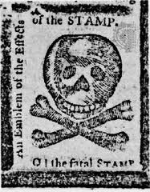
United States History
Enlightenment Ideas in Revolutionary America
#2: No Taxation without Representation

Source: First Continental Congress Resolutions, 1774

Resolved, that the foundation of English liberty, and all free government, is a right in the people to participate in their legislatures: and as the English colonists are not represented, and cannot be represented in the British Parliament, they are entitled to a free power of legislation in their several provincial legislatures in all cases of taxation and internal polity [politics].

But, we cheerfully consent to the operation of such Acts of the British Parliament as relate to the regulation of our external commerce, except every idea of taxation, internal or external, for raising revenue on the subjects of America without their consent.

United States History
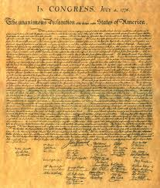
Enlightenment Ideas in Revolutionary America
#3: Consent of the Governed

Source: Declaration of Independence, 1776

We hold these truths to be self-evident, that all men are created equal, that they are endowed by their Creator with certain unalienable Rights, that among these are Life, Liberty and the pursuit of Happiness.--That to secure these rights, Governments are instituted among Men, deriving their just powers from the consent of the governed, --That whenever any Form of Government becomes destructive of these ends, it is the Right of the People to alter or to abolish it, and to institute new Government, laying its foundation on such principles and organizing its powers in such form, as to them shall seem most likely to effect their Safety and Happiness.

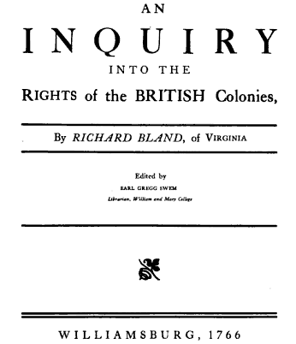
United States History
Enlightenment Ideas in Revolutionary America
#4: Social Contract

Source: An Inquiry into the Rights of the Colonies, 1766

Men in a State of Nature are absolutely free and independent of one another, but when they enter into a Society, and by their own Consent become Members of it, they must submit to the Laws of the Society according to which they agree to be governed. But though they must submit to the Laws, so long as they remain Members of the Society, yet they retain so much of their natural Freedom as to have a Right to retire [leave] from the Society, to renounce the Benefits of it, to enter into another Society, and to settle in another Country.

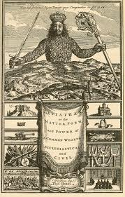
United States History
Enlightenment Ideas in Revolutionary America
#5: Natural Rights

Source: The Rights of the Colonists, 1772

Among the natural rights of the Colonists are these First. A Right to Life; Secondly to Liberty; thirdly to Property; together with the right to support and defend them in the best manner they can—Those are evidence of the Duty of Self Preservation, commonly called the First Law of nature. All men have a Right to remain in a State of nature as long as they please. Every man living in or out of a state of civil society, has a right peaceably and quietly to worship God according to the dictate of his conscience. The natural rights of men by entering into a Society are abridged or restrained so far as is necessary for the Great end of Society, the best good of the whole.

United States History
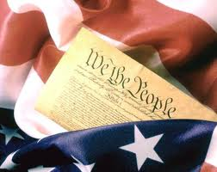
Enlightenment Ideas in Revolutionary America
#6: Popular Sovereignty

Source: Rights of the British Colonies Asserted and Proved, 1774

The end of government being the good of mankind, points out its great duties: It is above all things to provide for the security, the quiet, and happy enjoyment of life, liberty, and property. Where there is no positive government, all powers remain in the whole body of the people. The form of government is by nature and by right so far left to the individuals of each society, that they may alter it from a simple democracy or government of all over all, to any other form they please.

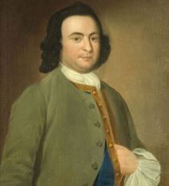
United States History
Enlightenment Ideas in Revolutionary America
#7: Right to Overthrow an Abusive Government

Source: The Virginia Declaration of Rights, 1776

That government is, or ought to be, instituted for the common benefit, protection, and security of the people, nation or community; of all the various modes and forms of government that is best, which is capable of producing the greatest degree of happiness and safety and is most effectually secured against the danger of maladministration; and that, whenever any government shall be found inadequate or contrary to these purposes, a majority of the community hath an indubitable, unalienable, and indefeasible right to reform, alter or abolish it, in such manner as shall be judged most conducive to the public weal.

