United States History Name:_________________________
Dr. King-Owen Date:___________ Period:_________
Reading and Study: Women’s Reform Movements

Directions: Read the following text and then construct a chart comparing women’s reform with anti-slavery, using the chart started for you on the back of this handout.

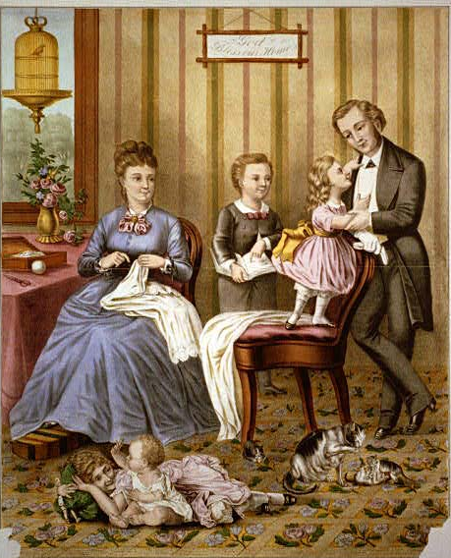
Differences between Men and Women In the early nineteenth century (1800-1860), it was a man’s world. A wife was supposed to stay in the home and obey her husband. Like a black slave, she could not vote or own property. If she disobeyed her husband, he had a legal right to beat her. The law looked at married women as being under the control of their husbands.

Changing Economic Roles The market and industrial revolutions of the early nineteenth century started to emphasize more strongly the differences between men and women. As men worked outside the home more, women became strongly associated with home life. Women were supposed to be protectors of the home, full of moral virtue, sympathy, and tenderness. But women resisted being confined to the home. They wanted the right to appear in public places and speak their minds on important issues.
The Ideal Home Life

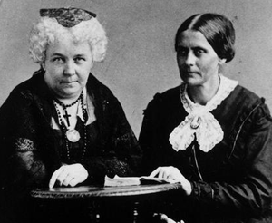
Revivals and Reform The revivals of the early nineteenth century had helped women to see their inner moral value. Women absorbed the message of perfection and understood that they could help improve not only the home, but the world outside of it. Women like Elizabeth Cady Stanton believed that the marriage vows should not include the idea of obedience to husbands. Stanton’s friend, Susan B. Anthony, traveled around to lecture about the importance of women’s rights.

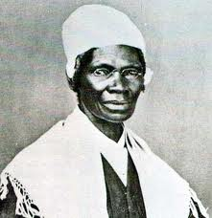
Women and Anti-Slavery Soon women all over the United States in the 1830s and 1840s began to call for reform. They demanded better education, the right to control their own property, and the right to custody of children after a divorce. Many women also participated in the Anti-slavery movement because they saw how similar their own problems were to those of slaves. Elizabeth Cady Stanton and Lucretia Mott went to the World Anti-Slavery conference in 1840, but the men in charge made the ladies sit behind a curtain so their presence would not offend men.
Elizabeth C. Stanton and Susan B. Anthony
Sojourner Truth spoke publicly about women’s rights in 1851: "I could work as much, and eat as much as man - when I could get it - and bear the lash as well! And ain't I a woman? I have borne children and seen most of them sold into slavery, and when I cried out with a mother's grief, none but Jesus heard me. And ain't I a woman?"
Seneca Falls Convention By 1848, women’s reformers decided to meet in Seneca Falls, New York, to discuss what to do about women’s rights. They issued a Declaration of Sentiments, which copied from the Declaration of Independence. “All men and women are created equal,” the ladies wrote. Even though the women at Seneca Falls did not agree on granting women the right to vote, they did call for other reforms in women’s education and marriage rights.
Comparison Chart for Anti-Slavery and Women’s Rights

 | Anti-Slavery | Women’s Rights
Who were the major leaders? | William L. Garrison  Frederick Douglass
What were their goals? | Immediate end to slavery  No payment to slave owners  Full rights to African-Americans to be citizens
How did they work to achieve their goals? | Spoke in public  Tried to convince people to change on their own  Issued newspapers  Visited churches

