United States History Name:___________________________________
Unit 5: Betting on the Civil War Date:___________________ Period:_______

Directions: It’s 1861 (Yes, you must suspend disbelief and transport yourself back in time. Well, get moving!). You are being offered a chance at placing a bet of $1,000 on the outcome of the war. Using the following data, would you have bet on the North or the South at the time? Why?

The North
- Total population: 23 million
- White population: 21.7 million
- Non-white population: 400,000
- Size: 824,731 square miles

The South
- Total population: 9.1 million
- White population: 5.4 million
- Slave population: 3.5 million
- Size: 770,425 square miles

The Economy of the North
- Manufacturing: 90% of all manufacturing in the U.S. is in the North
- Miles of railroads: 21,800

The Economy of the South
- Cotton production: 75% of all exports from the South in 1860 (mostly sold to the North and to England); total of 4.5 million bales in 1860
- Miles of railroads: 8,800

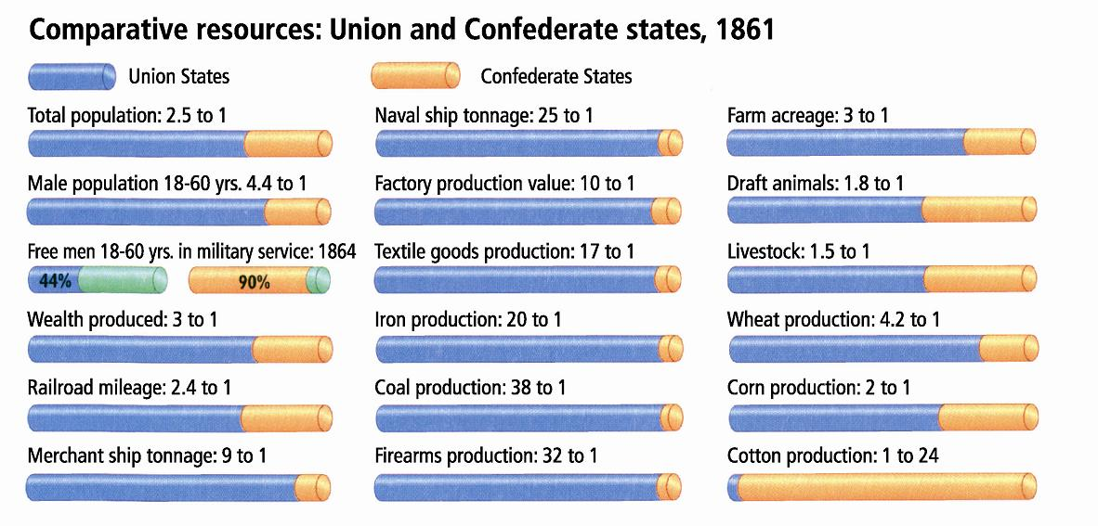

Strategic Considerations:

- The South is large and difficult to conquer. Southerners do not have to fight, they only have to resist being invaded by the North.
- The South has the larger percentage of highly qualified military officers.
- Southerners have the help of being motivated to protect their homes from invasion by Yankees. Yankees, on the other hand, have only the idea of preserving the “Union” to motivate soldiers.
- Southerners are confident that one southern can “whip” 3 Yankees in battle.
- Southerners believe that cotton is so important to the British economy that they will be able to force England to support the South during the war if they withhold cotton from the British.
- If the North wants to blockade the coast of the South to prevent them from trading with other countries, they will have to watch 3500 miles of coastline and twelve major ports.

Your Bet:
Who are you betting on winning the Civil War?

Your Bet and Why
1861 – at the start of the war
Bull Run, 1861
Antietam, 1862
Gettysburg, 1863
Sherman’s March to the Sea, 1864

