United States History
Unit 6: Unions after the Civil War

Directions: Read the following passages. Then construct a comparison chart for the different unions.

The Knights of Labor | The Knights of Labor were founded in 1869. Open to all workers, the Knights excluded only lawyers, bankers, gamblers, and liquor dealers. They even welcomed women as members. By 1886, they had 700,000 members under the leadership of Terence V. Powderly. They fought for an eight hour day, the end of child labor, and more worker control over the economy through a graduate income tax and cooperative ownership of industries. Their chief weapon against industrialists was the strike, though an 1886 strike against a railroad company failed. After 1890, membership dropped and the union completely disappeared. | 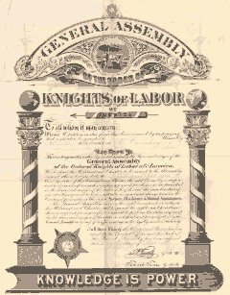
The American Federation of Labor | The American Federation of Labor formed in 1881. The AFL accepted only skilled workers who were experts in making goods. Under the leadership of Samuel Gompers, the AFL pushed for no government intervention in the labor-industry fight because what the government could give it could take away. The AFL called for better wages, shorter hours, and safer working conditions. Its general method of fighting was to use the strike. The AFL also wanted a closed shop, meaning all workers would have to belong to the union. If all workers did not agree to fight for their rights in the union, then the Union would be weakened. By working together, union members could engage in collective bargaining with their employer to get benefits for all workers. | 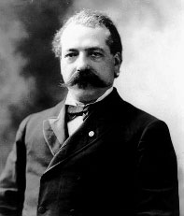
International Workers of the World (Wobblies) | Founded in 1905, the International Workers of the World (known as the Wobblies) believed that the AFL did not represent all workers. All workers, the Wobblies believed, should organize as a single class against the industrialists. All workers should be organized not by skill, but by the industry where they worked. That way, all the workers in an industry could use the power of the union against a single company. The IWW was well-known for its colorful strikes under the leadership of “Big Bill” Haywood. They proudly went to jail, held pickets and boycotts against industries, and fought back when attacked by industrialists and police. They fought for better pay and better working conditions. | 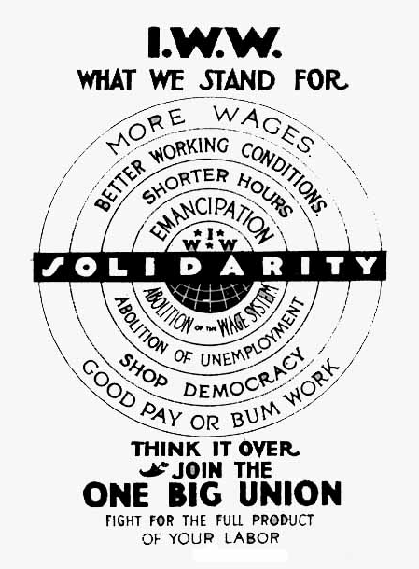

Glossary of Terms
Boycott – when consumers refuse to buy from a business which mistreats workers.
Closed shop – a workplace where all workers have to join the union.
Collective bargaining – when members of the union discuss problems with business owners in order to get a plan that will apply to all workers.
Picket – when workers and allies march in front of a business holding signs that bring attention to the bad practices of the business.
Skilled worker – a worker who has training or special knowledge in making a product.
Strike – when workers refuse to work in order to force an employer to improve working conditions.

Union Comparison Chart Name:_________________________

Date:______________ Period:______
 | Knights of Labor  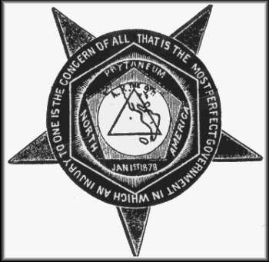 | American Federation of Labor  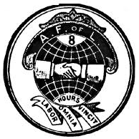 | International Workers of the World  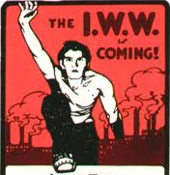
Major Leaders?
Goals?
Who Could Join?
Methods?

