United States History
Article: “The Wizard of Oz as an Allegory on Populism”

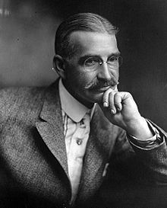
L. Frank Baum published The Wonderful Wizard of Oz in 1900, just four years after the Populist Party was defeated by the Republicans in the election of 1896. Baum’s story quickly became popular: a young girl, named Dorothy, living a dreary, colorless life in Kansas is suddenly swept up by a tornado and dropped into a magical, color-filled world known as Oz. After a series of adventures with a Scarecrow, Lion, and a Tinman, the young Dorothy returns home to Kansas. Baum, like Dorothy, lived in the western Great Plains, setting up a store and a newspaper in South Dakota. Moving to Chicago, and deciding to become a writer of children’s books, Baum finally achieved success with his Oz stories.
L. Frank Baum
In 1964, a high-school teacher named Henry M. Littlefield published an analysis of Baum’s Wonderful Wizard of Oz, claiming that Baum wrote the story as a thinly veiled commentary on the Populist Party. Littlefield claimed that the Wonderful Wizard of Oz was an allegory, a story in which the people, places, and events are disguised versions of real-life people, places, and events. Littlefield noticed all sorts of similarities between Baum’s characters and people who had been involved in the Populist movement. L. Frank Baum himself supported the Republican candidate, William McKinley, and even wrote a poem expressing all the good that would come if McKinley were elected president. So, if Baum intended the Wizard of Oz to be an allegory on the Populists, he was not painting a flattering picture of them.
Allegory: a story in which the persons, places, and events represent real-world persons, places and events.
In Baum’s story, the opening focuses on the gray, color-less life of poor farmers in Kansas. Dorothy, the young girl living on that farm, is being raised by her Uncle Henry and Aunt Em. Dorothy’s family represents the life of many western farmers and Dorothy herself may represent the fiery Populist speaker, Mary Lease. A tornado, a common weather disaster on the Great Plains, sweeps Dorothy into a magical land named Oz, where her house falls and kills the Wicked Witch of the East. The name Oz itself may be an abbreviation for ounce, possibly referring to the Populist fight over how many ounces of silver should be put into the economy to increase the money supply.
Dorothy takes the magical silver shoes (they are silver in the book) of the Wicked Witch of the East, another Populist reference. Populists wanted silver made into coins to increase the money supply. Dorothy is visited by the Good Witch of the North, who tells her she must take the Yellow Brick road to visit the Wizard in the Emerald City in order to return home to Kansas. The Yellow Brick road symbolized the gold standard, a dangerous path in Baum’s story, and in Baum’s day it was the issue that united Republicans and made Populists angry. The Emerald City, green because money and greed are both green, represents Washington, D.C. Thus, the Wizard himself represents the President of the United States.
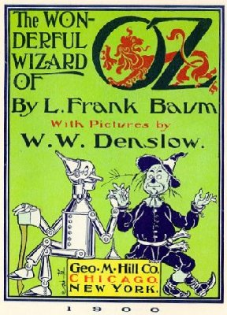
Accompanied by her faithful dog Toto, Dorothy sets out on the dangerous Yellow Brick Road. Toto is short for teetotaler, a person who does not drink alcohol. The teetotalers, or the Prohibitionists, were a group that supported the Populists. Along the way, Dorothy meets the brainless Scarecrow, who symbolizes the stupid western farmer. Baum may have been making fun of farmers who did not understand the causes of their own desperate situation; a great part of the crisis among farmers was caused by farmers producing too much, consequently lowering the cost of their produce. The Scarecrow joins Dorothy’s adventure to get brains for himself from the Wizard of Oz.
The trio then meet the Tinman, representing the rusted-out industrial workers whose hearts have been destroyed by greedy Robber Barons. Like the farmers, industrial workers may have been attracted to the idea of free coinage of silver because it would increase the money supply. In actuality, many urban residents voted against the Populist Party’s call for free coinage of silver because increasing the money supply would also have the effect of raising prices on food and rent in cities. Nevertheless, the Tinman joins the group on their way to the Emerald City. Finally, they pick up the Cowardly Lion, who roars loudly but is unable to conquer his own fears. The lion himself represents William Jennings Bryan, the Democratic candidate for President in 1896, a man whose “roar” is great but whose internal courage is missing. Bryan “stole” the Populist message to make it the platform of the Democratic Party in 1896.
As the group approaches the Emerald City, they are momentarily distracted by a poppy field, a field of beautiful flowers whose scent magically makes the group sleepy. The Poppy Field probably represents the issue of China and opium, since poppies are the source of opium. In 1896, the public was discussing the question of America’s involvement overseas, particularly in China and Cuba and that issue was a distraction from the Populist campaign for free silver. Luckily for the group, a sudden snowfall withers the poppies and they continue to the Emerald City. Passing through seven halls and climbing three flights of stairs, which symbolized the famous Crime of ’73 that took silver out of the money supply, Dorothy finally reaches the Wizard. The Wizard tells her that in order for him to grant her request, she and her companions must kill the Wicked Witch of the West, who represented all the evil forces that harmed the western farmer. The Wicked Witch desperately desires the silver shoes that Dorothy is wearing, wanting to take away the issue of silver that motivates the Populists.
Crime of ’73: The Coinage Act of 1873 removed silver from the money supply and made gold the standard of American money. The act thus decreased the money supply, angering debtors and western silver miners.
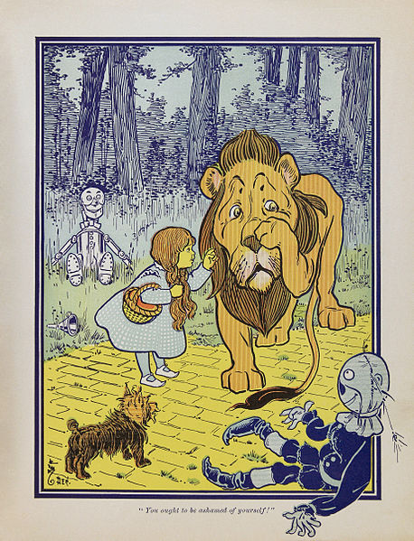
Knowing that Dorothy and her companions are coming, the Wicked Witch sends out a host of attacking animals: wolves, crows, and bees. She sends her yellow Winkie soldiers to capture Dorothy and friends but they are scared off by the Cowardly Lion. The yellow Winkies may be a reference to the “yellow-skinned” peoples of the Philippines, who would not be given independence by President William McKinley after the Spanish-American War in 1898. Finally, the Wicked Witch sends her winged monkeys, representing the Plains Indians, to sweep in and carry off Dorothy and friends. Fortunately for Dorothy, she is able to kill the Wicked Witch by throwing a bucket of water on her. As was the case for western farmers, water was always essential to winning the battle with the dry, western environment.
Dorothy and friends return to Oz and discover that the Wizard is nothing but an ordinary man, hiding behind smoke-and-mirrors as so many Presidents do. And like many Presidents, the Wizard offers solutions to each of their problems that sound clever and yet are utterly stupid. For the Scarecrow, the Wizard pours “bran, pins, and needles” into his head to make him “sharp” and give him “bran-new” brains. The Tinman gets a silk heart stuffed with sawdust. The Cowardly Lion gets a “potion” that will give him courage. Finally, the Wizard promises to return Dorothy back home in a balloon made of green silk but takes off without her after Toto chases a kitten. Like most Presidents, the Wizard flies away on “hot air.” Fortunately for Dorothy, the Good Witch of the South tells her that she has had the power to return home all along by clicking the heels of her silver shoes together three times.
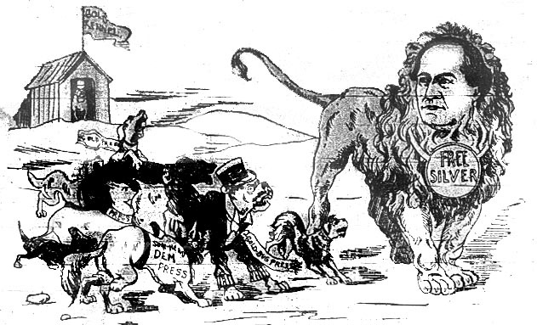
Dorothy returns home, having taken an adventure-filled journey on the silver shoes, just like the Populists in the Election of 1896. The bad economic times starting with the Panic of 1893 that energized the Populists slowly faded as the American economy improved. That may have been Baum’s point all along: that the Populists fought a crusade against all kinds of enemies, doing some good, but ultimately not changing the structure of American government because, as the economy improved, the public lost interest in reform. The American people accept quick and easy solutions—heads full of pins and bran, hearts full of sawdust, and courage potions—but are not interested in real, deep-seated change. It is hard to know for sure if Baum intended to write The Wonderful Wizard of Oz as an allegory or if he just borrowed unconsciously from symbols and ideas circulating during his life. Nevertheless, it has become one of the enduring books in American history and a perennial favorite of historians for the clever images that may tell the story of Populism.
1896 Cartoon Showing William J. Bryan as a Free Silver Lion

