United States History Name:__________________________
Unit 7: The Wizard of Oz: The Story of Populism Date:_______________ Period:______

Character in Oz | Real-Life Counterpart | How does the Oz character relate to Populism?
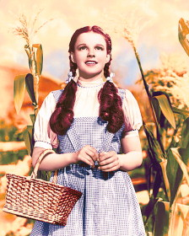 | Ordinary Americans | Simple, honest, good-hearted, but naive
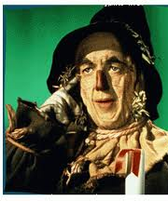 | The Farmer
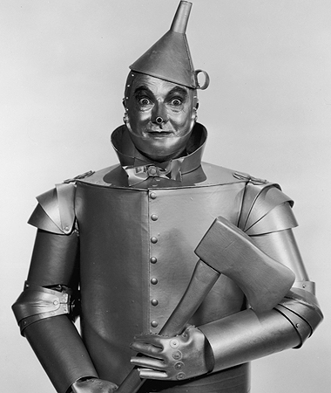 | The Industrial Worker
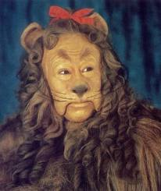 | William Jennings Bryan
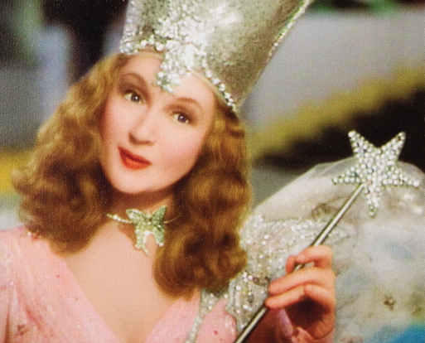 | The good people of the North
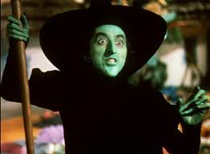 | Eastern bankers
 | The President
 | Washington, D.C.
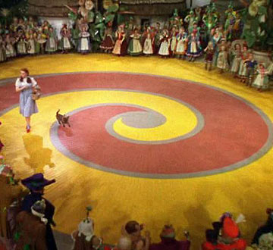 | The gold standard
 | Free coinage of silver
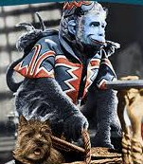 | Western Indians

