United States History Name:_________________________________
Unit 8, World War I: The Homefront Date:___________________ Period:_________

Directions: Using the information on the back of this handout, write down the major changes happening in home life during WWI.
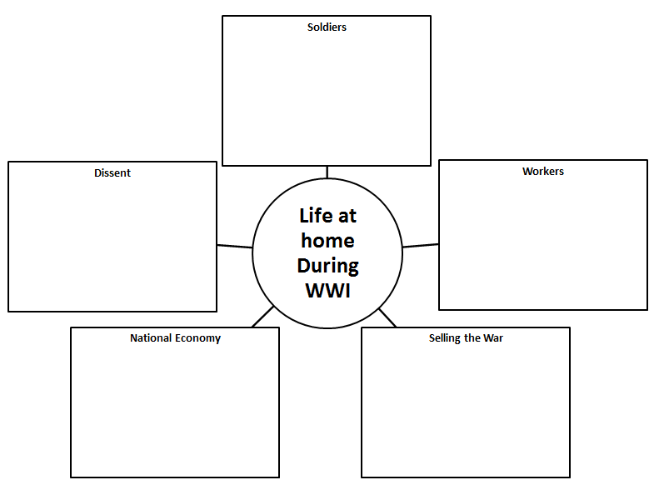
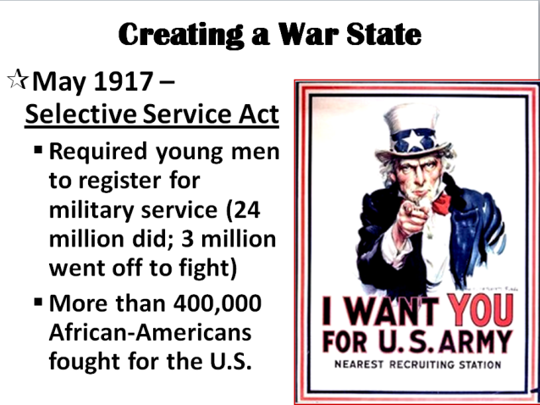 |  | 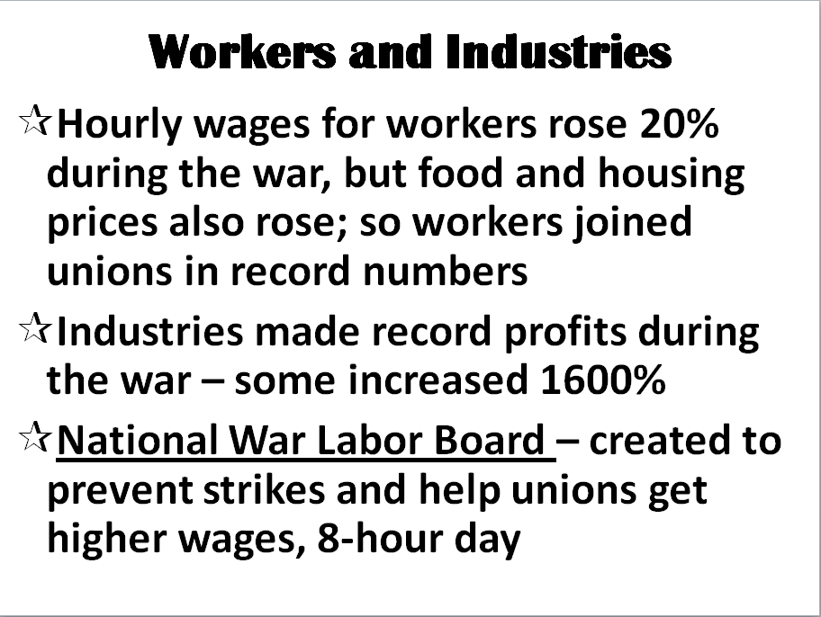
. | 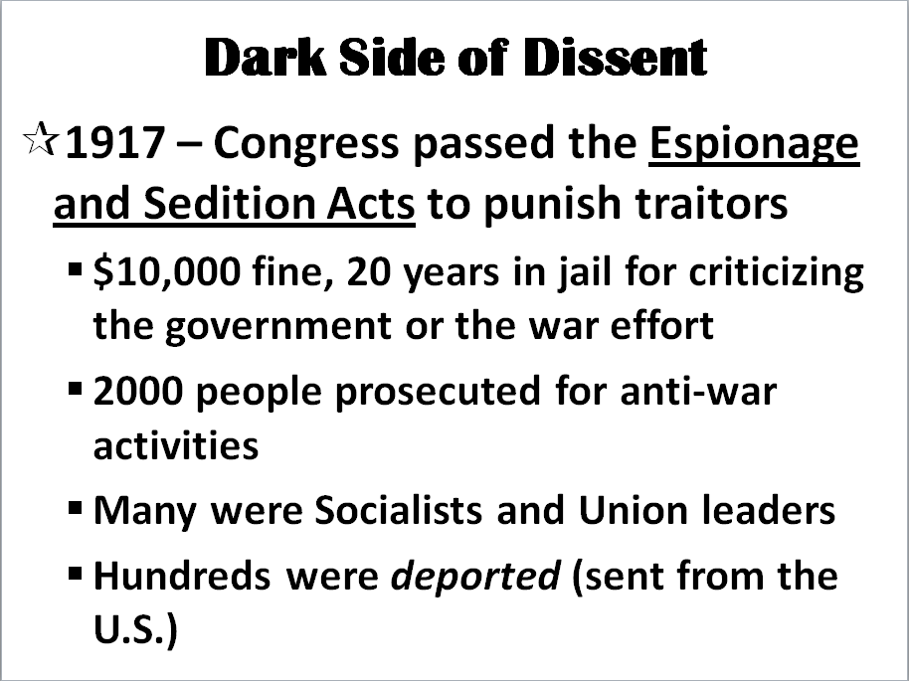 | 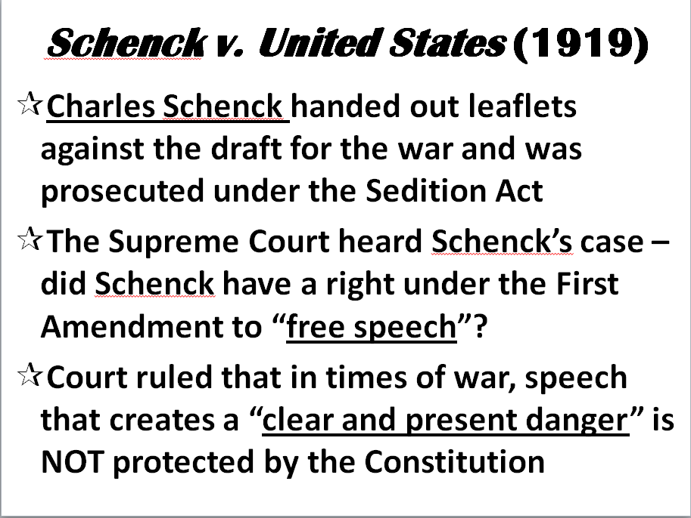

Central Question: How did American life change at home during World War I?
Write two sentences in response to the above question.

___________________________________________________________________________________________________________________________

