United States History Name: __________________________
Unit 7: Comparing Washington, Dubois, Barnett Date:______________ Period:_______

Booker T. Washington  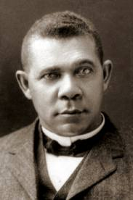  1856-1915 | W.E.B. DuBois  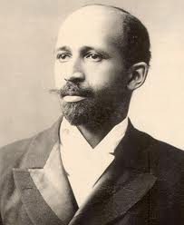  1868-1963 | Ida Wells Barnett  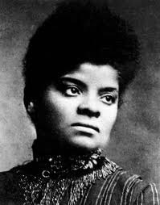  1862-1931
Born a slave in 1856, Booker T. Washington became an important leader after he worked hard to get an education. In 1881, he took his love of education to Alabama and built the Tuskegee Institute. At Tuskegee, Booker T. Washington taught one idea: that African-Americans would only get respect from whites if they learned skills and did manual labor. Washington thought that when blacks worked hard as farmers and shopkeepers, they earned respect from whites. Washington took his ideas across the United States, speaking about the need to invest in black education. He worked hard to find white investors who would give him money for education and tried not to criticize America’s racist ideas. In a famous speech in 1895 in Atlanta, Booker T. Washington even accepted segregation, noting that blacks and whites could be like fingers on a hand—connected, yet separate. He told his audience that blacks would be better off as farmers, mechanics, and domestic servants. | W.E.B. DuBois was the first African-American to earn a doctorate from Harvard University, where he studied history. Like Booker T. Washington, DuBois valued education. But he believed that black people should not train just to be farmers and mechanics. He thought that black intellectuals—he called them the “talented tenth”—could be leaders for African-American political and social rights. He sharply criticized the practices of segregation and discrimination against blacks. In 1909, DuBois and others founded the National Association for the Advancement of Colored People (NAACP) to fight against grandfather clauses, poll taxes, and lynching. The NAACP used every legal and political means possible to challenge unjust laws. They went to court to fight against the use of literacy tests and grandfather clauses and did win some cases by 1915. They also put pressure on state and national legislators to work for laws to protect black rights. In their magazine, The Crisis, they called for equal rights for blacks. | Ida Wells Barnett spent her life challenging injustice. In 1884, she was removed from a first-class railroad car by the conductor. She sued and won. In 1892, her friend Thomas Moss was lynched because he ran a successful grocery store. Thereafter, she began a life-long crusade against lynching. Her fiery newspaper editorials pointed out that black men were being lynched because they were successful, not because they raped white women. When a white journalist wrote that black women had no virtue or character, she helped to found the National Association of Colored Women in 1896. Later, she supported the National Association for the Advancement of Colored People. When that group’s white board of directors did not fight hard enough against racial injustice, she withdrew her support. She wrote repeatedly about the importance of blacks voting and standing up for their rights. She did not believe, like Booker T. Washington, that African-Americans should work for economic equality before they earned the respect of whites.

 | Booker T. Washington  1856-1915 | W.E.B. DuBois  1868-1963 | Ida Wells Barnett  1862-1931
Major Beliefs
Methods

Analyzing Quotes: Read the following quotes from DuBois, Washington, and Barnett. Pick one. How would you interpret it?

“The problem of the twentieth century is the problem of the color line.” (W.E.B. DuBois)

“Dignify and glorify common labor. It is at the bottom of life that we must begin, not at the top.” (Booker T. Washington)

“Brave men do not gather by thousands to torture and murder a single individual, so gagged and bound he cannot make even feeble resistance or defense.” Ida W. Barnett

