United States History
The Rise of the Totalitarian Regimes: ITALY
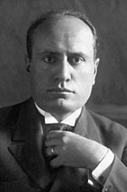  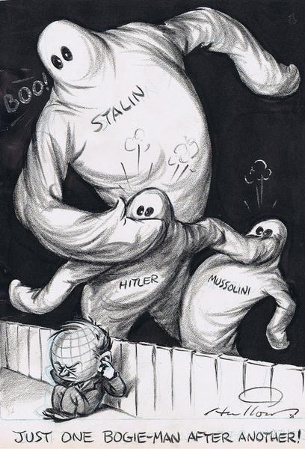  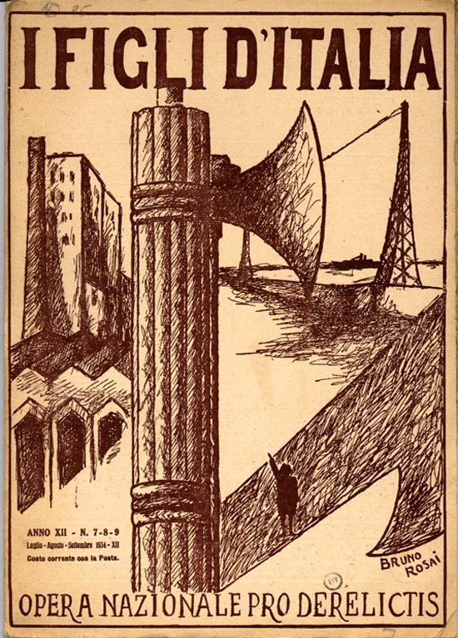 | Timeframe: 1920s – 1930s  Background: Italians were unhappy with the Treaty of Versailles that ended World War I. They thought they should have gotten more territory.  Economic Situation: Poverty was widespread in Italy.  How the Dictator Came to Power: Benito Mussolini was a newspaper editor who promised territorial expansion, benefits for workers, and land reform. Using a private army of followers he gathered, called the Black Shirts, Mussolini intimidated or killed his opponents. Mussolini’s political party, the Fascists, rejected democracy. The Italian government was weak and could not stop strikes and other worker violence. In 1922, the Black Shirts began a march on Rome demanding that the Italian King (Victor Emmanuel III) do something about the collapse of the government. The King asked Mussolini to be Prime Minister of Italy and gave him the powers of a dictator for one year.  How the Dictator Kept His Power: Mussolini limited the freedom of the press to make sure that his government controlled the news. He fixed elections and used his Black Shirts to arrest, intimidate, and even murder opponents. To get young people involved in his movement, Mussolini created the Fascist Youth. To help the economy out of the depression, Mussolini started wage and price controls and took over businesses. To give Italians the land that they wanted, Mussolini ordered an invasion of Ethiopia (in Africa) in 1936. He also signed a treaty of friendship with Adolf Hitler (Germany) in 1936.  The Ideology of the Dictator: Mussolini aggressively promoted the fascist message: strong national identity, single-party state, ruled by a supreme leader, a belief in the inferiority of other nations and races, and an emphasis on aggressive expansion. He rejected conflict between different social and economic classes because it undermined unity; he thus opposed the Soviet Union and communism. Fascists were frequently anti-Semitic. Fascists glorified the state and its leader, whom they called Il Duce.

United States History
The Rise of the Totalitarian Regimes: GERMANY
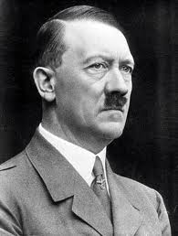  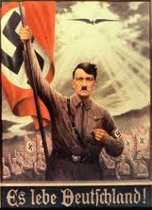  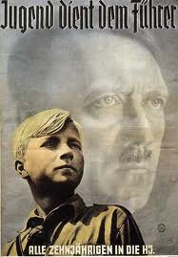 | Timeframe: 1920s – 1930s  Background: Germans were unhappy with the Treaty of Versailles – the war-guilt clause and the payment of reparations.  Economic Situation: The German economy collapsed by 1923, the government was weak, and political violence was common.  How the Dictator Came to Power: Adolf Hitler was the leader of the National Socialist Party in the 1920s. He tried to take over Germany in 1923 but was arrested and went to jail, where he wrote out his vision for Germany in a book called Mein Kampf (“My Struggle”). Hitler gathered followers with his message of German nationalism, hatred for Jews, ending the economic depression, opposition to communism, and rejection of the Treaty of Versailles. His followers organized the Brown Shirts (Sturmabteilung) to intimidate and attack opponents. With unemployment at 43% in 1932, Hitler’s promises earned the Nazis public support. They became the largest political party in power in the German government. In January 1933, the German President appointed Adolf Hitler as the Chancellor of Germany. An act in 1933 gave Hitler dictatorial powers for four years.  How the Dictator Kept His Power: Hitler invented enemies to unite his supporters. He first attacked the Communists by accusing them of starting a fire in the German parliamentary building, the Reichstag. He abolished freedom of speech and controlled elections so that Nazis would win. He abolished independent labor unions and organized his own personal body guards, the SS (Schutzstaffel) to shoot political enemies. Hitler attacked Jews more than any other group, however, claiming that they caused Germany’s losses in World War I and were responsible for the terrible Germany economy. Hitler aggressively promoted expansion into new territory, claiming that Germans needed lebensraum (living space). To help the economy, Hitler started a massive public works campaign – building highways, canals, and public buildings. He also put people to work building up the German army. To train young people in Nazi ideas, he started the Hitler Youth in 1922.  The Ideology of the Dictator: Hitler’s ideas were based in his belief in the superiority of the German race, the Aryan Race—the purest, most noble of all races. He aggressively used propaganda to spread his message of hatred for Jews and other “inferior” races. He strengthened his public image as the “Fuhrer,” or leader at rallies.

United States History
The Rise of the Totalitarian Regimes: SOVIET UNION
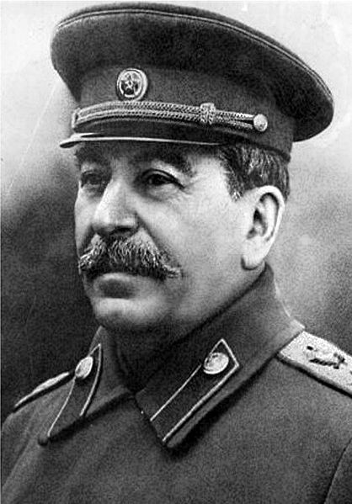  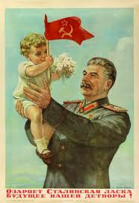  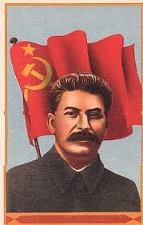 | Timeframe: 1920s – 1930s  Background: After the Bolshevik Revolution (1917), the Soviet Union came under the rule of the Communist Party.  Economic Situation: The Soviets had made a dramatic push towards industrialization in the late 1920s at a tremendous cost to the lives of most citizens.  How the Dictator Came to Power: Joseph Stalin was a leader under Vladimir Lenin (Chairman of the Communist Party), who had several strokes in 1922. Stalin used his position in the party to arrest and execute his enemies, often claiming that they were plotting against him. He used the Communist party secret police, the NKVD, to protect his hold on power. Between Stalin’s orders for the murder of his opponents and policies which resulted in peasants dying, historians estimate that Stalin was responsible for the death of 23,000,000 Soviets.  How the Dictator Kept His Power: Stalin began a plan of aggressive industrialization in 1928, called the Five Year Plan. The Soviet economy increased its industrial output by 250%. However, to do so, he collectivized farms, forcing peasants to work in factories and give up their land to form larger farms. The Soviets were a command economy—the state made all decisions about who would produce what. Soviet life became more dominated by a growing elite of experts; women got the right to divorce, have an abortion, and were encouraged to become doctors. Because the totalitarian leaders of Germany, Italy, and Spain despised Soviet communism, Stalin was actually an ally of the United States and Britain during World War II.  The Ideology of the Dictator: Stalin ruthlessly eliminated his enemies and controlled all media. All culture—lectures, films, art, novels, and music—had to convey the glory of the Soviet experiment. Atheism was promoted as the official state doctrine since religion was considered a base for independent thought and brainwashing of the public. The official ideas of communism rejected a class-based society and the ideas Marxism were promoted in education, especially in textbooks which pointed out how other countries (like the United States) had exploited working people under capitalism. These ideas were to be exported to other countries to help them undergo the revolution needed to overthrow capitalism.

United States History
The Rise of the Totalitarian Regimes: JAPAN
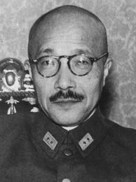  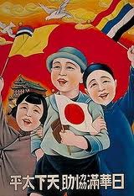  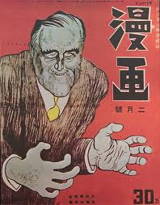 | Timeframe: 1920s-1930s  Background: The Japanese had industrialized and came to believe that they had a duty to protect Asia from the West.  Economic Situation: The Japanese had a growing population and industrial economy dominated by zaibatsu (monopolies), but had few natural resources to meet their needs.  How the Dictator Came to Power: Japan was ruled by an emperor who had little political power but who was an important national symbol. Hideki Tojo rose up in the Japanese army and was appointed Prime Minister of Japan in 1941 (by Emperor Hirohito). Tojo supported and expanded Japanese imperialistic policies aimed at controlling raw materials in Asia. The Japanese rejected western-style democracy and resented, in particular, the United States for its involvement in Japanese affairs. In the 1930s they invaded Manchuria and China and in 1940 they signed an alliance with two other expansionist powers, Germany and Italy.  How the Dictator Kept His Power: Tojo held six top government positions in the 1940s, putting him in control of the army, foreign affairs, education, and the economy. The Japanese, however, were depended upon oil and scrap metal from the United States and feared that the United States would stop Japanese expansion in the Pacific. Tojo, with permission of the emperor, moved forward with an attack on the United States at Pearl Harbor in 1941. During the war, Tojo used his power as education minister to indoctrinate the Japanese people with nationalist and militaristic propaganda. He promoted sterilization of the mentally unfit. He authorized the murder of civilians in other Asian nations (China, Philippines) who stood in the way of Japan’s leadership of Asia.  The Ideology of the Dictator: Japanese ideology did not originate with Tojo. The Japanese had been aggressively industrializing since the 1850s and the government had encouraged the development of the zaibatsus (monopolies). But Japan’s small size and limited resources had meant the need to find new markets in Asia. They aggressively rejected the involvement of the United States in Asian affairs, remembering long-standing dislike Americans had for Japanese immigrants on the West Coast (see the Gentleman’s Agreement, 1907). They believed that they could lead Asia away from western domination. “Asia for Asians,” was the Japanese motto.

United States History Name:__________________________
Chart: The Rise of the Totalitarian Regimes Date:_____________ Period:________

Totalitarianism: System of politics in which the state strives to control every aspect of public and private life, often both by force and the use of propaganda. Totalitarian states often have state-controlled news media, a single political party, a powerful leader who is almost worshipped, control over the economy, restriction of free speech, and use of violence to stop political criticism. Fascism is the most extreme form of a totalitarian order. As Benito Mussolini (Italian Fascist leader) said, “Everything within the state, nothing outside the state, nothing against the state.”

 | Country | Dates | Leader | How He Came to Power and Maintained Control
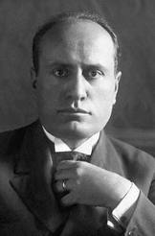 | Italy
 | Germany
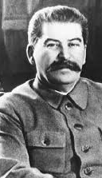 | Soviet Union
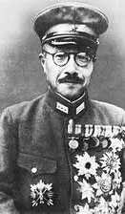 | Japan
EXTENSION: Using the above chart, write (on the back of this sheet) the similarities of how these totalitarian regimes came to power in the 1920s and 1930s.

