United States History

Unit 10 Reading: The Holocaust and the United States
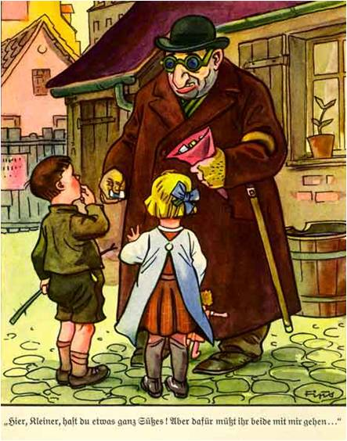
From the time he came to power, Adolf Hitler had targeted Jews for persecution. Hitler had used the Jews as scapegoats for Germany’s economic crisis and failure to win World War I. By the end of World War II, the world learned that Nazis murdered 6 million Jews and 5 million other people. The terrible nature of the tragedy of the Holocaust continues to cause people to wonder how such an evil could have happened and how we can prevent another like it in the future.

ROOTS OF THE HOLOCAUST
The term Holocaust means “completely burned.” It refers to the Nazi destruction of Jews whom Hitler consider inferior to Germans. Hitler believed that pure-blooded Aryans, those who were white and non-Jewish, were a superior race. According to Hitler, the inferiority of Jews had hurt Germany, causing the country to decline. His message of racial superiority made sense to a lot of Germans, who saw in Hitler’s ideas a simple explanation for the troubles Germany faced.
Anti-Jewish Propaganda from Germany.
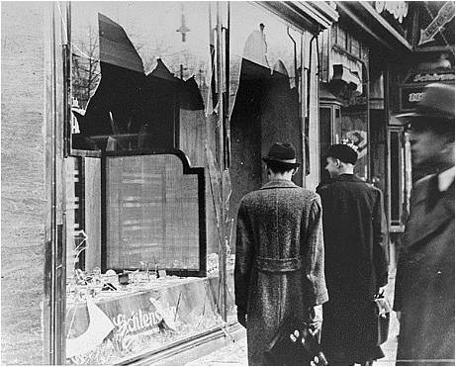
To attack Jews, Hitler first urged Germans to boycott Jewish businesses. He even forbade Jews from holding government jobs. By 1935, Hitler increased his attacks on Jews through the Nuremburg Laws, a set of policies that made it illegal for Jews to marry non-Jews, segregated Jews from non-Jews, and took away German citizenship from Jewish people. Nazis published anti-Jewish propaganda and taught children in German schools that Jews were dangerous to the German way of life. Germans studied their family trees to make sure there was no trace of Jewish blood among their ancestors. Anyone with a Jewish connection could be segregated and discriminated against.

On November 9, 1938, the Nazis ordered the German military to start violent attacks on Jews after a Jewish refugee in Paris killed a German diplomat. Secret police and the Nazi military destroyed 1500 synagogues and 7500 Jewish businesses. More than 200 Jews died in the attacks, which became known as Kristallnacht, or the “Night of Broken Glass.”

Between 1933 and 1937, nearly 129,000 Jews left Germany to escape the persecution. Jews were generally not welcome in many other countries, however, because anti-Semitism (dislike of Jews) was strong in many parts of the world, not just Germany. In 1939, an ocean liner named the St. Louis left Germany bound for Cuba with 900 Jewish refugees on board. Only 22 of them were allowed to stay in Cuba. The United States refused to accept any of them. So, the ship returned to Germany. 600 of the Jews who had been on board the ship later died in Nazi concentration camps.
Business Destroyed during Kristallnacht

THE “FINAL SOLUTION”
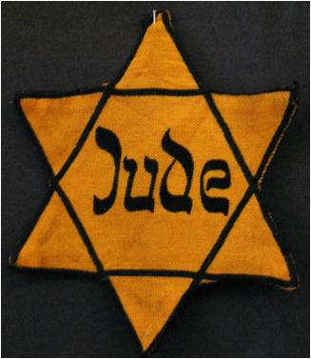
Segregation and discrimination against the Jews was not enough for Hitler and the Nazis. By 1942, Nazis had met together at the Wannsee Conference to discuss a “Final Solution” to the “Jewish Problem.” Nazis agreed that the only way to solve the “Jewish Problem” was to eliminate the Jews. When a nation decides to murder an entire group of people based on their race, politics, or culture, we call such a plan genocide.

The Nazis had begun building Concentration Camps in 1933. These camps were originally not designed for killing prisoners—instead, they were for forcing political prisoners to work. Nazis imprisoned anyone who opposed the Third Reich (the name for the German empire) and Hitler’s leadership. They arrested labor union leaders, communists, socialists, Jews, Gypsies, Jehovah’s Witnesses, homosexuals, beggars, drunkards, and the physically and mentally disabled. Prisoners had numbers tattooed on their arms and were forced to wear striped uniforms with patches that indicated their offense. People accused of political crimes wore red patches, homosexuals wore pink, Jews yellow, and Jehovah’s Witnesses wore purple. The process of labeling and tattooing the prisoners was part of the Nazi plan for de-humanization, taking away the human identity that gives people self-worth. Guards mistreated workers, abused them, starved them, tortured them, and even murdered them. People who survived the abuse often died from being worked to death. At some camps, doctors even performed medical experiments on prisoners.
Jewish Identification Patch
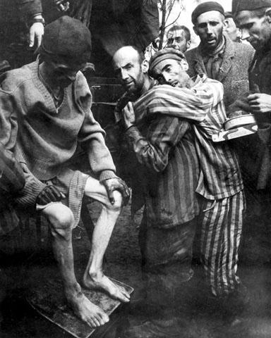
By 1942, Nazi leaders at the Wannsee Conference agreed to a plan to murder 11,000,000 European Jews. So the Concentration Camps became Death Camps. One of the largest of the death camps was Auschwitz in southern Poland. There, prisoners were told that they were going to take showers. Once inside the large shower-like rooms, Nazis pumped the rooms full of poison gas. Other camps simply lined up prisoners around a giant hole and shot people, pushing the bodies into the mass grave. After the prisoners died, Nazis used the fat from people’s bodies to make soap; they used human hair to make wigs, slippers, and mattresses; and they removed gold fillings from the teeth of the dead, along with wedding rings and any other valuables. The bodies were often burned in giant ovens called crematoriums. After the war, the world learned that the Nazis murdered around 12 million people.
Prisoners at a Concentration Camp

THE ALLIES AND THE HOLOCAUST
The horror of the Holocaust has caused many to wonder if the Allies could have done something to stop Hitler. Why did the United States not intervene sooner? The United States State Department did nothing to relax immigration laws, thus condemning many Jews to death because they could not get into America. Like Germany, the United States also had a tradition of anti-Semitism and especially believed that European immigrants came to America with radical ideas to overthrow American society. Other American officials thought that the American economy could not handle the arrival of immigrants during the late 1930s—they believed that more immigrants would mean more competition for jobs at a time when President Roosevelt’s New Deal still had not ended the Great Depression.
Henry Ford’s Dearborn Independent was an Anti-Jewish newspaper.
By 1942, reports of the mass killings of Jews and other Europeans had reached Americans. Some American leaders, at first, dismissed the reports as Jewish propaganda. The Allies, however, called a conference in Bermuda in 1943 to discuss the problem. Faced with the evidence of Hitler’s mass murder of Jews and others, the Allies still did nothing immediately. In 1944, President Franklin D. Roosevelt urged Congress to create the War Refugee Board, an agency that worked to help refugees from Europe. The board did not get enough money from the United States government to do its job. The board saved approximately 200,000 Jews but could have done more if it had adequate money.

The magnitude of Hitler’s crimes against humanity became clear after the fall of Germany in 1945. When Allied troops liberated the concentration camps, they saw the thin, gaunt faces of the survivors, the stacks of dead bodies, warehouses of human hair and gold, mass graves, and the ashes in the crematoriums. Most of the soldiers could not even take in how horrible the experience must have been. They were stunned by the evil of Nazi crimes.

THE RESULTS OF THE HOLOCAUST
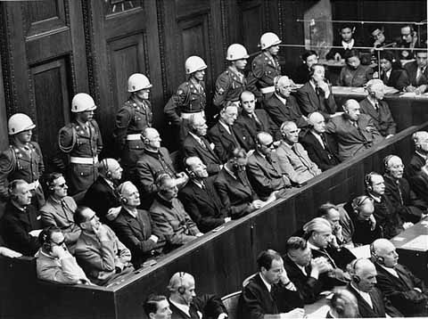
World-wide sympathy for the Jewish situation after the Holocaust helped to encourage world leaders to support the creation of a new state for Jews, the state of Israel. Formed in 1948, the state of Israel was carved from territory under the control of the British.

The world also watched as the trials of the Nazis responsible for the genocide took place in Nuremburg, Germany. Many Nazi leaders were tried for War Crimes, (unacceptable crimes against soldiers) and Crimes against Humanity (crimes involving the murder of civilians). Some of the Nazi leaders tried to defend their actions by saying that they had simply been “following orders.” At the end of the trials, 12 of the 24 defendants were found guilty and sentenced to death. The Nuremburg Trials established the principle that people who commit evil crimes against humanity are still responsible for their actions even if they were following orders.

Primary Sources on the Holocaust

Orders for Kristallnacht
Message from SS-Grupenführer Heydrich to all State Police Main Offices and Field Offices, November 10 1938 (from Nazi Conspiracy and Aggression - Washington, U.S Govt. Print. Off., 1946, Vol. III, p. 545-547).

Regards: Measures against Jews tonight.

a) Only such measures may be taken which do not jeopardize German life or property (for instance, burning of synagogues only if there is no danger of fires for the neighbourhoods).

b) Business establishments and homes of Jews may be destroyed but not looted. The police have been instructed to supervise the execution of these directives and to arrest looters.

Excerpts from the Wannsee Meeting, 1942:

III. Another possible solution of the problem has now taken the place of emigration, i.e. the evacuation of the Jews to the East, provided that the Führer gives the appropriate approval in advance.

These actions are, however, only to be considered provisional, but practical experience is already being collected which is of the greatest importance in relation to the future final solution of the Jewish question.

Approximately 11 million Jews will be involved in the final solution of the European Jewish question, distributed as follows among the individual countries. . . .

“Rabbis Report 'Cold Welcome' At White House,” Washington Times Herald, October 6, 1943

What was described as a "chilly reception" greeted representatives of the pilgrimage of 500 Orthodox rabbis to Washington when they arrived at the White House yesterday to place before President Roosevelt petitions for U.S. aid in rescuing Jews trapped in Europe and in obtaining British consent for free entry of Jews into Palestine.

Previously the delegation had placed their pleas for the rescue of the 5,000,000 Jews believed to be trapped in Hitler's European fortress before Congress.

"The fate of millions of human being lies in the hands of the American people," declared Rabbi Rosenberg, president of the Union of Orthodox Rabbis, in a statement before members of a congressional reception committee headed by Vice President Henry Wallace who met the delegation on the Capitol steps.

The Chief Executive was unable to meet the delegation because of the pressure of other business.

Quotes from Adolf Eichmann, Nazi War Criminal (1960-1962)
“To sum it all up, I must say that I regret nothing.” (1960)
“The war with the Soviet Union began in June 1941, I think. And I believe it was two months later, or maybe three, that Heydrich sent for me. I reported. He said to me: "The Führer has ordered physical extermination." These were his words.” (1961)
"I never did anything, great or small, without obtaining in advance express instructions from Adolf Hitler or any of my superiors." (1961)

