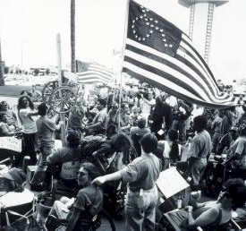 | Disability Rights Movement  1960s  Slogan: Access is a Right
This movement began in the late 1960s and worked to help people living with disabilities have an equal chance to be independent in society. They wanted society to recognize that having a disability did not mean that disabled people were completely incapable of taking care of themselves. They wanted buildings to be designed to be wheelchair friendly, to have the same opportunities to get jobs, and the right to live independently (without a guardian) if possible. They wanted society to recognize that they could still contribute and participate in schools, jobs, and public life—that they had something to offer if Americans would only realize that being disabled just meant being differently-enabled.

In 1973, Congress passed the Rehabilitation Act, which prohibited discrimination in federal programs. All services receiving federal money could not discriminate against an “otherwise handicapped individual” solely on the basis of his or her handicap. To protest exclusion of disabled people from public life, members of the American Coalition of Citizens with Disabilities held a sit-in in 1977 at the U.S. Department of Health, Education and Welfare. Another group protested the Denver Public Transit system in 1978 to complain that buses were not equipped for disabled people.
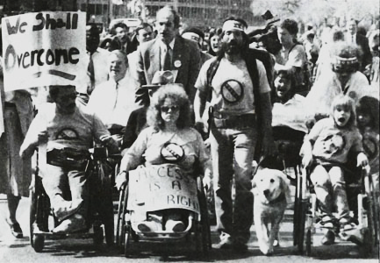

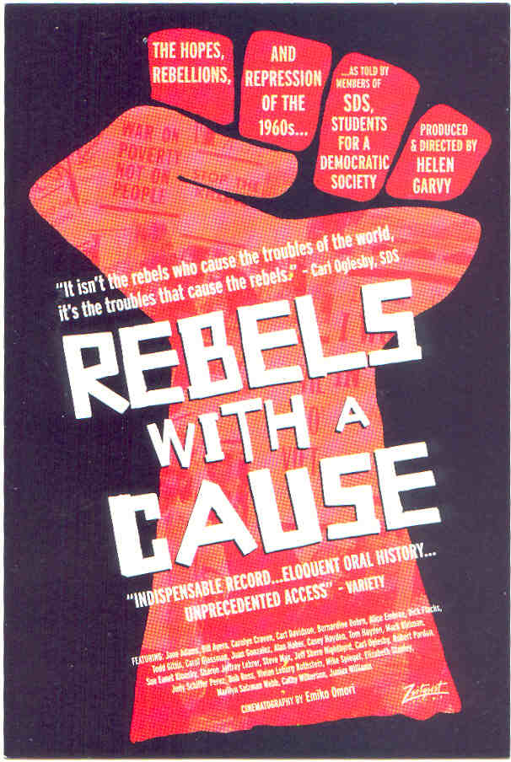 | Students for a Democratic Society  1960s  Slogan: Rebels with a Cause
Students for a Democratic Society (SDS) was a student activist movement in the United States that was critical of the United States’ Cold War policies, the threat of nuclear war, racial discrimination, economic inequality, big business, and the lack of true participatory democracy. They wanted greater citizen participation in government and more help for the poor. The organization developed and expanded rapidly in the mid-1960s before dissolving at its last convention in 1969.

SDS in 1962 issued a statement of their beliefs, known as the Port Huron Statement. They called for an end to racism, and end to the Cold War, reforms in education to make school more relevant to the concerns of students, and greater participation of American citizens in decisions made by the government. By the late 1960s, SDS was holding protests at universities, occupying buildings to protest against the Vietnam War and the conservative elites who ran universities. In 1968, students going on strike were able to shut down Columbia University. The movement, however, broke apart in 1969 as different groups inside SDS tried to gain control of the organization. A SDS faction, the Weathermen, helped to bring criticism of student activism because of their bombings of public buildings in 1969.
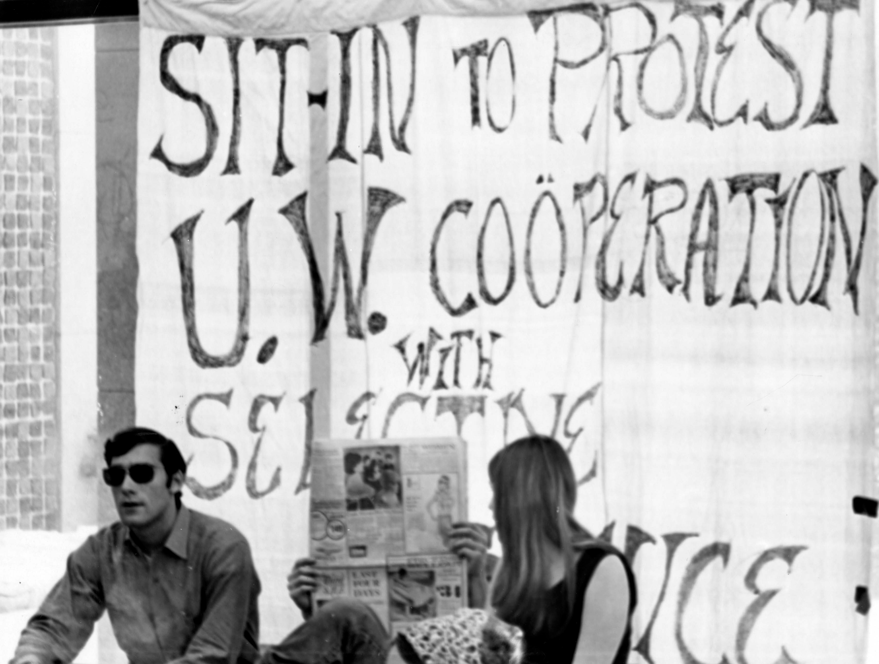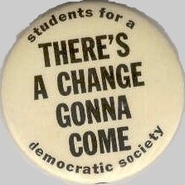

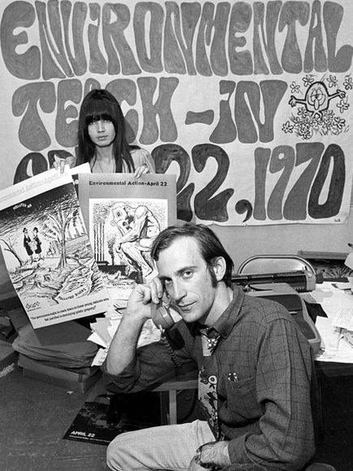 | Environmental Rights Movement  1970s - Present  Slogan: Earth First!
The Environmental Movement has focused not on the rights of people but the rights of people to live in a clean world. Rapid industrial growth by the 1960s had shown many people, not just those who study ecology, the dangers of industrial pollution. The Cuyahoga River, near Cleveland, for example, periodically burst into flame because of the petroleum waste being dumped into it. Everyone noticed the toxic clouds of smog (smoke + fog) that hung over cities, making it hard to breathe and see. Scientists began documenting the dangers of industrial pollution and humankind’s use of chemicals. Rachel Carson’s Silent Spring (1962) showed the dangers of DDT, a pesticide used to kill insects, to the reproductive life-cycles of many birds.

Drawing attention the need to preserve the environment from human damage, people all over the United States gathered April 22, 1970 for the first Earth Day. Congress soon passed a Clean Air Act (1970) and a Clean Water Act (1972) to control air and water pollution. To protect America’s natural resources, President Nixon created the Environmental Protection Agency in 1970. Despite attention to environmental issues, however, many companies continued to pollute the air and water. Anti-environmentalists have argued that the Earth can heal itself and that regulating businesses’ pollution hurts the economy by limiting jobs and imposing burdensome rules on businesses. The idea of a right to a clean environment is still hotly debated.
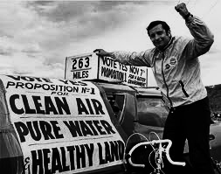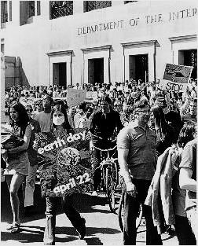
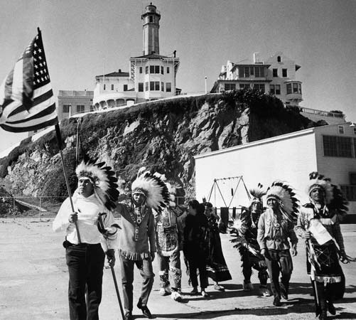 |  | American Indian Movement  1960s-1970s  Slogan: “A Right to Choose Our Way of Life”
In the 1930s, Congress had ended the policy of assimilation and returned to Indians control over their land and government. Then, in the 1950s, Congress enacted a new policy—Termination. Termination was designed to force Indians to assimilate into American society. Indians were encouraged to move to the cities and get jobs. The failure of termination helped to bring Indians together and they met in 1961 and issued the Declaration of Indian Purpose, which stressed that Indians must have the right to “choose our own way of life.”

In 1968, militant Indians founded the American Indian Movement. Congress had passed the Indian Civil Rights Act (1968), giving Indians the same rights as other Americans, but the members of AIM were fed up with centuries of injustice and negative stereotypes of Indians. Indians forcibly occupied several public places, claiming that their ancestors owned the land by right of first discovery. In 1969, they took over Alcatraz island; in 1972 they occupied the Bureau of Indian Affairs building in Washington, D.C.; and in 1973, they seized the town of Wounded Knee, South Dakota. Members of AIM wanted to bring attention to historical injustice, to gain independence for Indian peoples, and to force the public to abandon stereotypes of Indians as well as stop using Indians as mascots for sports teams.
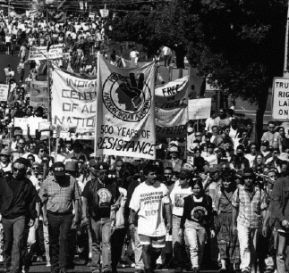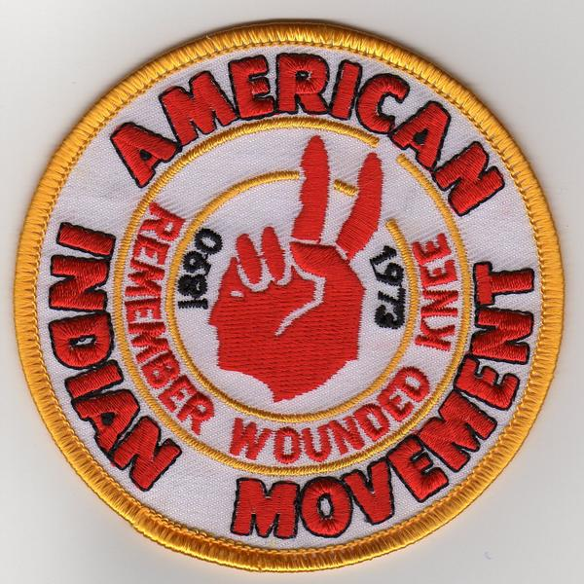

Latino Activism
1960s-1970s

Slogan: ¡Si, se puede! (Yes, it can be done)
Hispanic people had migrated into the United States in large numbers during World War II as part of the Bracero program. Between 1960 and 1970, the number of Hispanic migrants to the United States tripled, from 3 million to 9 million. They found work in the lowest-paying jobs, often in seasonal agricultural jobs out West. By the late 1960s, they grew resentful of discrimination against them as the “Chicano” movement grew strong. The Supreme Court had already ruled that Mexican-Americans could not be segregated and that the 14th amendment protected their rights, but those who identified with the Chicano movement still felt discrimination.

Chicano Movement leaders protested the lack of access to Spanish-language materials as well as the lack of recognition of Spanish and Mexican contributions to American history. Protests by 1974 helped to push the Supreme Court to rule that instruction in a student’s native language was a basic right. Chicano workers, led by Cesar Chavez, protested the lack of union rights for Hispanic farm workers. Chavez organized the United Farm Workers in 1965 and organized a national boycott of grapes and lettuce to force employers to recognize the Hispanic union.
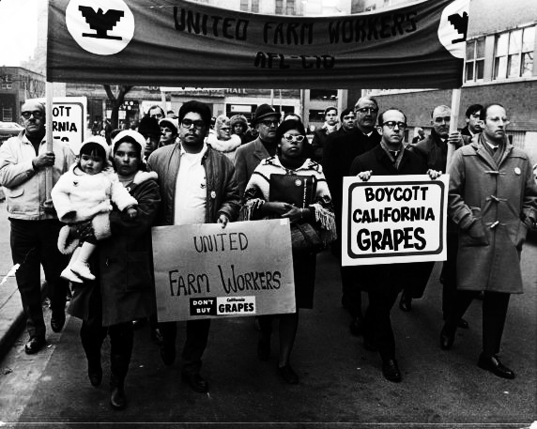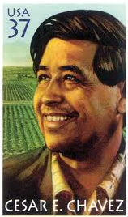

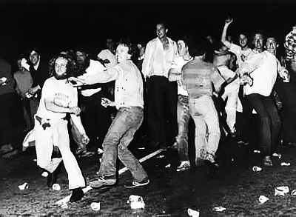 | Gay Liberation Movement  1960s-1980s (now the LGBTQ Movement)  Slogan: Come Out!
Gay and lesbian people had always been around in American history, but emerged onto the public stage after the Stonewall Riot of June 27, 1969. The New York police had often arrested people who went into the Stonewall Inn (a bar) simply for being there. But gays and lesbians, tired of being harassed, fought back. They wanted the public recognize that their relationships were not “sick,” that they deserved the right to be openly gay in public, and that being gay itself was not a disease. They were tired of being treated as second-class citizens and forced to hide their true identities to avoid losing their jobs, being harassed by the police, and, sometimes, even being killed by gay-bashers.

Gay and lesbian people held public marches and promoted their ideas to encourage the public to understand that being gay is not a disease and that gays and lesbians have the same kinds of loving, long-term term relationships as heterosexuals. One of their earliest victories was in 1973, when the American Psychological Association removed homosexuality from its list of mental illnesses. The movement has worked to increase the visibility of gays and lesbians in public life, symbolized by the first openly-gay mayor of San Francisco, Harvey Milk, who was elected in 1978. They have also worked to increase courses on gay and lesbian issues in schools, to end discrimination against gays and lesbians in the U.S. military, and to prohibit discrimination in jobs on the basis of sexual orientation.
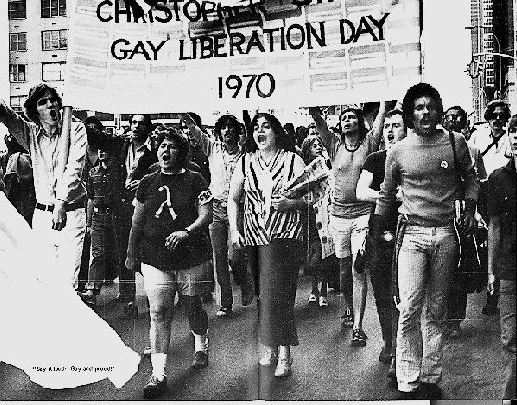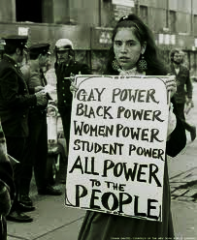

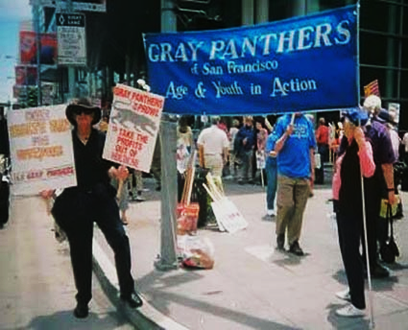 | Gray Panthers  1960s-Present  Slogan: Age and Youth in Action
Maggie Kuhn founded the Gray Panthers in 1971 after she was forced to retire at age 65 after working for the Presbyterian Church. Members of the movement wanted to fight age-discrimination—the assumption that the elderly should not work and cannot do the jobs of younger people. The elderly hated being treated like children, forced to live in giant “playpens,” their term for nursing homes. They worked to combat the widespread belief that the elderly had to withdraw from society to prepare for death.

The Gray Panthers did not just fight age discrimination but also opposed the Vietnam War, wanted health-care reform, opposed racism, and wanted to limit the nuclear war. Their favorite method to bring attention to social problems was guerilla theater, staging phony theatrical incidents to bring attention to injustice. For example, in 1974, four Gray Panthers staged an emergency medical response at the conference of the American Medical Association, trying to make a house call on the sick “AMA.” They tried to restart the AMA’s heart but dollar bills kept pouring out of the patient’s body. The theatrical stunt brought attention to the AMA’s concern more for profit than for the needs of the elderly. The group has also filed lawsuits against drug companies.

