Creedence Clearwater Revival
“Fortunate Son” (1969)
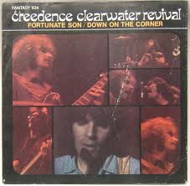
Some folks are born made to wave the flag,
Ooh, they're red, white and blue.
And when the band plays "Hail to the chief",
Ooh, they point the cannon at you, Lord,
It ain't me, it ain't me, I ain't no senator's son, son.
It ain't me, it ain't me; I ain't no fortunate one, no,
Yeah!
Some folks are born silver spoon in hand,
Lord, don't they help themselves, oh.
But when the taxman comes to the door,
Lord, the house looks like a rummage sale, yes,
It ain't me, it ain't me, I ain't no millionaire's son, no.
It ain't me, it ain't me; I ain't no fortunate one, no.
Some folks inherit star spangled eyes,
Ooh, they send you down to war, Lord,
And when you ask them, "How much should we give?"
Ooh, they only answer More! more! more! yoh,
It ain't me, it ain't me, I ain't no military son, son.
It ain't me, it ain't me; I ain't no fortunate one, one.
It ain't me, it ain't me, I ain't no fortunate one, no no no,
It ain't me, it ain't me, I ain't no fortunate son, no no no,

Country Joe and the Fish
“I Feel Like I’m Fixin to Die” (1967)

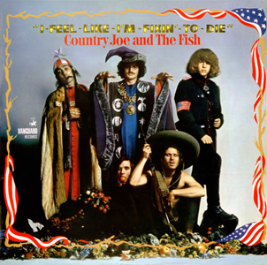
Well, come on all of you, big strong men,
Uncle Sam needs your help again.
He's got himself in a terrible jam
Way down yonder in Vietnam
So put down your books and pick up a gun,
We're gonna have a whole lotta fun.
And it's one, two, three,
What are we fighting for ?
Don't ask me, I don't give a damn,
Next stop is Vietnam;
And it's five, six, seven,
Open up the pearly gates,
Well there ain't no time to wonder why,
Whoopee! we're all gonna die.
Come on Wall Street, don't be slow,
Why man, this is war au-go-go
There's plenty good money to be made
By supplying the Army with the tools of its trade,
But just hope and pray that if they drop the bomb,
They drop it on the Viet Cong.
Well, come on generals, let's move fast;
Your big chance has come at last.
Now you can go out and get those reds
'Cause the only good commie is the one that's dead
And you know that peace can only be won
When we've blown 'em all to kingdom come.
Come on mothers throughout the land,
Pack your boys off to Vietnam.
Come on fathers, and don't hesitate
To send your sons off before it's too late.
And you can be the first ones in your block
To have your boy come home in a box.

