United States History
The Good Life: The American Economy, 1945-1972

For most Americans after World War II, life was good. Those people who had grown up during the Depression’s awful days witnessed a massive expansion of America’s industrial output. By every economic measure possible, Americans seemed to be doing well. There were some pockets of deep poverty, however, and the federal government set about reducing poverty in the 1960s. For many Americans, nonetheless, economic times were good. In fact, the social protests of the 1960s benefitted from the good times. People could worry about marching in the streets instead of worrying about where their next meal or rent paycheck was coming from. But, like all economic booms, the good times had to come to an end. Government spending, changes in the kinds of work Americans did, and changes in the international economy would bring the boom to an end by 1972.
By every economic measure from 1945 to 1972, however, most Americans seemed well off. The five recessions that happened during that period were short. Unemployment was low, hovering around 4.7% for the entire 27-year period. Inflation, or a rise in prices, also remained low. An item that cost $1.00 in 1945 cost $2.32 by 1972; by comparison, an item that cost $1.00 in 1945 would cost $12.65 today!
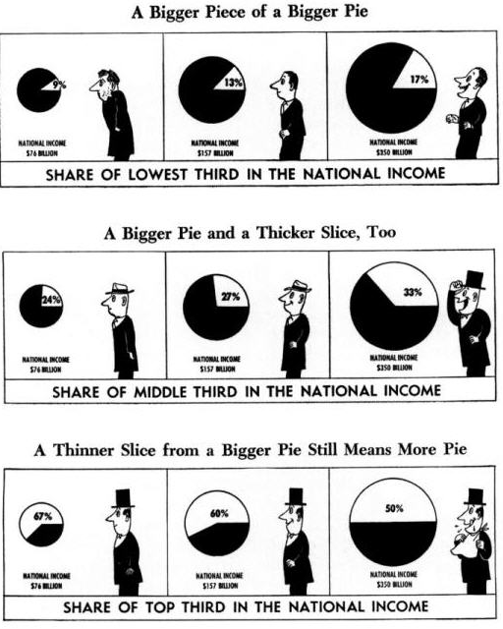
In terms of production of goods, Americans worked hard in automobile factories, turning out the cars that Americans needed for highways that connected them to suburbs and shopping centers. The automobile industry in the United States had little competition, so they could afford to pay high wages to workers. The value of goods and services in the United States between 1945 and 1972 thus doubled. As a result of the rising standard of living, Americans’ life expectancy rose from 63 to 67.
The rising standard of living helped to increase the size of the American economic pie. With a bigger pie to spread all around, Americans shared more in national prosperity. Prosperity might have benefitted the wealthy more than anyone else—for the top 1% of the nation owned 35% of the nation’s wealth in 1960—but hardly anyone noticed because everyone seemed to be sharing in the good times.
The economic boom of the 1945-1972 was made possible, in part, by the decline of unions. In 1947, Congress passed the Taft-Hartley Act, a law that limited strikes, allowed states to ban closed shops, and protected employers’ harassment of unions as “free speech.” Labor unions saw Taft-Hartley as a “slave labor” law and begged President Truman to veto it, which he did. But Congress was able to override his veto and the law helped to reduce union power. Unions themselves began to be less militant as they discouraged strikes. Some unions prevented strikes by negotiating COLAs, or Cost of Living Adjustments, into contracts with companies. The COLAs provided an automatic increase in pay for workers to match the rate of inflation. Union power also declined because of charges of corruption. In 1957 and 1958, Congress investigated charges of bribery and extortion in several unions. The public image of unions suffered as a result of the investigations.
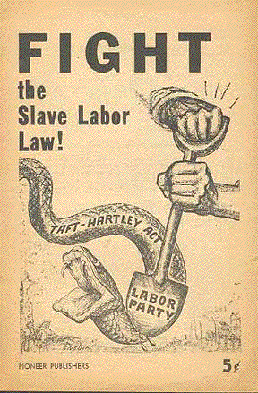
The economic boom of the 1945-1972 may have resulted from the growth of automobile industry jobs and other industrial work, but it also resulted from a change in the type of work that Americans did. More and more workers were becoming service sector workers—those who provided a service rather than made a good (like a car). Service workers included clerks, secretaries, food workers, maintenance workers, and others who did not make goods. Many of the service work jobs were low-paying but their increase did allow for more people, especially women, to have a job. A second change in the type of work during this period was the increase in the number of white collar jobs, or professional jobs such as those held by managers, supervisors, and executives. By 1956, there were more white collar jobs in America than blue collar jobs. Blue collar workers did manual labor—they built the cars and other goods that Americans wanted to buy—while white collar workers supervised.
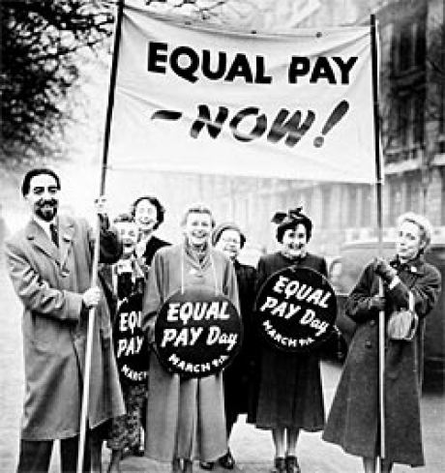
The increase in service jobs and the expansion of investment in education helped to open more jobs up for women in the period from 1945 to 1972. In 1950, only 31% of women worked outside the home; by 1960, that number had increased to 42%. Most women worked in four job categories: retail, clerical, health, or education. In other words, women could work as salesclerks, secretaries, nurses, or teachers without causing much debate. The higher-status jobs and higher-paying jobs always went to men. For example, while the teachers in an elementary school would almost always be women, the principal would always be a man. The fact that men had higher-paying, higher-status jobs meant that they made more money than women. The gap between men and women’s income in 1963 was 41 cents—for every dollar a man made, a woman made 59 cents. In 1963, Congress passed the Equal Pay Act to force companies to pay women equal money for equal work, but the law did not do anything about making sure that women got higher-paying positions that usually went to men. Today, women earn 77 cents for every dollar that a man makes.
By 1972, the signs of economic failure were beginning to be seen. Government spending on welfare programs (President Johnson’s Great Society) and on the war in Vietnam had increased inflation. More importantly, Americans could no longer beat their competitors in industrial production. The Japanese, for example, had copied American industrial production and could now produce cheaper and better cars and electronics. American companies also recognized that labor was cheaper outside the United States. RCA, a maker of electronics, for example, moved its plants eventually to Mexico to take advantage of cheaper labor. Cities that had expanded with the automobile industry—Cleveland and Detroit—saw the decline of industrial production. As jobs left these cities and the automobile makers closed down, old factories were left behind. As these factories decayed, they gave the name “Rust Belt” to a region that once had made its living by industrial production.
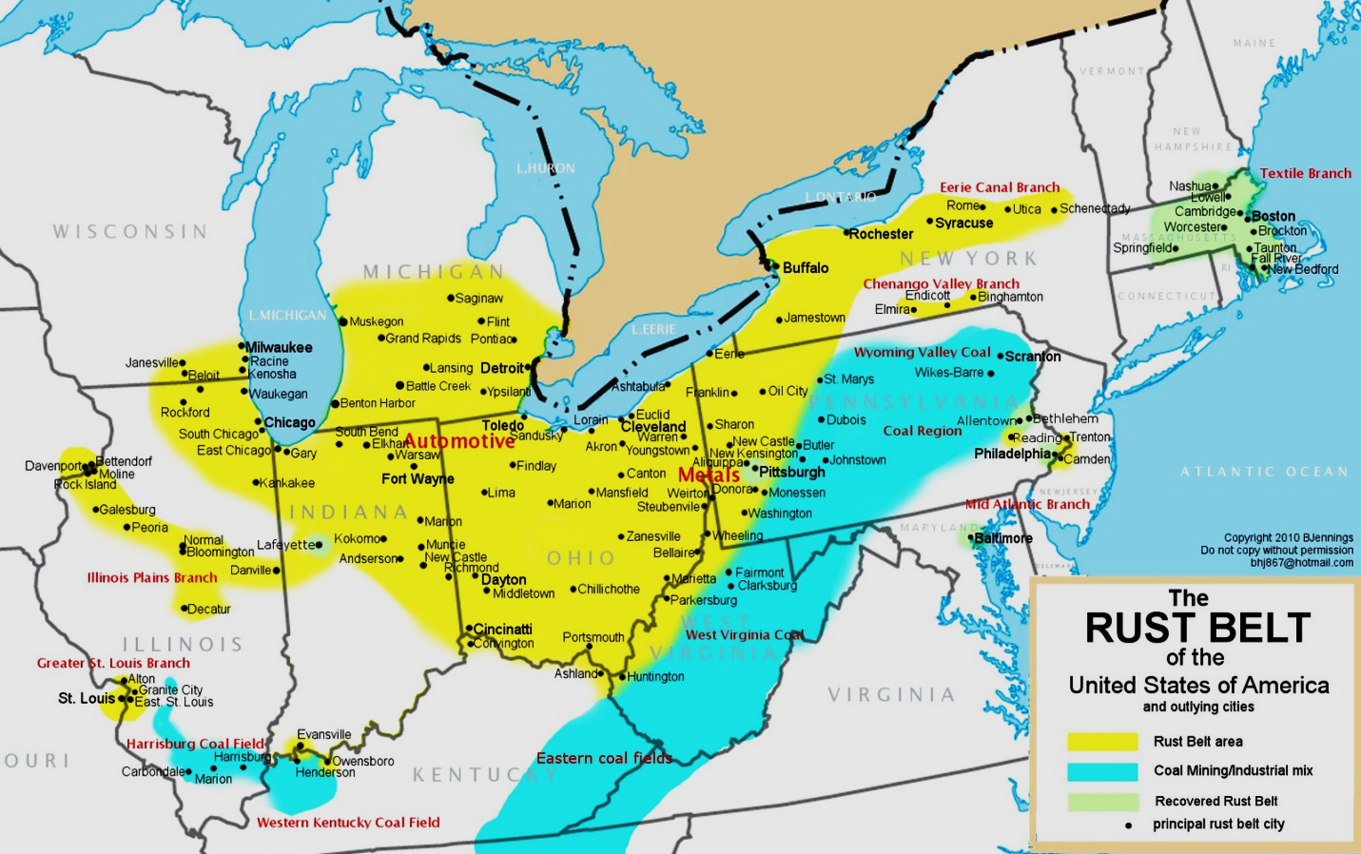
It is important to remember not everyone in the 1950s and 1960s shared in the prosperity of the decade. 1 out of every 5 families in the late 1950s lived in poverty, amounting to 30 million Americans. A great many of those living in poverty were America’s ethnic minorities—African Americans, Hispanics, and Native Americans. For a brief time, however, a good many Americans benefitted from the expansion of the economy. America’s industrial and economic success helped to convince Americans that the American way—not the Soviet way—was indeed the best in the world. Within the United States, it also further inspired those who did not share in that success to continue reaching for a bigger and better slice of the economic pie. Borrowing from the words of the theme song that opened the 1970 television sitcom The Jeffersons, Americans of all backgrounds hoped to be “moving on up” because they finally “got a piece of the pie.”

Who’s Getting a Piece of the Pie?

Study the following graphs/tables and then answer the questions on your outline sheet.

Graph A – Poverty Rate by Year, 1939-1989 (percentage of all people in poverty)

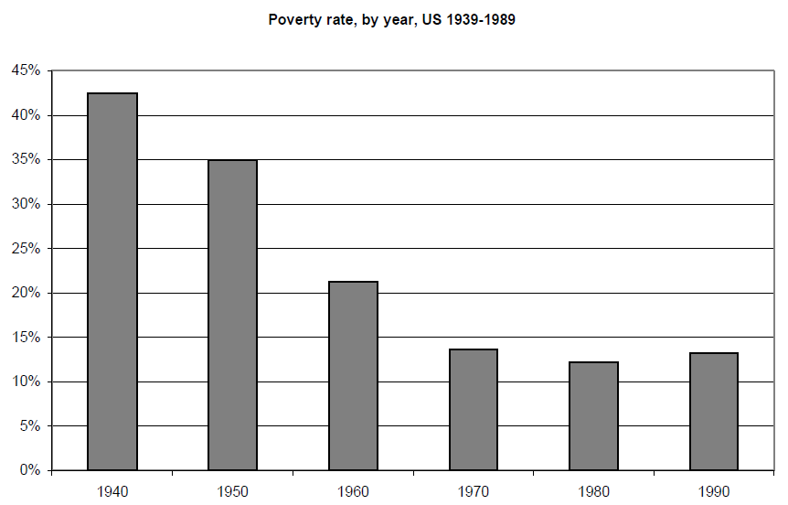

Table B – Poverty Rate of Household Heads by Gender (percent of households that impoverished)
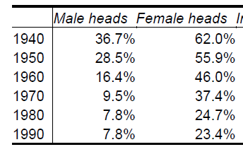
Table C -- Poverty Rates, 1960-1965 (in percentages)
 | All Americans | White Americans | Black Americans
1960 | 26.5% | 20.0% | 55.1%
1965 | 16.3% | 14.4% | 47.4%

Table D -- Average Yearly Income of Families, 1960-1965
 | White Families | Black Families
1960 | $29,553 | $16,359
1965 | $34,553 | $19,028

