The Warren Court

Directions: Read the summary for your court case. Then, list the topic, constitutional issue (what amendment in the constitution does the case involve?), and the decision of the court.

Baker v. Carr (1962)

Tennessee’s cities grew rapidly in the 1950s and 1960s, but the Tennessee legislature did not redraw state legislature districts for voting. That meant that rural areas elected more representatives to the state legislature than cities, even though the cities had more people. The Supreme Court ruled that the apportionment of state legislative districts is within the jurisdiction of federal courts. The Supreme Court directed a trial to be held in a federal court. The trial led to the 1964 Wesberry v. Sanders decision, which supported voters’ right to the equal protection guaranteed by the 14th Amendment and established the principle of “one man, one vote” (one person, one vote) for the apportionment of congressional districts.

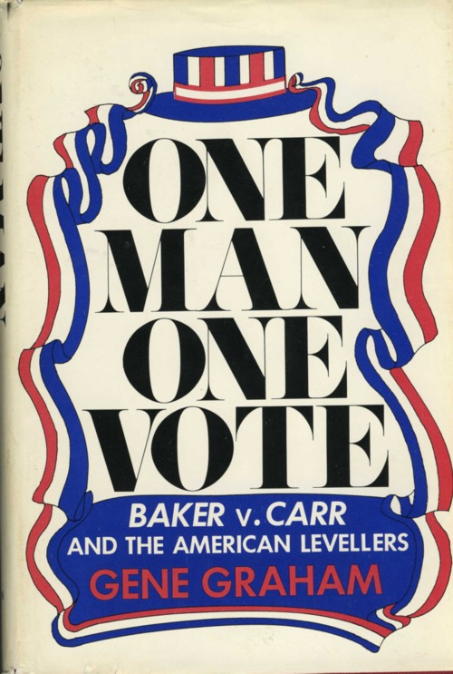
The Warren Court

Directions: Read the summary for your court case. Then, list the topic, constitutional issue (what amendment in the constitution does the case involve?), and the decision of the court.

Engle v. Vitale (1962)

The State Board of Regents of New York required students to recite a prayer at the beginning of each school day. A group of parents filed suit against the required prayer. The Supreme Court ruled that the recitation of a prayer in a public classroom was a violation of the establishment clause (government cannot establish an official state religion) of the First Amendment.

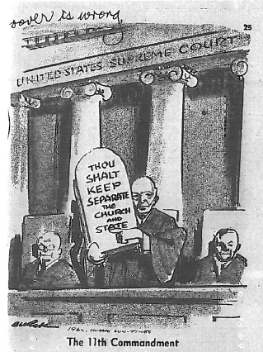
"Almighty God, we acknowledge our dependence upon Thee, and we beg Thy blessings upon us, our parents, our teachers and our country."
-the prayer in New York schools in 1962

The Warren Court

Directions: Read the summary for your court case. Then, list the topic, constitutional issue (what amendment in the constitution does the case involve?), and the decision of the court.

Escobedo v. Illinois (1964)

Danny Escobedo was questioned repeatedly by police without being able to talk to his lawyer. He was tricked into confessing to a murder, and then he sued because he had been denied access to counsel (lawyer). Access to counsel when accused of a crime is a Sixth Amendment right. The Supreme Court decided that accused persons must have access to counsel during the interrogation process.

The Warren Court

Directions: Read the summary for your court case. Then, list the topic, constitutional issue (what amendment in the constitution does the case involve?), and the decision of the court.

Gideon v. Wainwright (1963)

Gideon was charged with breaking into a poolroom. He could not afford a lawyer, and Florida refused to provide counsel (a lawyer) for trials not involving the death penalty. Gideon defended himself poorly and was sentenced to five years in prison. The Supreme Court called for a new trial, arguing that the due process clause of the Fourteenth Amendment applied to the Sixth Amendment’s guarantee of counsel for all persons accused of a crime. Gideon later was found not guilty with the help of a court-appointed attorney.
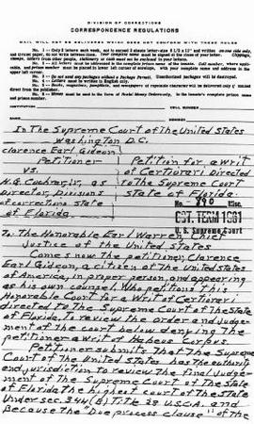
Because Gideon was poor, he hand wrote his petition to the Supreme Court to look into his case.

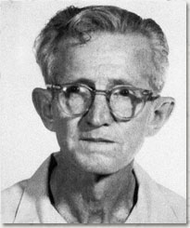

The Warren Court

Directions: Read the summary for your court case. Then, list the topic, constitutional issue (what amendment in the constitution does the case involve?), and the decision of the court.

Griswold v. Connecticut (1964)

Griswold worked as the Executive Director for Planned Parenthood League, and she gave information about birth control to married clients. Connecticut law prohibited passing out information about birth control (they considered it lewd), so she was charged. The law was struck down on the basis of the right to privacy, which is not explicitly mentioned in the Constitution. The Court said that together, the First, Third, Fourth, and Ninth Amendments, create a new constitutional right, the right to privacy in marital relations.

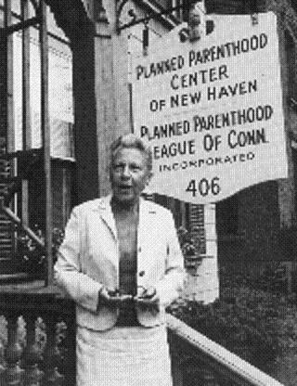

The Warren Court

Directions: Read the summary for your court case. Then, list the topic, constitutional issue (what amendment in the constitution does the case involve?), and the decision of the court.

Mapp v. Ohio (1961)

Admitting evidence gained by illegal searches into trial was permitted by some states before 1961. Cleveland police raided Dollree Mapp’s home without a warrant; they were searching for a fugitive and found obscene materials. She appealed her conviction, saying that the Fourth and Fourteenth Amendments protected her against improper police behavior. The Court agreed, extending “exclusionary rule” protections to citizens in state courts, saying that police must say in their search warrants exactly what they are looking for. Any other evidence seized that was not in the search warrant must be thrown out since the police weren’t looking for it to begin with.

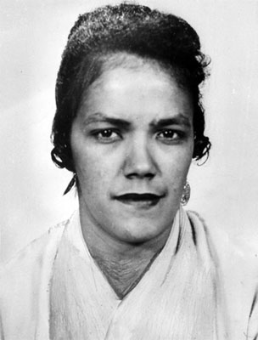

The Warren Court

Directions: Read the summary for your court case. Then, list the topic, constitutional issue (what amendment in the constitution does the case involve?), and the decision of the court.

Miranda v. Arizona (1966)

Arrested for kidnapping and sexual assault, Ernesto Miranda signed a confession including a statement that he had “full knowledge of [his] legal rights.” After conviction, he appealed, claiming that without counsel and without warnings, the confession was illegally gained. The Supreme Court agreed with Miranda that “he must be warned prior to any questioning that he has the right to remain silent, that anything he says can be used against him in a court of law, that he has the right to . . . an attorney and that if he cannot afford an attorney one will be appointed for him.” The court applied the 5th and 6th amendments to reach their conclusion.

