United States History
1830s Fires of Perfection Talk Show

Group: Temperance

Consumption of alcohol peaked in 1830 at just over 5 gallons of hard liquor (rum, whiskey, gin, brandy) per person, per year in the United States (today it is less than 2 gallons per person).

The economic difficulties of the 1820s and 1830s led people to use alcohol to cope with job loss, difficult work environments, and swings in the national economy. Traditionally, alcohol was consumed at work during a break, under the watchful eyes of your manager. Increasingly, however, more and more alcohol was consumed in bars and drunkenness became an epidemic.

Drunken men especially were seen as a threat to the home. They beat their wives and children and wasted the family’s money on booze.

At first, reformers tried to encourage people to not drink as much—to “temper” their hard drinking. Their efforts were not as successful, so they turned from persuading people to stop drinking to using the law to shut down bars and limit alcohol consumption. States began to pass laws to license bars and limit the amount of alcohol a person could have. By 1850, alcohol consumption dropped to 2 gallons per person, per year.

Ideas for Talk Show:
Preacher who is against alcohol
Reformed “drunkard”
Drunkard who beats his wife and children
Citizen concerned about the effect of local bars on crime

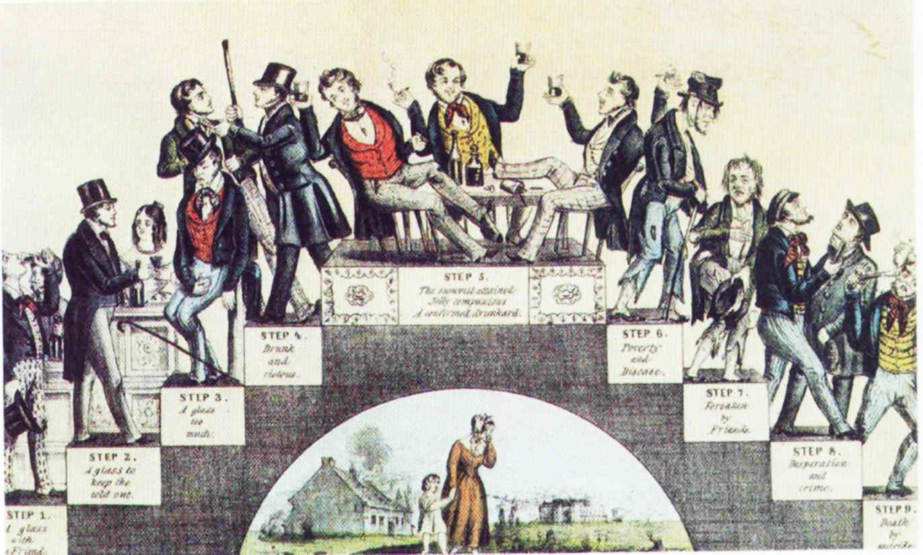

United States History
1830s Fires of Perfection Talk Show

Group: Utopias

In the 1830s, a number of Americans formed utopian settlements. A group of people would agree to buy a piece of land and work together to create an “ideal” world away from the crime, corruption, and loose morals of the cities. The utopianists thought that they could create the perfect life for themselves separated from the terrible conditions of the cities. There were more than 100 utopian communities established, mostly in the North and Midwest (Ohio had 15!).

Some utopias were religious while others were non-religious (secular). Brook Farm, in Massachusetts, was created for writers and thinkers as a place for individual improvement. Everyone was supposed to do chores and help make the farm successful while saving time for their writing and thinking. Oneida, founded in New York, was based on the idea of “free love.” There were no marriages—everyone entered into relationships with others freely. All children born of these relationships were raised by everyone. Some utopias, like the Shaker villages, banned reproduction completely. Shaker men and women were not allowed to have relationships.

Other utopians were formed to eliminate the class distinctions created by a capitalist economic system. They believed that everyone was born equal but that society—the corruption of modern urban life—destroyed that equality. Economic utopias worked to make sure that all members contributed equally to the welfare of the utopia while receiving equal benefits from living together. These experiments in an equal distribution of wealth were early examples of idea of socialism.

Ideas for Talk Show:
Members of various utopias
Neighbors of the utopia who think the utopians are “weird”
Person in the utopia who wants to get out
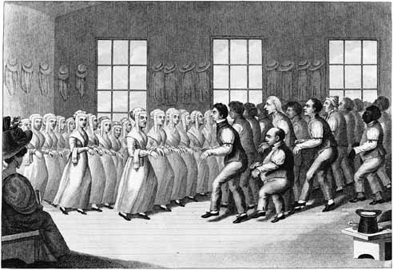

United States History
1830s Fires of Perfection Talk Show

Group: Women’s Rights

Women first started getting involved in national politics in the debates over slavery. Women often worked in local anti-slavery societies, passing out information, holding meetings, and encouraging people to join the anti-slavery work. Even while fighting for the rights of slaves, however, women found themselves oppressed. When two female South Carolina anti-slavery speakers, sisters Sarah and Angelina Grimke, tried to speak at a public lecture in the North, they were told that women should not speak to men in public. Women who talked in public to mixed sex groups were in danger of losing their femininity.

Socially, women in the 1830s were supposed to live up to the ideas of the “cult of true womanhood.” Women belonged in the home as the religious and moral leaders of the family. Their job was to raise children and make their husbands happy. Politics de-sexed a woman and took away her virtue. Women had very few rights at the time. On marriage, a woman lost all her property rights (they went to her husband), and he was legally responsible for her as if she was a child. Women wanted to be treated as the intellectual equals of men, better access to education, more control over their own property, and the right to speak in public about public issues.

Women first met at the Seneca Falls Convention (New York) in 1848 to draft a woman’s Declaration of Independence. While they could not agree that women should have the right to vote (some women felt that was a bit too much), they did agree that men were “tyrants” over women.

Ideas for Talk Show:
Women in anti-slavery movement
Women who were opposed to women’s rights
Men opposed to women’s rights

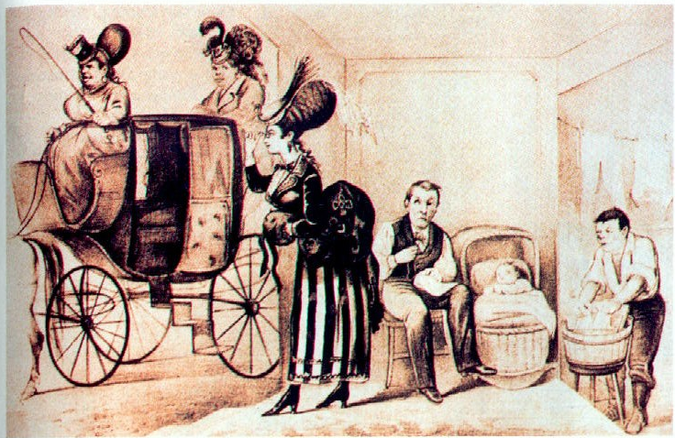

United States History
1830s Fires of Perfection Talk Show

Group: Prison and Asylum Reform

Until the 1820s, most people assumed that criminals were motivated by evil desires that exist in all from birth and deserved to be punished brutally (death or maiming was common even for petty theft). Because most people did not understand mental illness, many of the people who today would be treated for schizophrenia and other illnesses would have also been thrown into prison. Prisons were nasty and brutal places that often led to the premature deaths of those unlucky enough to be thrown into them.

A number of reformers in the 1820s and 1830s began to argue that prisons should be places for the rehabilitation of offenders. Instead of punishment, prisons needed to teach criminals the skills to be successful citizens. They also separated prisoners from each other so that prisoners would not pick up bad habits from each other. Reformers worked from the assumption that a bad environment creates bad people—bad people are made, not born.

Reformers separated adults from juveniles, creating the first juvenile treatment facilities in the 1820s and a system of reform schools. For those suffering from mental illness, reformers like Dorothea Dix pressured states to create hospitals where the insane could be housed separately and treated differently than criminals. Dix persuaded Massachusetts, Illinois, North Carolina, and Pennsylvania to revise how they treated those with mental illnesses.

Ideas for Talk Show:
Prisoner who has been “rehabilitated”
Reformer (like Dorothea Dix)
Average Citizen in a town with a “enlightened” prison system (could be for or against)

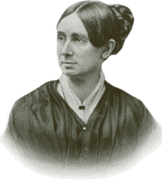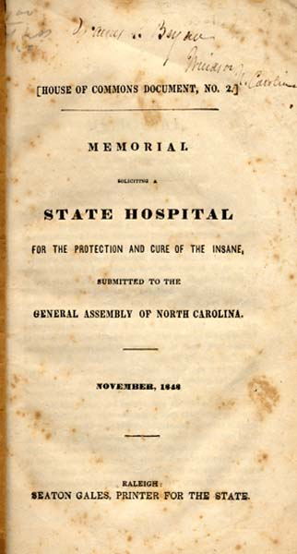

United States History
1830s Fires of Perfection Talk Show

Group: Education

Until the early 1800s, most Americans assumed that education was the responsibility of the family. Wealthy families would hire private tutors to teach their children. Boarding schools were available—at expensive rates of tuition, room, and board—to teach the children of the wealthy as well. Only in Massachusetts, under Puritan leadership in the 1640s, did the idea of public schooling take root early in American history. The Northwest Ordinance of 1787 also set aside land in the Midwestern territories for schools, but free public schooling was very rare before the 1830s.

In Massachusetts, Horace Mann led the way in the 1830s for a free public school movement. By 1852, Massachusetts had the first teacher training school, the first public high school, the first board of education, and the first compulsory school attendance law. Mann believed that Americans should teach children the skills they needed to be good citizens. Mann thought that education would relieve social tensions by showing young children what they had in common as citizens of the United States. He also thought that education could teach the values that every child needed—the values of a broadly Protestant Christian nation and a capitalist economic system.

Free public schools quickly grew, particularly in the North and Midwest. The South was slower to adopt the free public school movement because of the expense of taxing the public to pay for the education of all children. As a result, literacy surged in the North while it languished in the South.

Ideas for Talk Show:
Horace Mann
Parent of a child who supports free public education
Parent of a child who opposes free public education
A child in Massachusetts

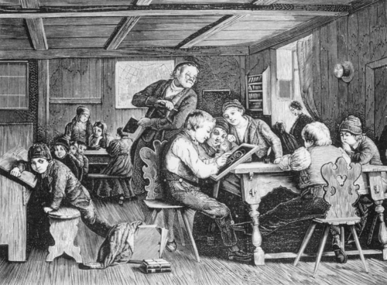

United States History
1830s Fires of Perfection Talk Show

Group: Transcendentalism

The Transcendentalists were a group of American writers who were part of the Romantic Movement in American arts between 1815 and 1840. Romanticism focused on emotions, intuition, nature, and self-discovery. The Transcendentalists, in particular, wanted to overcome the “civilization” of urban life and reconnect with an authentic, real world. Ultimately, they hoped to experience the deep mysteries of life.

Transcendentalists were deeply influenced by eastern religions, particularly Hinduism. By probing the mysteries of experience and consciousness, they hoped to mystically unify with the creator who transcended all reality. They believed in the inherent goodness of mankind and nature, assuming that mankind’s corruption results from living in cities—urban evils teach good people to be bad. Some transcendentalists returned to a more “natural life” by living in utopian communes. One, Henry D. Thoreau, lived in a cabin near Walden Pond for two years in 1845. Thoreau preached the virtues of living a simple life.

Ralph Waldo Emerson defined many of the ideas of the Transcendentalists in an 1837 speech called “The American Scholar.” Emerson called upon Americans to establish a new vision of America’s destiny in which American intellectuals would think for themselves and not merely parrot back the ideas of Europeans. The beauty of American nature would provide the means for American intellectuals to have their intellectual “declaration of independence.”

Ideas for Talk Show:
Transcendentalist writer such as Emerson or Thoreau
Reader of Transcendentalist literature
Critic of Transcendentalists

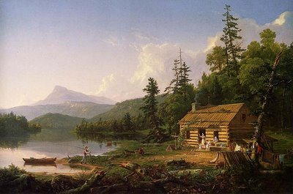

United States History
1830s Fires of Perfection Talk Show

Group: Mormonism

The founder of Mormonism, Joseph Smith, came from a deeply unsuccessful family who suffered from several economic disasters. The family moved to New York in 1817, where a number of revivals shook the region, creating excitement for Christianity, but also confusing young Joseph, who had trouble understanding how every preacher who came to town could have the “right views.”

The Smith family supplemented their income by digging for treasure; Joseph claimed the ability to locate lost items and buried treasure. One night, in 1823, he claimed that the angel Moroni revealed to him the location of buried golden plates and other artifacts. In 1827, Smith recovered the golden plates and began the work of translating them from “reformed Egyptian.” By 1829, the Book of Mormon was completed. Quickly gathering converts, the new religious movement established a community in Kirtland, Ohio in 1831.

Mormons were attacked by their neighbors frequently in their early years. Smith’s promotion of a church-sponsored bank resulted in failure and a warrant for Smith’s arrest for bank fraud. The Mormons fled to Missouri, where they began to call themselves the Church of Jesus Christ of Latter Day Saints. Neighbors again attacked the Mormons and even the governor of Missouri urged a “war of extermination” on the religious group. They moved to Illinois (Nauvoo) and began a program of missionary work to Europe. While in Nauvoo, Smith announced ideas that have had a long association with Mormonism – multiple wives (1841), baptism of the dead (1840), and first anointing of men (1842). By 1844, Smith would be murdered by an Illinois mob because his neighbors thought he was attempting to create a separate Mormon state within a state. To escape persecution, Brigham Young moved a large portion of the group to Utah in 1847.

Ideas for Talk Show:
Joseph Smith
Early Mormon Converts
Anti-Mormon Neighbors

