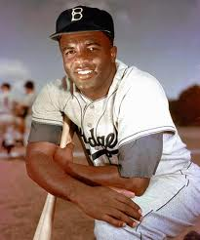
Milestones of Civil Rights #2

Jackie Robinson Breaks the Color Barrier in Baseball, 1947

Since the 1880s, black and white baseball players did not play together on the same team. The custom of de facto (concerning the fact) segregation, or segregation that is not protected by law, had required that black and white athletes be separated.

Jackie Roosevelt Robinson grew up in a sharecropper’s family in Georgia and played in the black baseball leagues until 1947. He also served in a segregated army unit during World War II. The Brooklyn Dodgers asked Robinson to play for them in 1947. Robinson became the first African-American player on a white team. He faced many challenges. Racist baseball players on other teams told him to go “back to the cotton fields.” Even fans shouted racial slurs. But Robinson stayed and his managers and owners supported him.

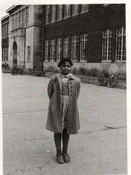
Milestones of Civil Rights #3

Brown v. Board of Education ends the doctrine of “separate but equal” 1954

Since the end of World War II, it was becoming more difficult to defend the idea of “separate but equal.” Separation implied that blacks were not equal to whites. Psychologists even showed that black children preferred to play with white dolls because they believed that being white led to a better life.

In Topeka, Kansas, Oliver Brown sued the school board because his daughter Linda had to travel almost a mile to a segregated school even though an all-white school was closer to her home. Other parents joined with Brown to take the case to the Supreme Court. The Supreme Court ruled that segregation itself suggested inequality and the inferiority of African Americans. The court threw out the old idea of “separate but equal” from the Plessy v. Ferguson case (1896).

Southerners did not like the Brown decision. It undermined de jure segregation (concerning the law), which was segregation that had a basis in law codes. White southerners closed schools (one Virginia school system closed for 5 years) and used the police to prevent black students from attending white schools. It would take many years before full integration would happen.

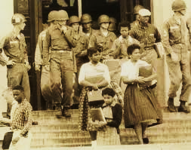
Milestones of Civil Rights #4

The Little Rock Nine attend an integrated school backed by federal troops, 1957

The Brown v. Board of Education case (1954) had ordered schools to de-segregate, but that process took time in many southern states. By 1957, the Little Rock School Board had agreed to enroll 9 black students at Central High School in Little Rock, Arkansas.

White racists threatened violence against the “Little Rock Nine” and the Governor of Arkansas used the National Guard to prevent the “Nine” from going to Central High School. President Dwight Eisenhower, angry at the Governor of Arkansas for blocking the Supreme Court’s orders, sent the United States Army to Little Rock. The power of the federal government would now be used to force a state to accept integration.

The Little Rock Nine faced numerous physical and verbal incidents by bullies. White students threw acid on one black student. In 1958, the Governor of Arkansas used his power to have the schools closed for a year. He wanted to re-open them as “private schools” for whites only. However, the schools re-opened in 1959 and integration continued.

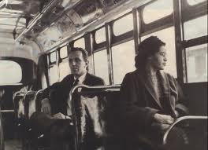
Milestones of Civil Rights #5

Black citizens in Montgomery, Alabama force the buses to integrate, 1955

Many African Americans had challenged segregation on buses before Rosa Parks did in 1955. They hated having to give up their seats for white passengers or being forced to sit in the back of the bus.

Rosa Parks, a member of the NAACP, refused to give up seat to a white person and was arrested. Members of the black community knew that they made up almost three-quarters of all bus riders and that if they stopped riding the busses, the companies would give in to African American demands. Black citizens in Montgomery organized carpools to avoid the buses.

White racists firebombed the houses of Martin Luther King, Jr. and Ralph Abernethy, local organizers of the boycott. Police arrested black citizens but soon found that they filled their jails and ran out of room. African Americans were using nonviolent protest—breaking the law, but peacefully—to bring attention to the problems of racism. After the Supreme Court agreed that segregation on buses was illegal, the boycott ended in 1956.

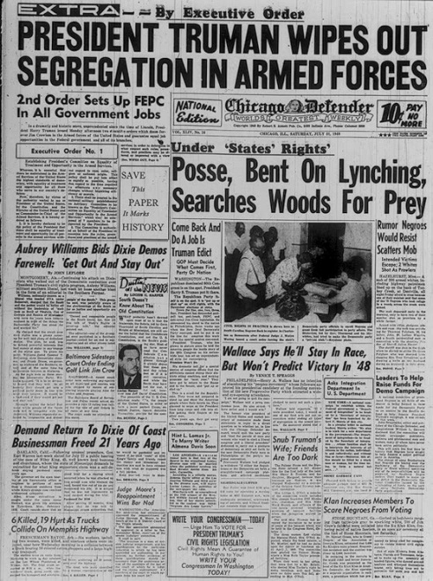
Milestones of Civil Rights #1

President Truman orders the U.S. military to de-segregate soldiers, 1948

Discussions of ending segregation in the United States military began in 1945. The murder of two black veterans and their wives in Georgia in 1946 made it clear to President Truman that something needed to be done. After studying the issue, Truman decided to issue Executive Order 9981 in 1948, ending segregation in the American military.

At first, both the Army and Marines defended segregation but the Navy and Air Force said that they supported integrating black soldiers. As the United States entered the Korean War (1950), segregation in the military started to decline. By 1953, the Army reported that 95% of African-American soldiers were serving in integrated units. The victory over racism that African-Americans fought for during World War II (Double-V) was becoming a reality in the military.

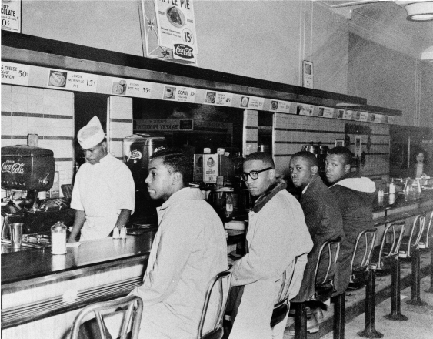
Milestones of Civil Rights #6

Students challenge segregated lunch counters in Greensboro, N.C., 1960

College students at the North Carolina Agricultural and Technical College (NC A&T) could not eat the Woolworth’s café in downtown Greensboro because they were African American.

Using the tactic of nonviolent protest—breaking the law, but peacefully—four young college students sat at the lunch counter in 1960. They were not served. Soon, more students came and developed the technique of the sit-in. They would sit in a store and take up space, preventing other customers from getting in. Black leaders had already found that this technique worked in jails—once they had filled the jails, white policemen had to let them go or not have enough room for other criminals. The example of the sit-ins in Greensboro inspired other students to stage sit-ins across the South.

Sit-ins were not always nonviolent. White customers verbally and physically assaulted black protesters. Black protestors had to “turn the other cheek” and not give into the temptation to be violent in return. They wanted to prove that they were “better” than those whites who mistreated them. Eventually, many lunch counters desegregated and started serving black customers. Many businesses understood that it made good sense to treat all customers nicely—or risk losing business and money.

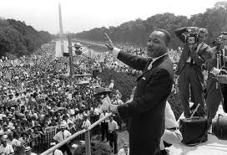
Milestones of Civil Rights #7

March on Washington—“I Have a Dream,” 1963

African Americans and others organized a March on Washington for Jobs and Freedom in August 1963. They met on the steps of the Lincoln Memorial to celebrate civil rights and demand an end to Jim Crow.

A. Philip Randolph, who had pressed President Franklin D. Roosevelt to ban discrimination defense industries during World War II, planned the Washington march. Nearly 300,000 people came to Washington, D.C.

The marchers were there to show support for a Civil Rights bill that President John F. Kennedy had introduced into Congress. For 17 minutes, Martin Luther King, Jr. held the attention of the crowd as he gave his now-famous “I Have a Dream” speech.

King called upon America to live up to its noblest ideals: “that all men are created equal.” He looked forward to day when his children would live in a nation where they were judged not by the color of the skin but by “the content of their character.” He called for freedom to ring from every mountain and valley of America. He ended triumphantly with words of promise from an old spiritual: “Free at last! Free at last! Thank God Almighty, we are free at last!”

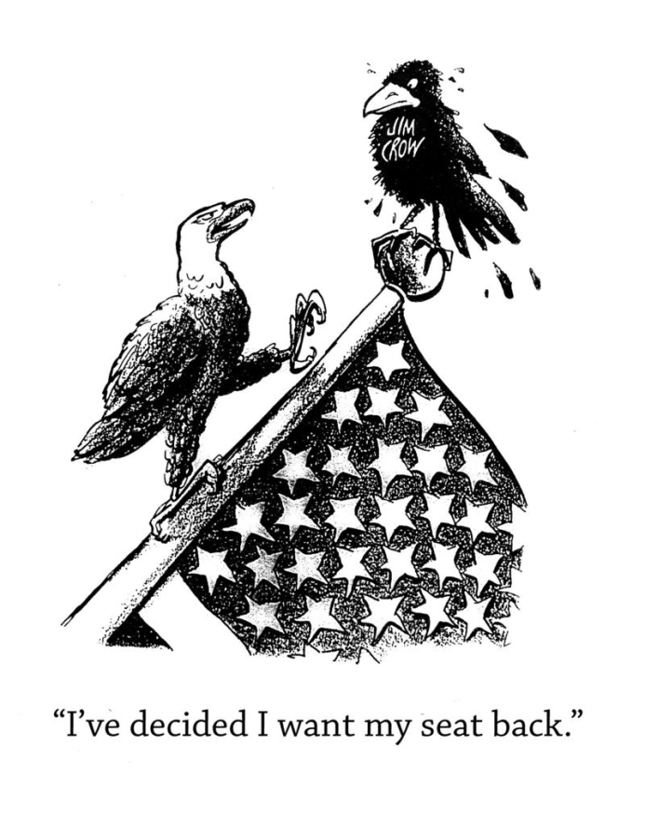
Milestones of Civil Rights #8

Congress bans racial discrimination in public facilities – Civil Rights Act, 1964

The citizens who joined in the March on Washington in 1963 gave public support to a Civil Rights bill working its way through Congress.

Congress approved the legislation in 1964 but it was not easy to do so. Southern opponents of the bill tied up Congress by speaking for hours—one Senator spoke for fourteen hours.

The Civil Rights Act of 1964 outlawed racial segregation in public facilities, unequal voter registration laws, discrimination based on race, color, religion, and sex (women). No longer could African Americans be forced to accept a “separate but equal” world in public.

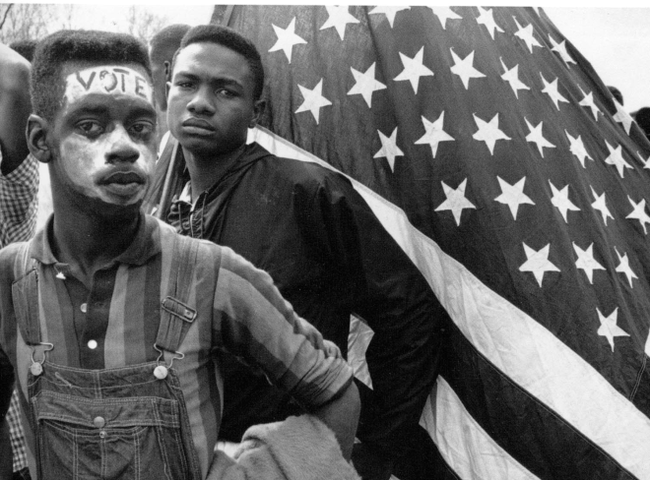
Milestones of Civil Rights #9

Congress bans discrimination in voting—Voting Rights Act, 1965

Even though the Civil Rights Act of 1964 had outlawed some discrimination against African Americans in voting registration, it did not cover literacy tests. Since the 1880s, states had used literacy tests to keep African Americans from voting.

The Voting Rights Act of 1965 forbid the use of any means to keep citizens from voting that was based in race or color.

