United States History
Sources on Women’s Roles, 1945-1965

SOURCE A: Marynia Farnham and Ferdinand Lundberg, Modern Woman: The Lost Sex (1947)

Work that entices women out of their homes and provides them with prestige only at the price of feminine relinquishment, involves a response to masculine strivings. The more importance outside work assumes, the more are the masculine components of the woman's nature enhanced and encouraged. In her home and in her relationship to her children, it is imperative that these strivings be at a minimum and that her femininity be available both for her own satisfaction and for the satisfaction of her children and husband.

She is, therefore, in the dangerous position of having to live one part of her life on the masculine level, another on the feminine. It is hardly astonishing that few can do so with success. One of these tendencies must of necessity achieve dominance over the other. The plain fact is that increasingly we are observing the masculinization of women and with it enormously dangerous consequences to the home, the children (if any) dependent on it, and to the ability of the woman, as well as her husband to obtain sexual gratification."
SOURCE B: Helen B. Andelin. Fascinating Womanhood. (1963)
- Based on a series of pamphlets published in 1922 by the Psychology Press (St. Louis) called “The Secrets of Fascinating Womanhood”

Dos | Don’ts
- Do accept him at face value. | - Don’t try to change him.
- Do admire the manly things about him. | - Don’t show indifference, contempt, or ridicule towards his masculine abilities, achievements or ideas.
- Do recognize his superior strength and ability. | - Don’t try to excel him in anything which requires masculine ability.
- Do be a Domestic Goddess. | - Don’t let the outside world crowd you for time to do your homemaking tasks well.
- Do work for inner happiness and seek to understand its rules. | - Don’t have a lot of preconceived ideas of what you want to out of life.
- Do revere your husband and honor his right to rule you and your children. | - Don’t stand in the way of his decisions, or his law.

SOURCE C: Governor Adlai Stevenson on the Role of Women, 1955

You may be hitched to one of these creatures we call "Western man" and I think part of your job is to keep him Western, to keep him truly purposeful, to keep him whole. This assignment for you, as wives and mothers, has great advantages.

In the first place, it is home work--you can do it in the living-room with a baby in your lap or in the kitchen with a can opener in your hand. If you're really clever, maybe you can even practice your saving arts on that unsuspecting man while he's watching television!

In modern America the home is not the boundary of a woman's life. There are outside activities aplenty. But even more important is the fact, surely, that what you have learned and can learn will, fit you for the primary task of making homes and whole hum an beings in whom the rational values of freedom, tolerance, charity and free inquiry can take root.

SOURCE D: Betty Friedan, The Feminine Mystique (1963)

The problem lay buried, unspoken, for many years in the minds of American women. It was a strange stirring, a sense of dissatisfaction, a yearning that women suffered in the middle of the twentieth century in the United States. Each suburban wife struggled with it alone. As she made the beds, shopped for groceries, matched slipcover material, ate peanut butter sandwiches with her children, chauffeured Cub Scouts and Brownies, lay beside her husband at night--she was afraid to ask even of herself the silent question--"Is this all?"

The suburban housewife--she was the dream image of the young American women and the envy, it was said, of women all over the world. The American housewife--freed by science and labor-saving appliances from the drudgery, the dangers of childbirth and the illnesses of her grandmother.
A mother of four who left college at nineteen to get married told me:
I've tried everything women are supposed to do--hobbies, gardening, pickling, canning, being very social with my neighbors, joining committees, running PTA teas. I can do it all, and I like it, but it doesn't leave you anything to think about--any feeling of who you are. I never had any career ambitions. All I wanted was to get married and have four children. I love the kids and Bob and my home. There's no problem you can even put a name to. But I'm desperate. I begin to feel I have no personality. I'm a server of food and putter-on of pants and a bed maker, somebody who can be called on when you want something. But who am I?
SOURCE E: Advertisements for Miltown, a popular antidepressant from the 1950s
- Sales of the drug jumped 985% in a single year (1955)
- By 1956, 1 out of every 20 Americans was taking the drug
- They were heavily marketed to women

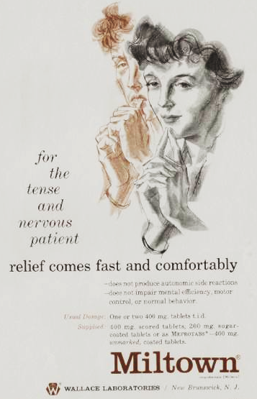 | 