HOWL [edited] (1955) United States History
Allan Ginsberg The Beat Generation

For Carl Solomon

I

I saw the best minds of my generation destroyed by
madness, starving hysterical naked,
dragging themselves through the negro streets at dawn
looking for an angry fix,
angelheaded hipsters burning for the ancient heavenly
connection to the starry dynamo in the machin-
ery of night,

yacketayakking screaming vomiting whispering facts
and memories and anecdotes and eyeball kicks
and shocks of hospitals and jails and wars,
whole intellects disgorged in total recall for seven days
and nights with brilliant eyes, meat for the
Synagogue cast on the pavement,
who wandered around and around at midnight in the
railroad yard wondering where to go, and went,
leaving no broken hearts,
who reappeared on the West Coast investigating the
F.B.I. in beards and shorts with big pacifist
eyes sexy in their dark skin passing out incom-
prehensible leaflets,
who distributed Supercommunist pamphlets in Union
Square weeping and undressing while the sirens
of Los Alamos wailed them down, and wailed
down Wall, and the Staten Island ferry also
wailed,
who were burned alive in their innocent flannel suits
on Madison Avenue amid blasts of leaden verse
& the tanked-up clatter of the iron regiments
of fashion & the nitroglycerine shrieks of the
fairies of advertising & the mustard gas of sinis-
ter intelligent editors, or were run down by the
drunken taxicabs of Absolute Reality,
who drove crosscountry seventytwo hours to find out
if I had a vision or you had a vision or he had
a vision to find out Eternity,
ah, Carl, while you are not safe I am not safe, and
now you're really in the total animal soup of
time
the madman bum and angel beat in Time, unknown,
yet putting down here what might be left to say
in time come after death,
and rose reincarnate in the ghostly clothes of jazz in
the goldhorn shadow of the band and blew the
suffering of America's naked mind for love into
an eli eli lamma lamma sabacthani saxophone
cry that shivered the cities down to the last radio
with the absolute heart of the poem of life butchered
out of their own bodies good to eat a thousand
years.
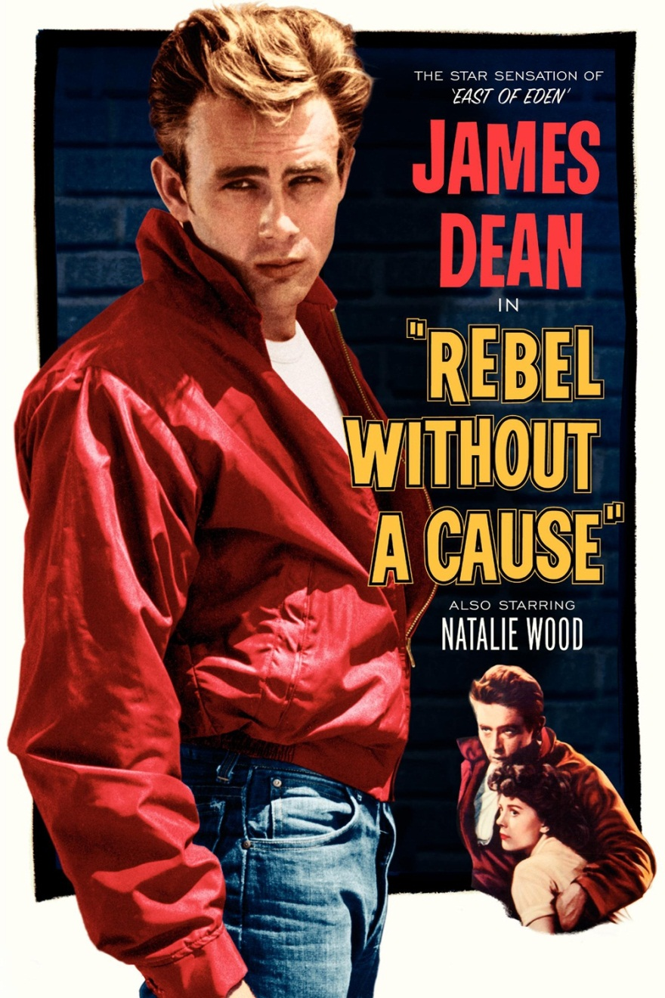
John Clellon Holmes, “This is the Beat Generation,” New York Times Magazine (1952)
It was John Kerouac who said, "You know, this is really a beat generation." More than a mere weariness, it implies the feeling of having been used, of being raw. It involves a sort of nakedness of mind, and, ultimately, of soul; a feeling of being reduced to the bedrock of consciousness.
Brought up during the collective bad circumstances of a dreary depression, weaned during the collective uprooting of a global war, they distrust collectivity. But they have never been able to keep the world out of their dreams. Their adolescence was spent in a topsy-turvy world of war bonds, swing shifts, and troop movements. Their brothers, husbands, fathers or boy friends turned up dead one day at the other end of a telegram. The peace they inherited was only as secure as the next headline. It was a cold peace.
Squaresville, U.S.A. vs. Beatsville, Life (September 21, 1959)

Venice (California) throve with the rebellion of the beatnik, who ridicules U.S. society as “square” talks a strange language and loves to chant his poetry while jazz bands or bongo drums play accompaniments. As the beatniks continue to gain followers, the clash between the squares and the beats is taking place in many small ways over the U.S.

Dr. Fredric Wertham, “What Parents Don’t Know About Comic Books,” Ladies Home Journal (1953)

My investigations and those of my associates have led us, very unexpectedly at first, but conclusively as the studies went on, to the conclusion that crime comics are an important contributing factor to present-day juvenile delinquency. Not only are crime comics a contributing factor to many delinquent acts, but the type of juvenile delinquency of our time cannot be understood unless you know what has been put into the minds of these children.

Crime comics create a mental atmosphere of deceit, trickery, and cruelty. Many of the children I have studied have come to grief over it. How best to summarize the attitudes most widely played up in crime comics? One might list them in some such way as this: assertiveness, defiance, hostility, desire to destroy or hurt, search for risk and excitement, aggressiveness, destructiveness, sadism, suspiciousness, and adventurousness.

