United States History Name:___________________________
Unit 7 Reading: The Populist Movement Date:________________ Period:_____

PART I: THE FARMERS GET ORGANIZED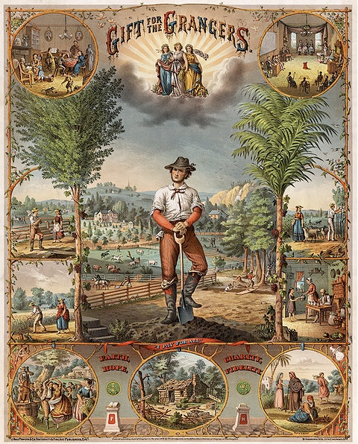  Farmers faced serious problems after the Civil War. The prices they could sell their crops for kept going down. This was because the United States was withdrawing greenbacks—money printed for the Civil War—from circulation. The decline in prices also meant that farmers had to pay back their loans in money that was worth more than when they borrowed it. Farmers urged the government to increase the money supply. But the government refused.  Meanwhile, farmers continued to pay high prices to transport grain. Often they paid as much to ship their crops as they received for them. Many farmers were almost ruined. The time, it seemed, had come for reform. Many farmers joined together to push for reform. In 1867, a farmer named Oliver Hudson Kelley started an organization that became known as the Grange. Its original purpose was to provide a place for farm families to discuss social and educational issues. By the 1870s, however, Grange members spent most of their time and energy fighting the railroads by getting states to pass Granger laws, which regulated the rates railroads could charge customers.  Members of the Grange soon founded other organizations to help farmers. They included the Farmers’ Alliances. These organizations included teachers, preachers, and newspaper editors who sympathized with farmers. Alliance members traveled throughout the Great Plains. They educated farmers about a variety of issues, including how to obtain lower interest rates and ways to protest the railroads. | List TWO problems farmers faced after the Civil War:  How did the Grange deal with railroads?  What did the Farmer’s Alliances do?
PART II: THE POPULIST PARTY IS BORN  Alliance leaders realized that to make far-reaching changes, they needed political power. So in 1892, they created the Populist Party, or People’s Party. The Populist Party wanted to help farmers by having the government take control of railroads and store farmers’ crops until prices for crops improved. It also called for reforms to make government more democratic. These reforms included direct election of senators and a secret ballot to stop cheating in voting.  The Populist Party appealed to many struggling farmers and laborers. In 1892, the Populist presidential candidate won more than a million votes. That was almost 10 percent of the total vote. In the West, Populist candidates won numerous local elections.  Then, in 1893, the nation faced an economic crisis called the Panic of 1893. The causes of the panic started in the 1880s. During that decade, many companies and individuals had borrowed too much money. But starting in 1893, many of these companies went bankrupt because they were not making enough money to pay back their loans. Many people lost their jobs.  As the panic continued through 1895, political parties began to choose candidates for the 1896 presidential election. The central issue of the campaign was which metal, gold or silver, would be the basis of the nation’s money. On one side were the “silverites” who favored bimetallism, the use of both gold and silver to back paper money. On the other side were the “gold bugs” who favored the gold standard—backing dollars solely with gold. “Gold bugs” favored gold because using the gold standard would keep prices from rising. Silverites favored bimetallism because it would make more dollars available and therefore wages would rise.  Republicans were “gold bugs.” They selected William McKinley for president. The Democrats and the Populists both favored bimetallism. Both parties nominated William Jennings Bryan. Bryan delivered an emotional speech, known as the “Cross of Gold” speech, in support of bimetallism. But on election day McKinley won. McKinley’s election brought an end to Populism. The movement left two powerful legacies: a message that poor people and less powerful groups in society could organize and have a political impact, and an agenda of reforms many of which would be enacted in the 20th century. | What did reforms did the Populists want?  Who supported the Populist Party?  What caused the Panic of 1893?  Why did “Silverites” want bimetallism?  What did “Gold Bugs” want a gold standard only?  What were the legacies of Populism?

