United States History
Unit 7: Populism from the Woman’s Perspective--Mary Lease

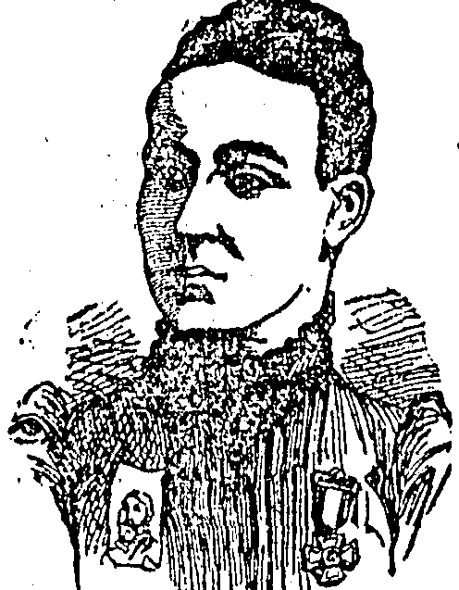

SOURCE A
“Conscienceless capital is robbing manhood of its prime, mothers of their motherhood and sorrowing children of their sunshine and joy. For 100 years the speculators, the land robbers, the pirates and gamblers of the nation have knocked unceasingly at the door of congress and congress has in every instance acceded to their demands. ” (Atchison Daily Globe, Atchison, KS, February 26, 1891)

SOURCE B
“As a result one man, a railroad king, acquires from the labor of all more wealth in a lifetime than the assessed value of six of our great states. The western farmers who depends upon eastern markets finds himself robbed by unjust railroad rates...Our present system of money loaning and usury enables a few to tie a string around every dollar that comes west and jerk it back almost immediately to the eastern money centers...The American workingman is becoming a slave, the American farmer a peasant…A general suspension of immigration is necessary for a few years, or until such time as the government will own and operate the highways of the nation in the interest of all and issue money for the people and not for the national banks.” (The North American, Philadelphia, PA, February 15, 1893)

SOURCE C
A lot of women in congress the past twenty-five years could not have made a worse muddle than the men have. This is woman’s day out-it is the woman’s day or age; the mother’s voice is needed in the political arena to appeal for the prosperity and protection of their children. Is there any need for women in politics? Under the present financial system we can never hope to lift the burden of debt that has been heaped upon the people of America; the rich are growing richer and the poor growing poorer. This is no longer the land of the free and the home of the brave, but the land of the rich and the home of the slave. (The Milwaukee Sentinel, Milwaukee, WI, August 25, 1893)

SOURCE D
“Kansas People should raise more hell, and less corn.” (Atchison Daily Globe, Atchison, KS, September 5, 1895)

SOURCE E
It is no longer a government of the people, by the people, and for the people, but a government of Wall Street, by Wall Street, and for Wall Street. The great common people of this country are slaves, and monopoly is the master. The [political] parties lie to us and the political speakers mislead us. We were told two years ago to go to work and raise a big crop, that was all we needed. We went to work and plowed and planted; the rains fell, the sun shone, nature smiled, and we raised the big crop that they told us to; and what came of it? Eight-cent corn, ten-cent oats, two-cent beef and no price at all for butter and eggs-that's what came of it. The politicians said we suffered from overproduction. Overproduction, when 10,000 little children, so statistics tell us, starve to death every year in the United States… (Speech from 1900)

