United States History
Primary Source: Montgomery Improvement Association Flyer, 1956

During the Montgomery Bus Boycott (1955), black citizens in Montgomery, Alabama refused to ride public buses, which were segregated. In 1956, a federal court ruled that the segregated buses were unconstitutional. The boycott against the segregated buses lasted 381 days and made Martin Luther King, Jr. known across the country as a leader in the civil rights movement.

Integrated Bus Suggestions

This is a historic week because segregation on buses has now been declared unconstitutional. Within a few days the Supreme Court Mandate will reach Montgomery and you will be re-boarding integrated buses. This places upon us all a tremendous responsibility of maintaining, in face of what could be some unpleasantness, a calm and loving dignity befitting good citizens and members of our Race. If there is violence in word or deed it must not be our people who commit it.

For your help and convenience the following suggestions are made. Will you read, study and memorize them so that our non-violent determination may not be endangered. First, some general suggestions:
1. Not all white people are opposed to integrated buses. Accept goodwill on the part of many.
2. The whole bus is now for the use of all people. Take a vacant seat.
3. Pray for guidance and commit yourself to complete non-violence in word and action as you enter the bus.
4. Demonstrate the calm dignity of our Montgomery people in your actions.
5. In all things observe ordinary rules of courtesy and good behavior.
6. Remember that this is not a victory for Negroes alone, but for all Montgomery and the South. Do not boast! Do not brag!
7. Be quiet but friendly; proud, but not arrogant; joyous, but not boistrous.
8. Be loving enough to absorb evil and understanding enough to turn an enemy into a friend.

Now for some specific suggestions:
1. The bus driver is in charge of the bus and has been instructed to obey the law. Assume that he will cooperate in helping you occupy any vacant seat.
2. Do not deliberately sit by a white person, unless there is no other seat.
3. In sitting down by a person, white or colored, say "May I" or "Pardon me" as you sit. This is a common courtesy.
4. If cursed, do not curse back. If pushed, do not push back. If struck, do not strike back, but evidence love and goodwill at all times.
5. In case of an incident, talk as little as possible, and always in a quiet tone. Do not get up from your seat! Report all serious incidents to the bus driver.
6. For the first few days try to get on the bus with a friend in whose non-violence you have confidence. You can uphold one another by glance or prayer.
7. If another person is being molested, do not arise to go to his defense, but pray for the oppressor and use moral and spiritual forces to carry on the struggle for justice.
8. According to your own ability and personality, do not be afraid to experiment with new and creative techniques for achieving reconciliation and social change.
9. If you feel you cannot take it, walk for another week or two. We have confidence in our people.

GOD BLESS YOU ALL.
THE MONTGOMERY IMPROVEMENT ASSOCIATION
The Rev. M. L. King, Jr., President

United States History
Primary Source: The Sit-In Movement

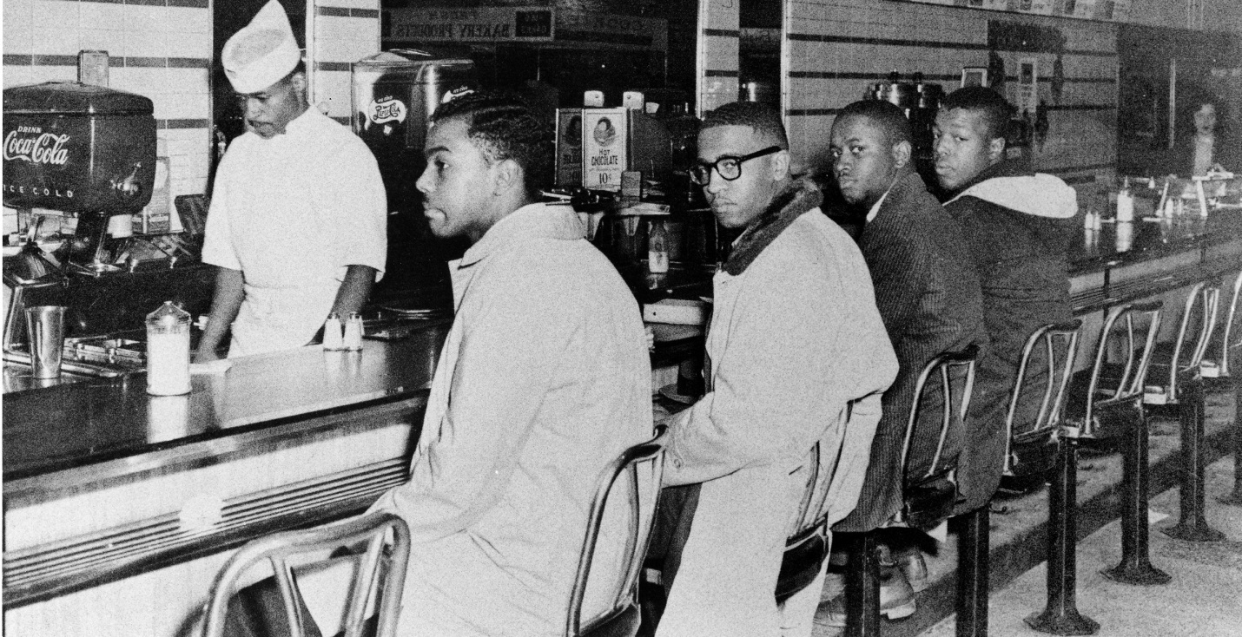
On February 1, 1960, four black students from the North Carolina Agricultural and Technical College sat down at a downtown Greensboro Woolworth’s Lunch counter. Blacks could not eat at the whites’ only counter. Inspired by the example of the four black students, students across the United States began sit-ins at segregated lunch counters. Not all sit-ins were peaceful, despite the nonviolent approach of the civil rights leaders (see the bottom photo from Mississippi, 1963). Woolworth’s gave into the sit-in protestors, however, and desegregated their lunch counters on July 26, 1960.
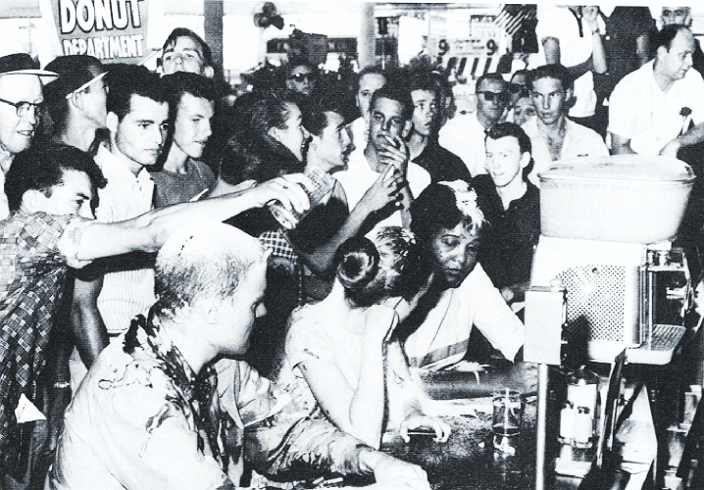

United States History
Primary Source: The Freedom Riders

In 1960, the United States Supreme Court outlawed segregation in waiting rooms, lunch counters, restrooms, and on buses that traveled from state to state (interstate travel). Black passengers, however, still faced harassment in the Deep South. In May of 1961, leaders of CORE (Congress of Racial Equality) began a “Freedom Ride” through the South on buses. Some of the buses were attacked and burned by whites and many Freedom Riders were beaten and arrested. Freedom Riders had showed the ugly reality of segregation was still alive. Their pressure on the federal government forced the Interstate Commerce Commission in 1961 to finally order all “whites only” signs to be removed. The following is an interview with on the riders, Jim Zwerg, describing how his group was attacked in Alabama.

Q: You were attacked when you arrived at the bus station?

Zwerg: The idea had been that cars from the community would meet us. We'd disperse into these cars, get out into the community, and avoid the possibility of violence. It was meant to be as non-violent as possible, to avoid confrontation as much as possible.

Well, before we got off the bus, we looked out and saw the crowd. You could see things in their hands -- hammers, chains, pipes... there was some conversation about it. As we got off the bus, there was some anxiety. We started looking for the cars. But the mob had surrounded the bus station so there was no way cars could get in and we realized at that moment that we were going to get it.

There was a fellow, a reporter, with an old boom mike and he was panning the crowd. And that's when this heavy-set fellow in a white T-shirt... he had a cigar as I remember... came out and grabbed the mike and jumped on it... just smashed it... basically telling the press, "Back off! You are not going to take any pictures of this. You better stay out or you're going to get it next." You could hear crowd yelling and of course a lot of them were, "Get the nigger-lover!" I was the only white guy there.

I bowed my head and asked God to give me the strength and love that I would need, that I put my life in his hands, and to forgive them. And I had the most wonderful religious experience. I felt a presence as close to me as breath itself, if you will, that gave me peace knowing that whatever came, it was okay. Before I opened my eyes, I was grabbed. I was pulled over a railing and thrown to the ground. I remember trying to get up on all fours because you try to get back to your group.

Q: Were you hurt?

Zwerg: Traditionally a white man got picked out for the violence first. That gave the rest of the folks a chance to get away. I was told that several tried to get into the bus terminal. I was knocked to the ground. I remember being kicked in the spine and hearing my back crack, and the pain. I fell on my back and a foot came down on my face. The next thing I remember is waking up in the back of a vehicle and John Lewis handing me a rag to wipe my face. I passed out again and when I woke up I was in another moving vehicle with some very southern-sounding whites. I figured I'm off to get lynched. I had no idea who they were. Again, I went unconscious and I woke up in the hospital. I was informed that I had been unconscious for a day and a half. One of the nurses told me that another little crowd were going to try and lynch me. They had come within a half block of the hospital. She said that she knocked me out in case they did make it, so that I would not be aware of what was happening. I mean, those pictures that appeared in the magazines, the interview... I don't remember them at all. I do remember a class of students -- I think they were high school age, coming to visit me one time.
United States History
Primary Source: The Selma Marches, 1965

African Americans in Alabama by 1965 had begun to challenge the laws that prevented them from voting. But even when those laws were overturned by the courts, they still had to face violence from whites intent on keeping blacks from voting. 600 civil rights marchers decided to walk from Selma, Alabama to Montgomery in March 1965. On the first attempt, March 7, 1965, the 600 civil rights marchers were attacked by state and local police with tear gas and billy clubs. On the third attempt at a march, the protestors, protected by the U.S. Army and the National Guard, made it all the way to the state capitol.

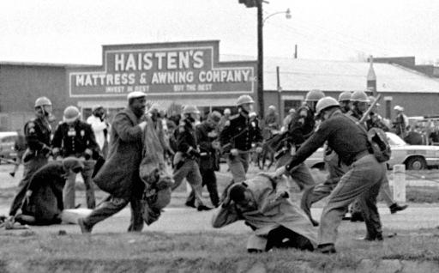
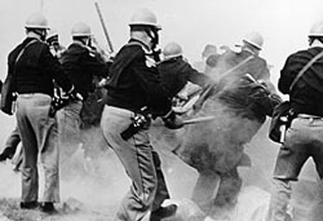

United States History
Primary Source: The Birmingham Campaign, 1963

Martin Luther King, Jr.’s Southern Christian Leadership Conference, put pressure on the city of Birmingham, Alabama in 1963 to end discrimination laws. Birmingham police, led by Eugene “Bull” Connor, cracked down on the protestors, often turning high-pressure water hoses against them or using police dogs on protestors. Martin Luther King, Jr. himself was jailed (for the 13th time) in 1963. He would write the famous “Letter from Birmingham Jail” from prison, which argued against delaying justice to African Americans. Tension was especially high in the city in September 1963, when members of the Ku Klux Klan bombed a Baptist church and killed four girls. All of the pressure eventually led to the desegregation of the city. And “Bull” Connor lost his job.

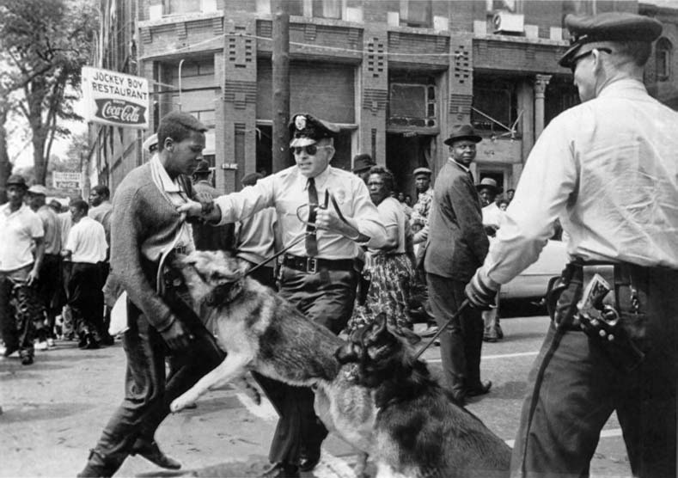
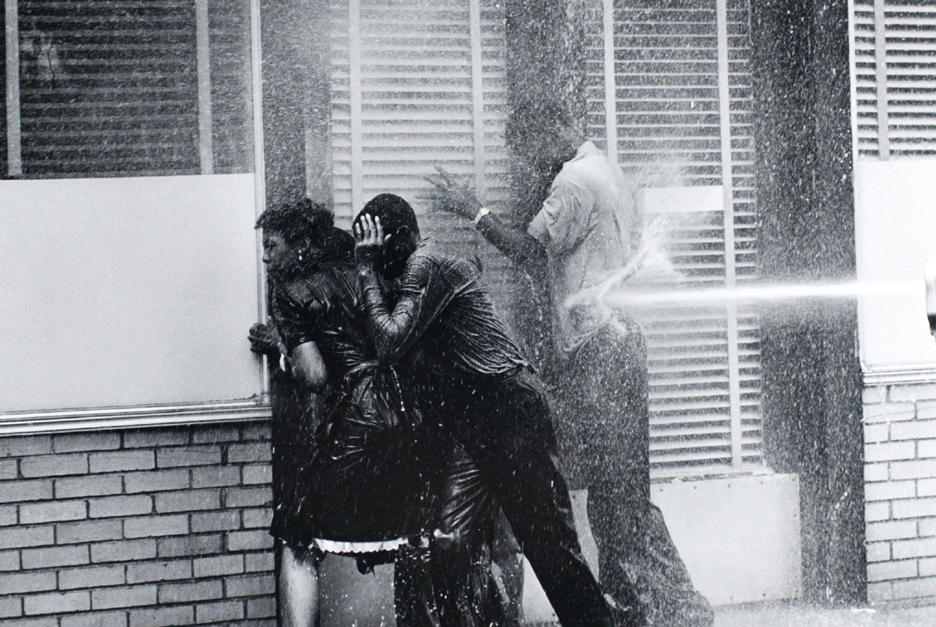

United States History
Primary Source: Freedom Summer, 1964

Freedom Summer began in 1964 as a project to register as many black voters in Mississippi as possible. In 1962, only 6.7% of eligible black voters in Mississippi were actually registered to vote. Volunteers went around helping black citizens register and learn about the elections process. It was a dangerous time for civil rights workers. The White Citizens’ Council and the Ku Klux Klan terrorized civil rights workers. 4 civil rights volunteers were killed, 80 received beatings, and more than 1000 people went to jail. The most devastating act of violence occurred June 21, 1863, when three workers (James Chaney, Michael Schwerner, and Andrew Goodman) were arrested and then murdered by local KKK members. The passage of the Voting Rights Act of 1965 helped the cause but did not eliminate violence.

Memories of Terri Shaw
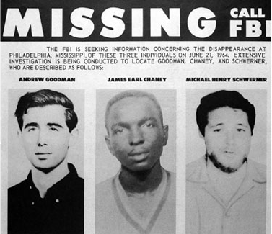
[We had] lessons in how to protect your vital organs while being beaten and what happens when a mob gets out of hand.

... There were a couple of small-time "bombings" which caused no damage but added to the atmosphere of fear. A few local supporters received anonymous telephone calls and threats of assassination. Many more were fired from their jobs or taken off welfare, although this supposedly is illegal.

...Thanks to the Justice Department [JD] case, the registration test had been simplified somewhat. Although it still included interpretation of a section of the Mississippi constitution, the registrar had to choose from 14 sections selected by the JD rather than the entire 286. However, it is still up to the registrar to decide whether the interpretation is correct or not, and the JD's brief has page after page showing tests carelessly written by almost illiterate whites who "passed" contrasted with meticulously accurate interpretations by educated Negroes who, of course, "failed." The names of all those who take the test are published in the local newspaper for 2 weeks, leaving them open to reprisals.

...The... most serious incidents concerning volunteers were beatings. The first occurred on July 10 when the Rabbi Arthur Lelyveld of Cleveland, (a Ministers Project volunteer) and two white male college students were beaten while on their way to one of the churches where lunch was served after a morning of canvassing. They were attacked by two white men who had been following them in a pickup truck without license plates. Shouting "white nigger" and "nigger lover" they beat the rabbi and one of the students with an iron bar. The other student was kicked down an embankment, pummeled and kicked, and finally, his assailant shoved his canvassing notes into his mouth, shouting "eat this... nigger lover." All three were treated at a hospital and the rabbi was hospitalized over night.

...The civil rights act, signed on July 2, brought little change in Hattiesburg. Some local Negroes tested the lunch counters and were served at Woolworths's and Kress's both of which immediately became the objects of Citizens' Council boycotts. (Mississippi's anti-boycott law is enforced only against civil rights groups.) Walgreens took the coward's way out and closed the lunch counter...

United States History
Primary Source: The Little Rock Nine, 1957

After the Supreme Court ordered the desegregation of public schools in 1954 (Brown v. Board of Education), schools moved slowly to integrate black students. Little Rock Central High, in Little Rock, Arkansas, would integrate students in 1957. The nine were chosen for their good grades and attendance: Ernest Green, Elizabeth Eckford, Jefferson Thomas, Terrence Roberts, Carlotta Walls LaNier, Minnijean Brown, Gloria R. Karlmark, Thelma Mothershed, and Melba P. Beals. The governor of Arkansas, Orval Faubus, tried to block the students from going to school, but President Eisenhower ordered federal troops to protect the students.

Interview with Melba Patillo Beals

When you got to school that first day what did you encounter?

I discovered that things were going to be violent. I had never really been in a position where people came at me so violently. I had no idea that grownups could act up and misbehave like this. Sure, I had heard about these things. But as a child you don't really understand until they happen to you. These grownups were threatening to kill me. These grownups were coming at me with baseball bats and pieces of brick, they were walking up to me, slapping me, spitting on me. Well come on, now, this isn't the way grownups behave.

How did the kids inside the school behave?

They were organized to get us out. Period. They had been trained by the segregationists, and most of them were quite hostile. Now, in the beginning, there were a few children who were very sweet and who tried to be at least civil. But within days, these kids had stopped being friendly. They were threatened by their classmates. And some of them actually got beaten up. So they looked the other way. Sometimes painfully, I'm sure, but they looked the other way.

Where did you find the strength to survive?
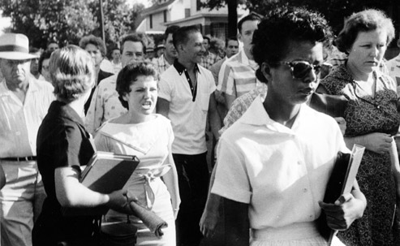
My ability to survive was my grandmother and my mother's teaching. I had been taught all my life to believe to believe in God, and that you live and breathe and have your strength in Him. That your strength doesn't come from you, it comes through you from God.

I would come home from school and say "I hate these people! What are they doing to me?" I'd be whining, crying, sometimes bloody, sometimes drenched with broken eggs. My grandmother would say, "OK. What good happened today? What were the blessings? Is this a good day given to you by God? You're moving, and you're walking. You're OK. And this is your task for now. You have to complete this task."

