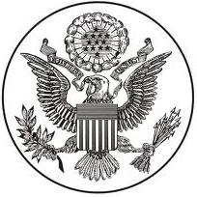
DEPARTMENT OF STATE
OFFICE OF PUBLIC AFFAIRS
INFORMATION MEMORANDUM NO. 28
1a
January 7, 1949

The Soviet Union desired to have a strong central government (which might lend itself to communist infiltration and seizure). The Soviet Union also desired to prolong the economic chaos in Germany in order to induce the kind of hopelessness that yields to communist arguments, and therefore prevented economic unification. In addition, the Soviet Union demanded large reparations against Germany (10 billion dollars) in order to gain powerful control over Germany. The U.S. and Britain believed that the German people should be allowed to decide what form of government they desired and should make this decision under normal conditions.

On June 23, 1948 the U.S.S.R. imposed a blockade of rail and road traffic from the Western zones into Berlin. The Western powers countered with an air lift. An abandonment of Berlin would be interpreted throughout Germany and Europe as evidence of our lack of determination both to defend our rights and to support democratic peoples in their effort to resist totalitarian threats and pressures.

PRESIDENT HARRY S. TRUMAN'S ADDRESS BEFORE A JOINT SESSION OF CONGRESS, MARCH 12, 1947
2a
Mr. President, Mr. Speaker, Members of the Congress of the United States:
The United States has received from the Greek Government an urgent appeal for economic assistance. The very existence of the Greek state is today threatened by the terrorist activities of several thousand armed men, led by Communists, who defy the government's authority at a number of points, particularly along the northern boundaries.
One of the primary objectives of the foreign policy of the United States is the creation of conditions in which we and other nations will be able to work out a way of life free from coercion. To ensure the peaceful development of nations, free from coercion, the United States has taken a leading part in establishing the United Nations.
The peoples of a number of countries of the world have recently had totalitarian regimes forced upon them against their will. I believe that it must be the policy of the United States to support free peoples who are resisting attempted subjugation by armed minorities or by outside pressures.
I believe that we must assist free peoples to work out their own destinies in their own way.
I believe that our help should be primarily through economic and financial aid which is essential to economic stability and orderly political processes.
The seeds of totalitarian regimes are nurtured by misery and want. They spread and grow in the evil soil of poverty and strife. They reach their full growth when the hope of a people for a better life has died. We must keep that hope alive.
The free peoples of the world look to us for support in maintaining their freedoms.
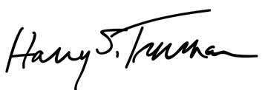
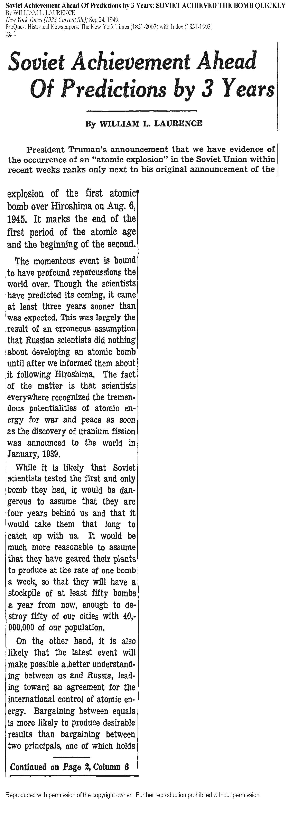
3a

New York Times
September 24, 1949

4a
861.00/2 - 2246: Telegram

The Charge in the Soviet Union (Kennan) to the Secretary of State

SECRET

Moscow, February 22, 1946--9 p.m. Received February 22--3:52 p.m.

Part 1: Basic Features of Post War Soviet Outlook, as Put Forward by Official Propaganda Machine

(a) USSR still lives in antagonistic "capitalist encirclement" with which in the long run there can be no permanent peaceful coexistence.

(b) Everything must be done to advance relative strength of USSR as factor in international society.

(c) To undermine general political and strategic potential of major western powers. Here poor will be set against rich, black against white, young against old, newcomers against established residents, etc.

(d) In foreign countries Communists will, as a rule, work toward destruction of all forms of personal independence, economic, political or moral.

Much depends on health and vigor of our own society. World communism is like malignant parasite which feeds only on diseased tissue. Every courageous and incisive measure to solve internal problems of our own society, to improve self-confidence, discipline, morale and community spirit of our own people, is a diplomatic victory over Moscow.

We must formulate and put forward for other nations a much more positive and constructive picture of sort of world we would like to see. It is not enough to urge people to develop political processes similar to our own. Many foreign peoples, in Europe at least, are tired and frightened by experiences of past, and are less interested in abstract freedom than in security. They are seeking guidance rather than responsibilities. We should be better able than Russians to give them this. And unless we do, Russians certainly will.

Winston Churchill gave this speech at Westminster College, in Fulton, Missouri on March 5, 1946
The United States stands at this time at the pinnacle of world power. It is a solemn moment for the American democracy. As you look around you, you must feel not only the sense of duty done, but also you must feel anxiety lest you fall below the level of achievement. Opportunity is here now, clear and shining, for both our countries.
5a

It is my duty, however, to place before you certain facts about the present position in Europe. From Stettin in the Baltic to Trieste in the Adriatic an iron curtain has descended across the Continent. Behind that line lie all the capitals of the ancient states of Central and Eastern Europe. Warsaw, Berlin, Prague, Vienna, Budapest, Belgrade, Bucharest and Sofia; all these famous cities and the populations around them lie in what I must call the Soviet sphere, and all are subject, in one form or another, not only to Soviet influence but to a very high and in some cases increasing measure of control from Moscow.

In a great number of countries, far from the Russian frontiers and throughout the world, Communist fifth columns are established and work in complete unity and absolute obedience to the directions they receive from the Communist center. Except in the British Commonwealth and in the United States where Communism is in its infancy, the Communist parties or fifth columns constitute a growing challenge and peril to Christian civilization.

Our difficulties and dangers will not be removed by closing our eyes to them. They will not be removed by mere waiting to see what happens; nor will they be removed by a policy of appeasement. What is needed is a settlement, and the longer this is delayed, the more difficult it will be and the greater our dangers will become. From what I have seen of our Russian friends and allies during the war, I am convinced that there is nothing they admire so much as strength, and there is nothing for which they have less respect than for weakness, especially military weakness.

