United States History
Songs of the American Revolution

American Taxation by Peter St. John; Free America by Joseph Warren

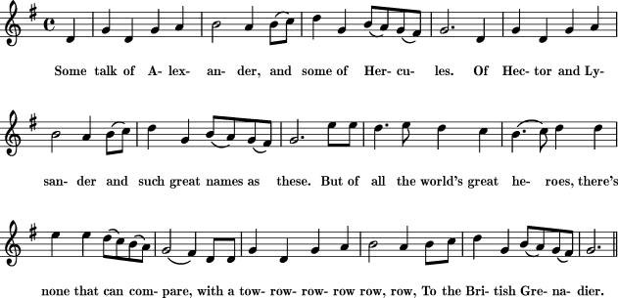
tend to what I say con- cern- ing the tax –a – tion of North A- mer – i - ca
Glo-ry you pres – ent –ly shall hear I’ll give a true re- la - tion at-
While I re - late my stor - y A - mer - i - cans give ear Of Brit-ains fa - ding

The cruel lords of Britain, who glory in their shame,
The project they have hit on they joyfully proclaim;
Tis what they're striving after our rights to take away,
And rob us of our charter in North America.

O King, you've heard the sequel of what we now subscribe,
Is it not just and equal to tax this wealthy tribe?
The question being asked, his majesty did say,
My subjects shall be taxed in North America.

Our fathers were distressed, while in their native land,
By tyrants were oppressed, as we do understand;
For freedom and religion they were resolved to stray,
And trace the desert regions of North America.

God bless this maiden climate, and through her vast domain
May hosts of heroes cluster that scorn to wear a chain.
And blast the venal sycophants who dare our rights betray;
Assert yourselves, yourselves, yourselves For brave America.
Lift up your hearts, my heroes, and swear with proud disdain,
The wretch that would ensnare you shall spread his net in vain;
Should Europe empty all her force, we'd meet them in array,
And shout huzza, huzza, huzza For brave America.

The Liberty Song, John Dickinson
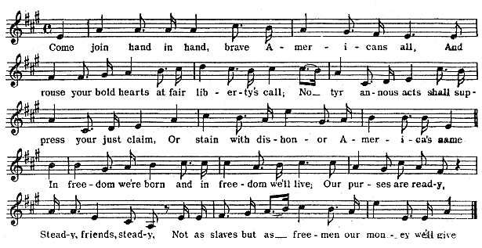

The Rich Lady Over the Sea
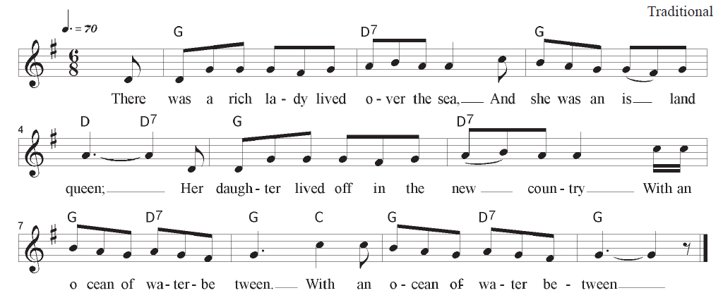

The old lady's pockets were filled with gold,
Yet never contented was she,
So she ordered her daughter to pay her a tax,
Of thruppence a pound on the tea. (Repeat 2x)
Oh mother, dear mother, the daughter replied,
I'll not do the thing that you ask,
I'm willing to pay fair price on the tea,
But never the thruppenney tax. (Repeat 2x)
You shall, cried the mother, and reddened with rage,
For you're my own daughter, you see,
And it's only proper that daughter should pay
Her mother's a tax on the tea. (Repeat 2x)
She ordered her servant to come up to her,
And to wrap up a package of tea.
And eager for thruppence a pound she put in
Enough for a large family. (Repeat 2x)
The tea was conveyed to her daughter's own door,
All down by the oceanside,
But the bouncing girl poured out every pound
On the dark and the boiling tide.
And then she called out to the island queen,
Oh mother, dear mother, called she,
Your tea you may have when 'tis steeped enough,
But never a tax from me! (Repeat 2x)

