United States History Name:________________________________
Unit 6: Western Railroads and Cattle Trails Date:___________________ Period:________

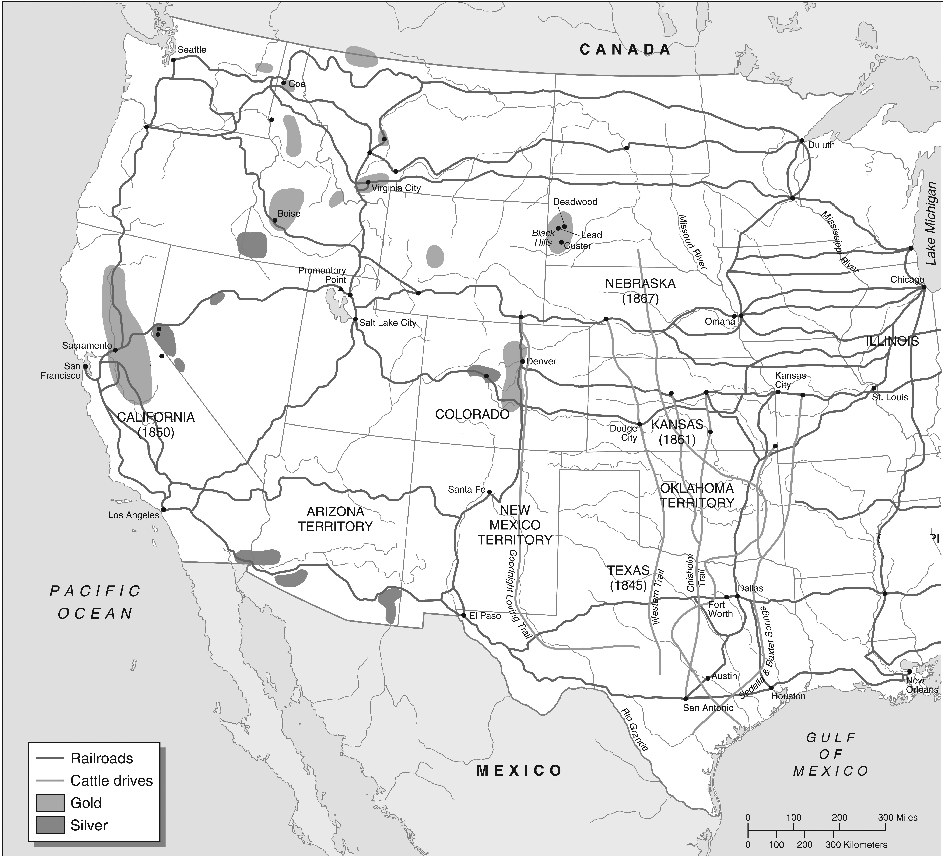

- Where are most of the railroads located—North or South? Why?

- Why do the cattle trails go north?

- What do you think happened to towns along cattle trails and railroads?

