United States History
Was the Korean War Worth the Cost?

CHINA BECOMES A COMMUNIST

COUNTRY
Since the 1920s the Chinese Communists struggled against the Nationalist government led by Chiang Kai-shek. The United States supported Chiang because he opposed communism and sent him aid. But U.S. officials knew that Chiang’s government was inefficient and corrupt.
Mao Zedong led the Communist forces in the North. He won the support of many Chinese peasants. President Truman refused to send American troops to help the Nationalists fight communism.
In 1949, Chiang Kai-Shek and his Nationalist forces had to flee to Taiwan, an island off the coast of China. China was now Communist. Containment in China had failed! American conservatives said that the United States had “lost” China because not enough had been done to help the Nationalists. Conservatives claimed that the U.S. government was filled with Communist agents. American fear of communism began to burn out of control.

FEAR OF COMMUNIST INFLUENCE
Some Americans felt that Communists could threaten the U.S. government from within. Republicans accused the Truman administration of being “soft on communism.” In response to this pressure, Truman set up a Loyalty Review Board. The Board investigated over 3 million people. About 200 were fired. Many people felt that these investigations were unconstitutional. The accused were not allowed to see the evidence against them or to face their accusers.
In 1947, Congress had set up the House Committee on Un-American Activities (HUAC). Its purpose was to look for Communists both inside and outside government. HUAC concentrated on the movie industry because of suspected Communist influences in Hollywood. Many people were brought before HUAC. Some agreed that there had been Communist infiltration of the movie industry. They snitched on others to save themselves.
Ten people called before HUAC refused to testify. They said the hearings were unconstitutional. The Hollywood Ten, as they were called, were sent to prison for their refusal to testify before HUAC. In response to the HUAC hearings, Hollywood executives created a list of some 500 people they thought were Communist-influenced. They refused to hire the people on this blacklist. Many people’s careers were ruined.

A SPY CASE STUNS THE NATION
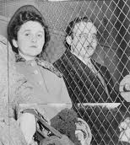
In 1949, the Soviet Union tested an atomic bomb. Most people thought that it would take the Soviets much longer to develop their own atomic bomb. A British scientist admitted giving the Soviets secret information about the American bomb. He also accused two Americans: Ethel and Julius Rosenberg. The Rosenbergs were members of the American Communist Party. They denied the charges of spying. But they were convicted and sentenced to death. People from all over the world appealed for clemency for the Rosenbergs. They said the evidence against them was weak. The Supreme Court refused to overturn the decision, and the Rosenbergs were executed in 1953.

MCCARTHY LAUNCHES HIS “WITCH HUNT”
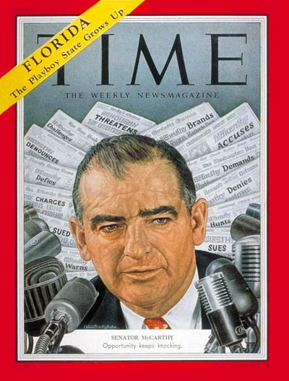
In early 1950, Republican Senator Joseph McCarthy made headlines. He claimed that Communists were taking over the government and said that he had a list of 200 “communists” in the government. He also said the Democrats were guilty of treason for allowing this Communist infiltration. McCarthy never produced any evidence to support his charges. These unsupported attacks on suspected Communists became known as McCarthyism. Later, the term McCarthyism also came to mean the unfair tactic of accusing people of disloyalty without producing evidence.
In 1954, McCarthy made accusations against the U.S. Army. The Senate hearings were broadcast on national television. The American people watched McCarthy bully witnesses but produce no evidence. McCarthy lost public favor. The Senate voted to condemn him. McCarthy was disgraced and died of acute hepatitis (from excessive alcoholism) in 1957.

THE KOREAN WAR
The loss of China to the Communists, the Soviet development of an atomic bomb, and the Rosenberg case had increased fears of Communism in the early 1950s. More important, however, was the Korean War, which lasted from 1950 to 1953. The Korean War—a war fought to contain Communism—is what made the anti-Communist hysteria and witchhunts of Joseph McCarthy so powerful in the early 1950s.
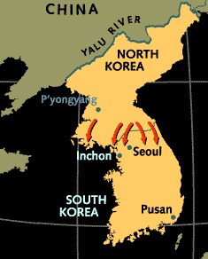
At the end of World War II, Japanese forces in northern Korea surrendered to the Soviets. In southern Korea, the Japanese surrendered to the Americans. Two nations then developed. They were separated by the 38th parallel, a line that divides Korea at 38 degrees north latitude.
In 1948, South Korea became an independent nation. North Korea became a Communist nation. Each claimed the right to rule all of Korea. In June 1950, North Korea started the Korean War by invading South Korea.
President Truman was afraid another Asian nation was about to fall to communism. He ordered air and naval support for South Korea without getting a declaration of war from Congress. Then the United Nations agreed to help South Korea. Troops from 16 nations—most of them American—were sent to South Korea. They were led by General Douglas MacArthur.
North Korean troops conquered the South Korean capital of Seoul. Then MacArthur launched a counterattack. His forces trapped about half the North Korean Army, which surrendered. MacArthur’s success in Korea made him a national hero.
UN and South Korean forces advanced toward the 38th parallel. If they crossed it, the war would become an offensive rather than a defensive one. In October 1950, the UN told MacArthur to cross the 38th parallel and reunite Korea. The Chinese opposed UN forces moving into North Korea. China said it would not let the Americans near its border. The UN ignored the threat and advanced. Then Chinese troops entered North Korea. They drove UN forces back. In January 1951, the Communists recaptured Seoul. For two years, fighting continued. But neither side advanced. MacArthur wanted to extend the war into China. He even suggested dropping atomic bombs on China. Truman was against this strategy.
The Soviets were allies of the Chinese. President Truman felt bombing China would start World War III. MacArthur continued to argue for his plan. He spoke to the press and to Republican leaders. Truman felt that he could no longer allow MacArthur’s insubordination. He fired MacArthur as commander. At first, the American public sided with MacArthur. Later, they came to agree with Truman’s idea of a limited war.
Meanwhile, a cease-fire went into effect in June 1951. Both sides agreed on a demilitarized zone at the 38th parallel. An armistice was signed in July 1953. The agreement was a stalemate and, technically, the war with North Korea remains in effect. Korea was still divided between Communist North Korea and non-Communist South Korea. Many people felt that American lives had been lost for little gain. As a result, the American people rejected the party in power, the Democrats, in the 1952 election. Republican Dwight D. Eisenhower was elected president.
The fighting in Korea cost the United States $67 billion dollars (in 1953 money), or about one-fourth of the cost of World War II. 37,000 American soldiers died in Korea and 103,000 were wounded. It was the first war in American history not declared by Congress as the Constitution requires, since Truman sent troops under the authority of the United Nations. It was also the first war in which the U.S. Army fought in de-segregated units. The Korean War was also the first “hot war” of the Cold War, in which the United States actually fought to contain Communism by military means. Communism today remains in North Korea but South Korea is still free. Undoubedly, the war also increased anti-Communist hysteria and it is no coincidence that Joseph McCarthy was most successful in his witch-hunts against Communists at the same time the Korean War was being fought.
In the long-term the Korean War made relations with China worse and led to a massive increase in the American military budget to fight Communism. By 1960, one-half of the entire federal budget was devoted to military spending and more than a million U.S. soldiers were stationed around the world.

